Supplementary Information for
Structure of the Drosophila ALKA chloride channel responsible for alkaline taste sensation
Jiaxian Xiao#, Yu Jia#, Mingyu Gong, Yuqi Li, Weiping Li, Dandan Qian*, Huahua Sun*, Renhong Yan*, Deshun Gong*

*To whom correspondence should be addressed:
qiandd@nankai.edu.cn; sunhuahua@nankai.edu.cn; yanrh@sustech.edu.cn; gongds@nankai.edu.cn.

This PDF file includes:

Figure S1-S7
Table S1

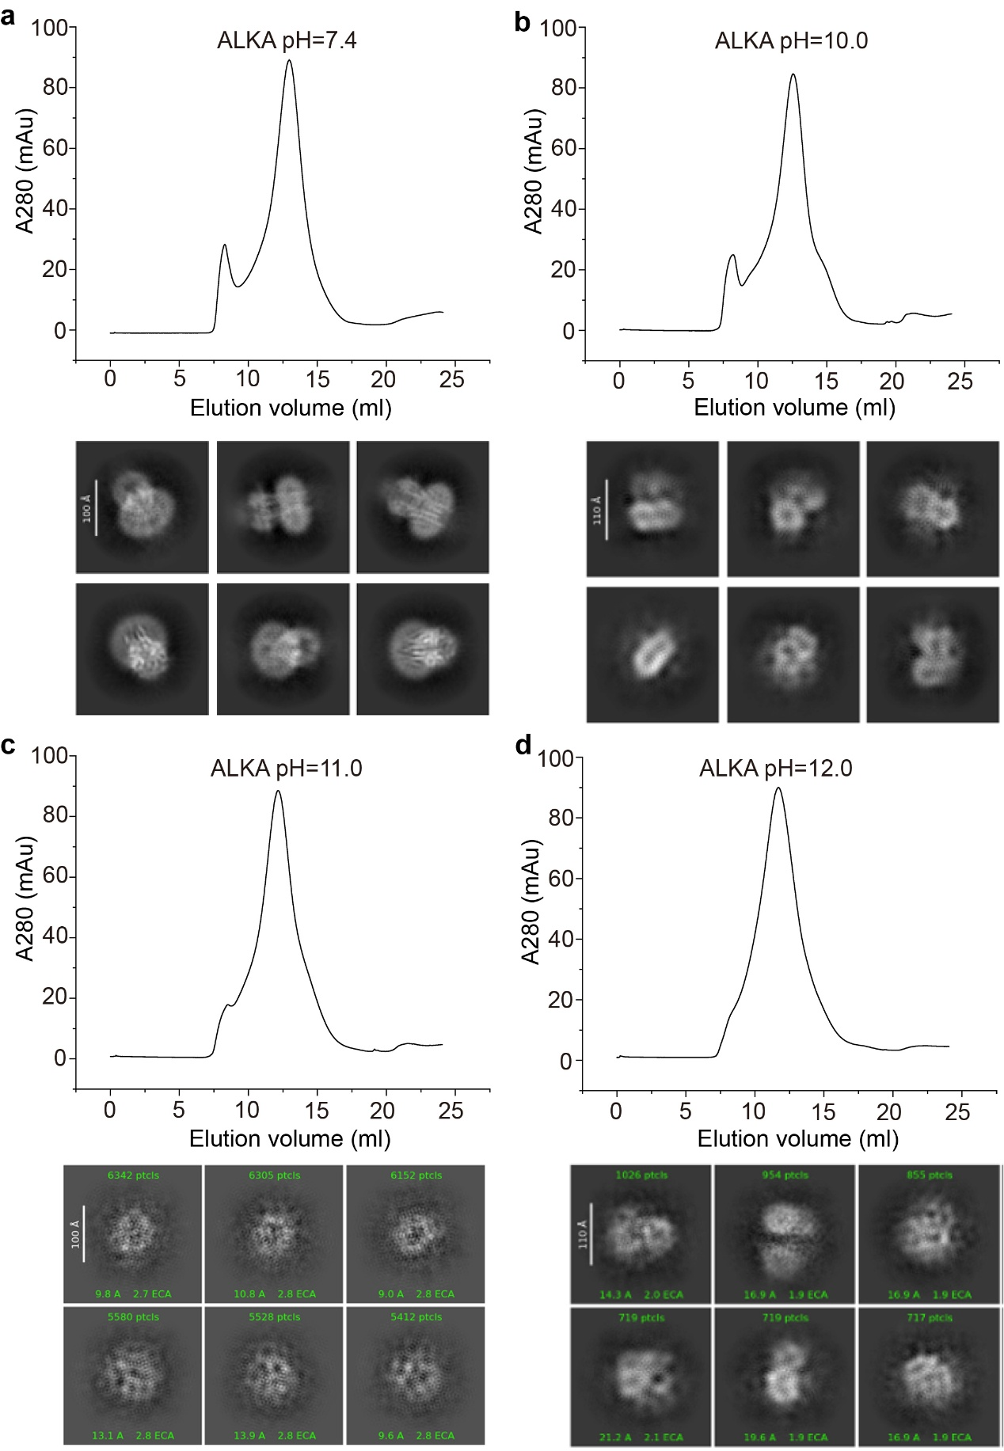
Supplementary Figure S1 | Protein purification and cryo-EM analysis of ALKA samples under varying pH conditions. a, The ALKA channel exhibits clear secondary structure features following 2D class averaging. Chromatogram from size-exclusion chromatography (SEC) and representative 2D class averages of ALKA at pH 7.4. b-d, The ALKA channel loses its structural features upon prolonged exposure to high-pH conditions, as revealed by 2D class averaging. Chromatograms from SEC and representative 2D class averages of ALKA at pH 10.0-12.0, respectively.

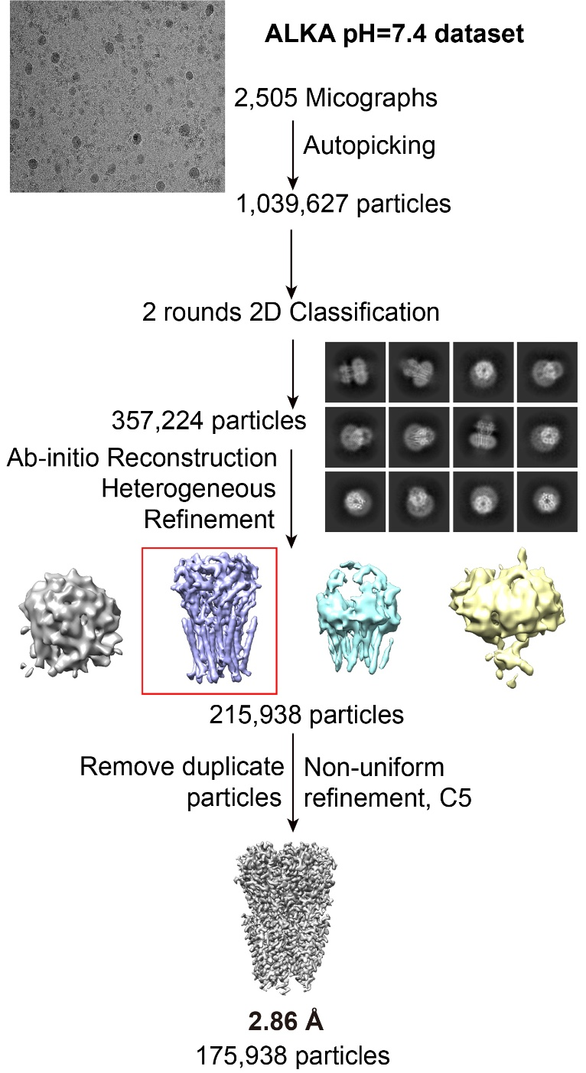
Supplementary Figure S2 | Flowchart for cryo-EM data processing. Please refer to Materials and methods for details.
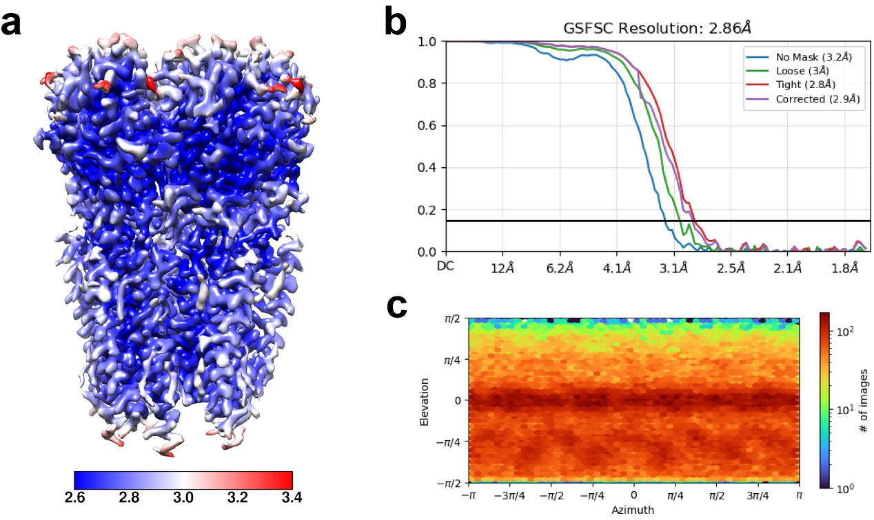
Supplementary Figure S3 | Local resolution map, resolution estimation, and angular distribution of particle orientations in the reconstruction. a, The local resolution maps of the reconstruction. b-c, Gold-standard Fourier shell correlation curves and angular distribution of the particles used for the final reconstruction.

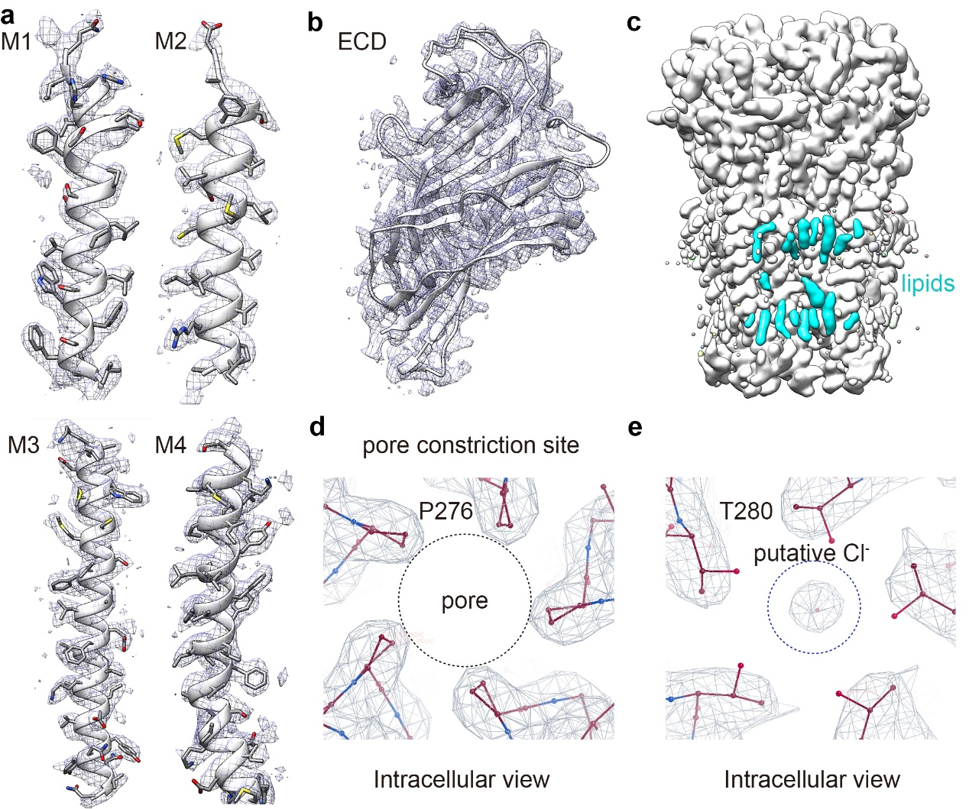
Supplementary Figure S4 | Representative local EM maps of ALKA. a, The EM maps of the four TM helices. b, The EM map of the ECD. c, The EM maps of lipids associated with ALKA. d, The EM map of proline constriction site. e, The EM map of the putative chloride ion.

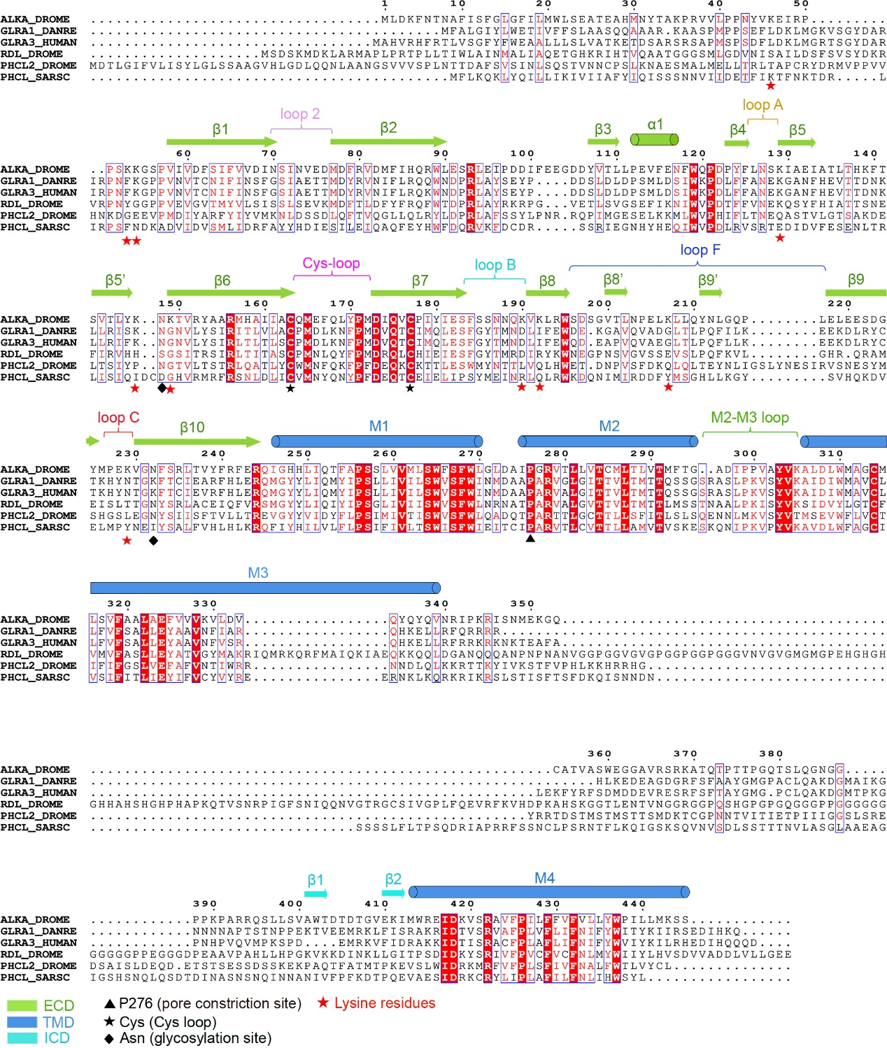Supplementary Figure S5 | Sequence alignment of ALKA with its homologues.

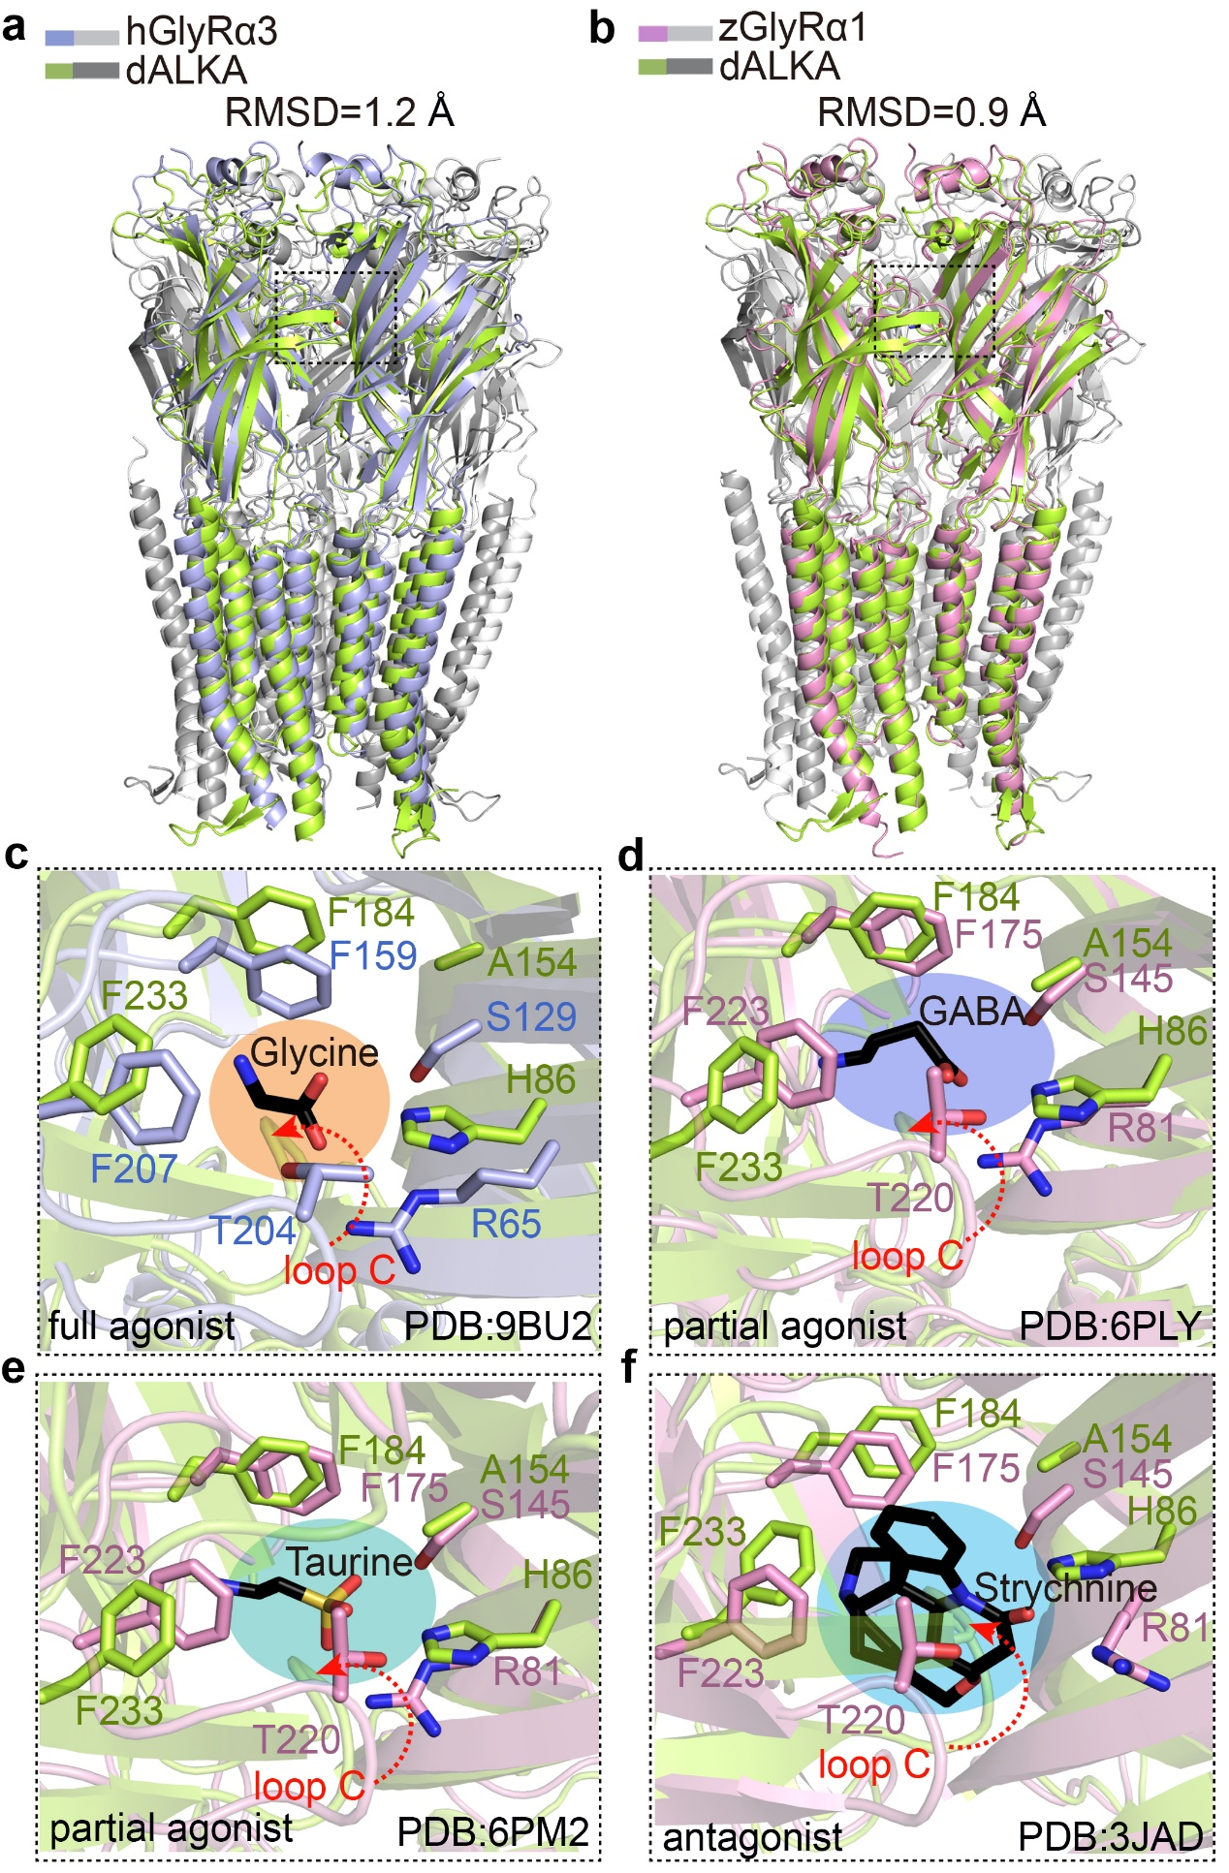
Supplementary Figure S6 | Structural comparison of ALKA with GlyRs. a-b, The structure of ALKA is similar to those of human GlyRα3 and zebrafish GlyRα1, with all structures aligned relative to a protomer of ALKA. c-f, Steric hindrance is expected to occur upon binding of various ligands to the ALKA channel.

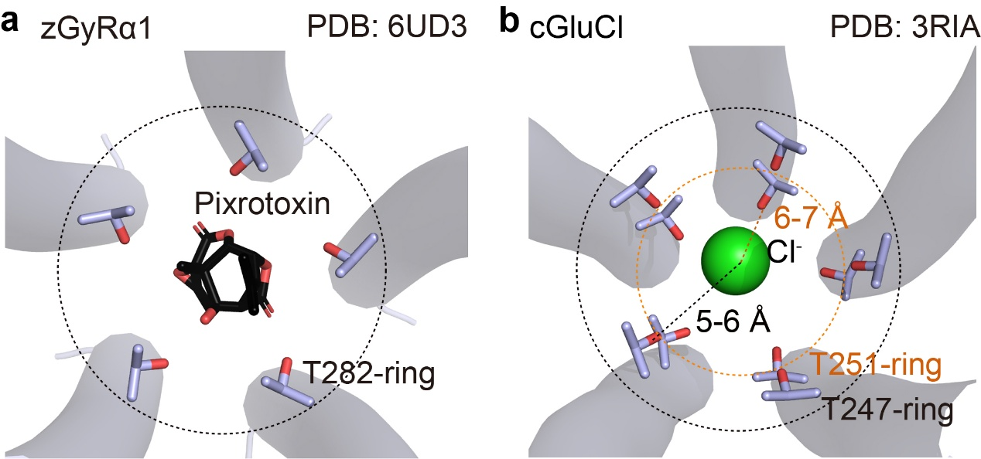
Supplementary Figure S7 | A threonine ring located within the pore of the cysLGIC family is observed to bind the channel blocker pixrotoxin and the chloride ion. a, The channel blocker picrotoxin is coordinated by the T282 ring in zebrafish GlyRα1. b, A chloride ion is coordinated by the T247 and T251 rings in C. elegans GluCl.

Supplementary Table S1 | Cryo-EM data collection, refinement and validation statistics
 |  | ALKA pH7.4
Data collection and processing
Magnification |  | 105,000
Voltage (kV) |  | 300
Electron exposure (e–/Å²) |  | 50
Defocus range (μm) |  | -1.2 to -2.0
Pixel size (Å) |  | 0.827
Symmetry imposed | C5
Movies  Final particle images (no.) | 2505  175,938
Map resolution (Å)  FSC threshold | 2.86  0.143
Refinement
Model composition  Non-hydrogen atoms | 14,721
Protein residues | 1,770
Ligands | 21
B factors (Å²)  Protein  Ligands | 40.05  77.40
R.m.s. deviations  Bond lengths (Å) | 0.005
Bond angles (°) | 1.008
Validation
MolProbity score | 1.86
Clashscore  Poor rotamers (%) | 8.88  2.22
Ramachandran plot  Favored (%)  Allowed (%)  Outliers (%) | 97.4  2.6  0.0

