Supporting Information
Figs. S1 to S10
Fig. S1. Enrichment of gE-specific B cells in tumor tissues of LZ901-immunized C57BL/6 mice.
- Flow cytometric analysis was performed to determine the proportion of B cells in the tumor tissues of C57BL/6 mice immunized with the recombinant zoster protein vaccine (LZ901).
- CD19⁺ B cells were isolated from tumor tissue and spleen of LZ901-immunized C57BL/6 mice using magnetic bead separation. The isolated B cells were then stimulated with 5 ng/mL IL-4 and 2 μg/mL CD40L. The secretion of gE-specific IgG of B cells seperated from tumor and spleen was measured through ELISA. The results indicated that B cells specific to the varicella-zoster virus glycoprotein E (gE) enriched higher in tumor tissues than in spleen . Data are presented as the mean ± s.d. Statistical significance was determined using one-way ANOVA.

Fig. S2. PBAP-gE Inhibition of PD-L1 Binding to PD-1 in vitro.
A) Coomassie Blue staining of sPD-1-gE and PBAP-gE confirming the expression and purity of the recombinant proteins.
B) Immunofluorescence staining showing colocalization of PBAP-gE with intrinsic PD-L1 on 4T1 cells. Scale bars, 25 μm.

Fig. S3. Flow Cytometer Gating Strategy for Activation Analysis of KIL C.2 cells.
KIL C.2 cells were identified by gating on CD3⁻NK1.1⁺ populations, and intracellular IFN-γ expression and NKG2A expression of different groups were analyzed.

Fig. S4. Evaluation of Trop2-CAR and Trop2-CAR-PBAP Cells in Vitro.
A) Retroviral transduction efficiency and CAR expression analysis. The transduction efficiency and CAR expression (mean fluorescence intensity, MFI) of Trop2-CAR and Trop2-CAR-PBAP cells were assessed.
B) Cytotoxicity assay. The cytotoxicity of Trop2-CAR and Trop2-CAR-PBAP cells against B16-Trop2 cells and B16-F10 cells was evaluated by LDH assay, B16-F10 cells were used as a negative control.
C) PBAP secretion analysis. The secretion of PBAP by Trop2-CAR-PBAP cells was measured upon co-culture with B16-F10 (negative control) and B16-Trop2 cells.
For panels B, data are presented as the mean ± s.d. Statistical significance was determined using unpaired t test. ns indicates not significant (P > 0.05).

Fig. S5. Analysis of tumor-infiltrating immune cells by Flow cytometer
Flow cytometer analysis of tumor-infiltrating CD4⁺ T cells and the IFN-γ⁺ proportion in CAR-T cells and NK cells. ns indicates not significant (P > 0.05).

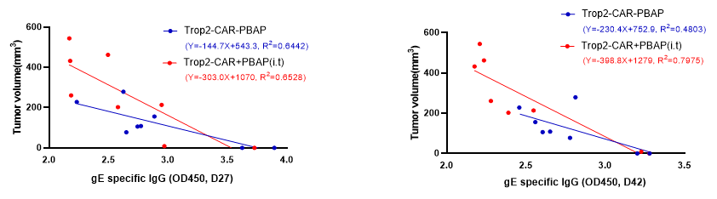
Fig. S6. The tumor volume is negatively correlated with gE-specific IgG antibody levels.
Correlation analysis of tumor volume with gE-specific IgG antibody levels (OD450) at Days 27 and 42 between Trop2-CAR-PBAP treatment group and Trop2-CAR + PBAP treatment group.

Fig. S7. Correlation analysis of tumor volume with gE-specific IgG antibody among the GE group, LZ901 group, and GE-I53-50 immunization group.
A) Particle size distribution analysis of GE-I53-50 and I53-50 nanoparticles.
B) Flow cytometer analysis of CAR-T cells in the spleen.
C) Flow cytometer analysis of tumor-infiltrating immune T cells and the IFN-γ⁺ proportion in CAR-T cells and NK cells.
D) Correlation analysis of tumor volume with gE-specific IgG antibody levels (OD450) at Days 27 and 42 among the GE group, LZ901 group, and GE-I53-50 immunization group.
For bar charts in panels B, C and D data are presented as the mean ± s.d. Statistical significance was determined using one-way ANOVA. ns indicates not significant (P > 0.05).

Fig. S8. PBAP-Her2 Inhibition of PD-L1 Binding to PD-1 in vitro.
A) Coomassie Blue staining was applied to detect the expression and purity of the recombinant proteins sPD-1-Her2 and PBAP-Her2.
B) Colocalization of PBAP-Her2 with intrinsic PD-L1 on MDA-MB-231 cells was demonstrated by immunofluorescence staining. Scale bars, 25 μm.

Fig. S9. Flow cytometer Gating Strategy for Activation Analysis in NK cells.
NK cells were identified by gating on CD3⁻, NK1.1⁺ populations, and analyzed for intracellular IFN-γ expression and NKG2A expression.
Fig. S10. PBAP-Her2 Synergizes with Antibody-Drug Conjugates Kadcyla in NSG Mice Bearing Subcutaneous Tumors
Representative immunostaining images for PD-L1, PBAP-Her2, and Antibody-Drug Conjugates (ADC) Kadcyla. Nuclei are shown in blue with DAPI. Scale bars, 20 μm.

