Supplementary Materials

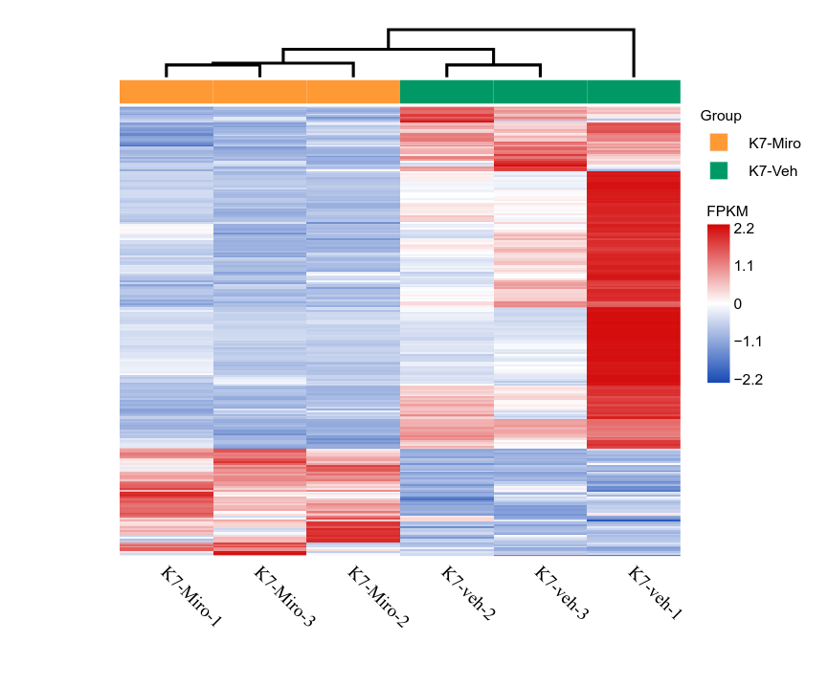
Supplementary Figure S1：Heat map of hierarchical clustering based on differentially expressed genes identified from transcriptomic analysis.

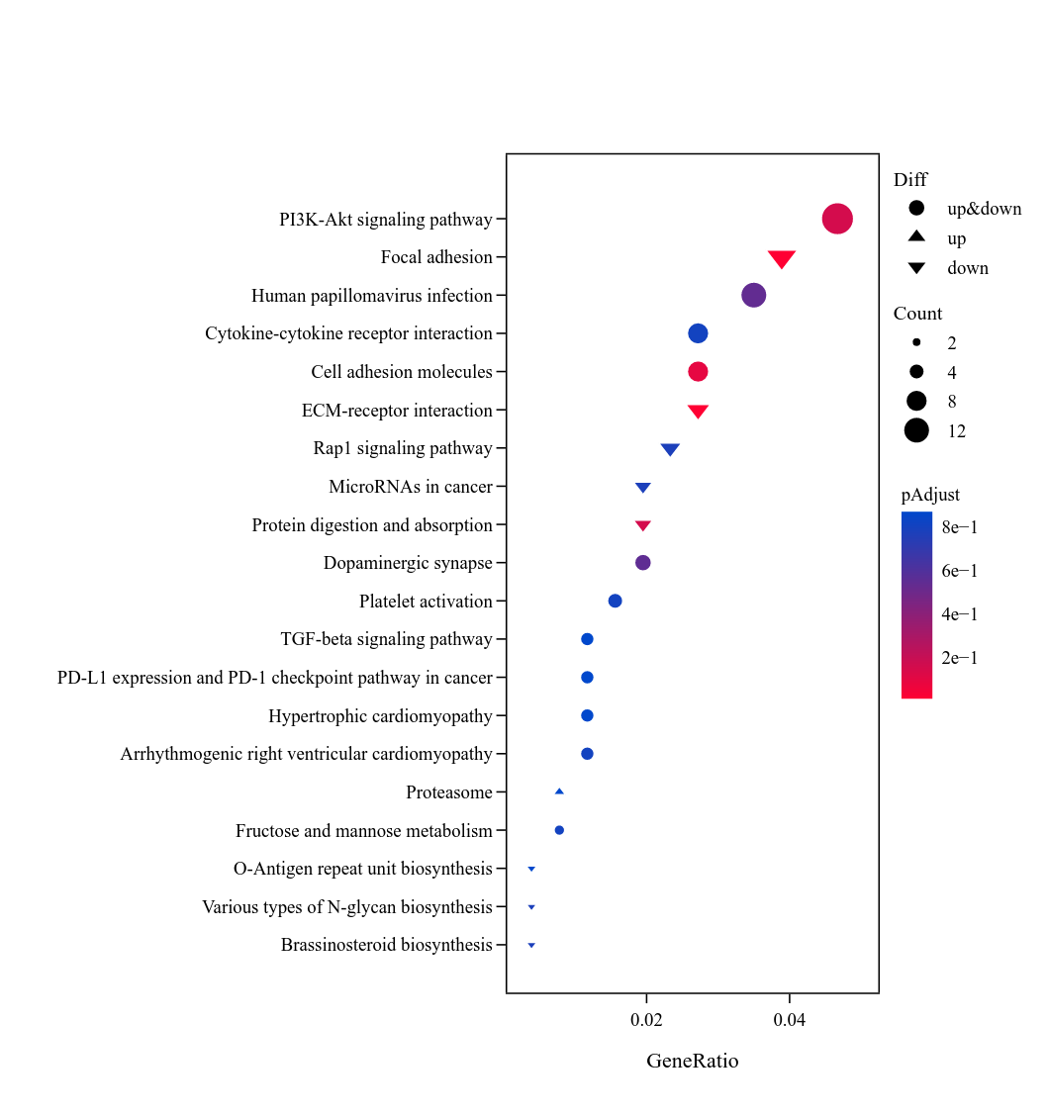
Supplementary Figure S2:KEGG functional enrichment analysis plot based on differentially expressed genes from transcriptomic analysis.

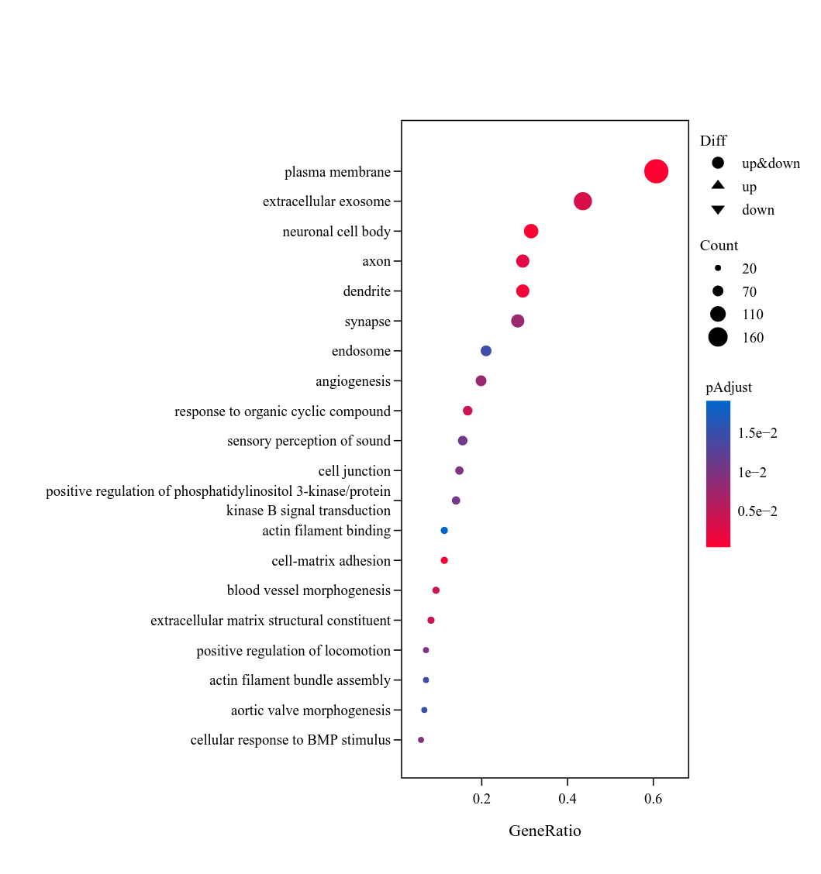

Supplementary Figure S3: GO functional enrichment analysis plot based on differentially expressed genes from transcriptomic analysis.

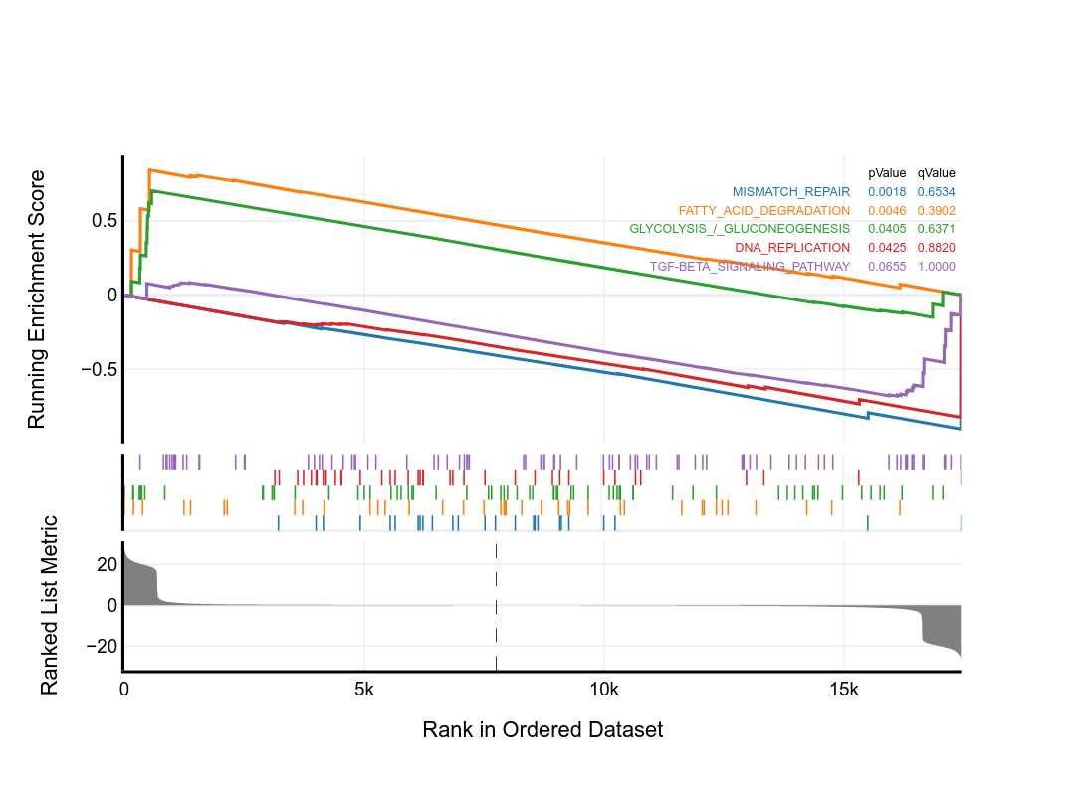
Supplementary Figure S4: Gene Set Enrichment Analysis based on differentially expressed genes from transcriptomic analysis.

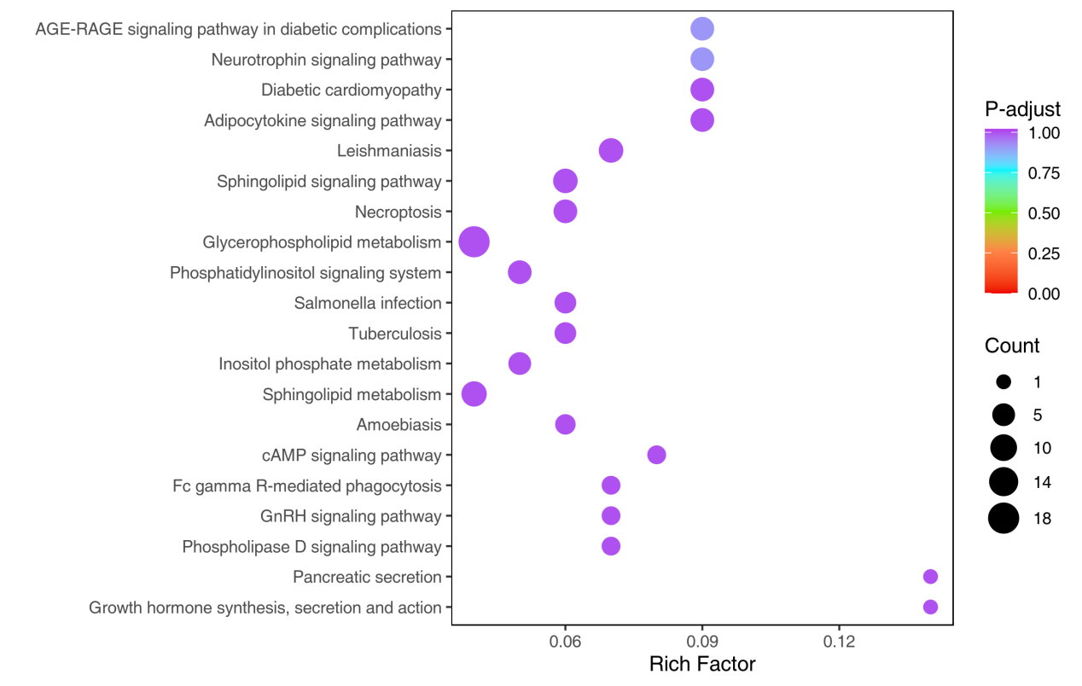
Supplementary Figure S5: KEGG enrichment diagram of differential lipids

Supplementary Methods – Transcriptomic Analysis
- Sample Preparation and Sequencing
Total RNA was extracted from the cell samples, and RNA integrity was confirmed. Sequencing libraries were prepared and subjected to high-throughput sequencing on the Illumina platform.
- Quality Control of Raw Data
Raw sequencing data in FASTQ format were subjected to quality control (QC) procedures to remove low-quality reads and contaminants. Reads were filtered as follows:Removing reads with adapter contamination. Removing reads with >10 ambiguous nucleotides (N bases).Removing reads where >40% of bases had a quality score ≤ Q30. Removing reads shorter than 100 bp after trimming.Post-filtering, each sample achieved a clean read rate >94%, with GC content ~49–51%.
- Read Alignment
Clean reads were aligned to the Homo sapiens reference genome (GRCh38.112) using HISAT2, which efficiently aligns reads including those spanning splice junctions. The alignment rate ranged between ~83% and ~88% across samples. Reads were uniquely or multiply mapped to the genome, and strand-specific mapping rates were also recorded.
- Transcript Assembly and Quantification
Aligned reads were assembled into transcripts using StringTie, which provides accurate transcript reconstruction and abundance estimation. Gene expression was quantified as FPKM (Fragments Per Kilobase per Million mapped reads) and TPM (Transcripts Per Million) values.
- Data Saturation and Bias Assessment
Saturation analysis was performed to ensure sufficient sequencing depth for comprehensive gene detection. Randomness of mRNA fragmentation was assessed by examining the evenness of coverage across transcripts. Additionally, GC content, base composition distribution, and insert size distribution were evaluated to confirm library quality and randomness.

6. Data Analysis

6.1 Expression and Differential Analysis
Normalized gene expression levels were visualized using boxplots and principal component analysis (PCA) to assess sample clustering and biological reproducibility. Differentially expressed genes (DEGs) were identified using DESeq2, applying the following criteria:Adjusted P < 0.05 (multiple testing correction) and |log₂FoldChange| ≥ 1.

6.2 Functional Annotation and Enrichment Analysis
DEGs were annotated using gene ontology (GO) and Kyoto Encyclopedia of Genes and Genomes (KEGG) databases. GO and KEGG pathway enrichment analyses were conducted using hypergeometric tests to identify significantly overrepresented biological processes, cellular components, molecular functions, and pathways. Gene set enrichment analysis (GSEA) was also performed to explore pathway-level changes.

Supplementary Methods – Transcriptomic Analysis
- Lipid Metabolomic Analysis
HPLC-grade acetonitrile (ACN), methanol (MeOH), isopropanol (IPA), dichloromethane (CH₂Cl₂), and methyl tert-butyl ether (MTBE) were purchased from Merck (Darmstadt, Germany). HPLC-grade formic acid (FA) and ammonium formate (AmFA) were obtained from Sigma-Aldrich (St. Louis, MO, USA). Ultrapure water was produced using a Milli-Q system (Millipore, Billerica, MA, USA). Lipid standards were purchased from Sigma-Aldrich or Avanti Polar Lipids (Alabaster, AL, USA).

2. Cell Sample Preparation
Samples were thawed on ice, and the cell pellet was resuspended in 100 μL of ultrapure water containing protease inhibitors (PMSF and EDTA). A 50 μL aliquot of the suspension was mixed with 500 μL of methanol, MTBE, and internal standard mixture, then vortexed for 15 minutes. Subsequently, 100 μL of water was added, vortexed for 1 minute, and centrifuged at 12,000 rpm for 10 minutes at 4 °C. The supernatant (300 μL) was collected, dried, and reconstituted in 200 μL of solvent, stored at –80 °C, and used for LC–MS/MS analysis.The remaining 50 μL of cell suspension was subjected to three freeze–thaw cycles, centrifuged at 12,000 rpm for 10 minutes, and the supernatant was collected for protein quantification using a BCA Protein Assay Kit.

3. HPLC Conditions
Sample extracts were analyzed using an LC–ESI–MS/MS system (UPLC, ExionLC AD; MS, QTRAP® 6500+ System, Sciex). The UPLC was equipped with a Thermo Accucore™ C30 column (2.6 μm, 2.1 × 100 mm). The solvent system was:Solvent A: acetonitrile/water (60:40, v/v) with 0.1% formic acid and 10 mM ammonium formate.Solvent B: acetonitrile/isopropanol (10:90, v/v) with 0.1% formic acid and 10 mM ammonium formate.The gradient elution program was as follows:0 min, A/B = 80:20 → 2 min, 70:30 → 4 min, 40:60 → 9 min, 15:85 → 14 min, 10:90 → 15.5 min, 5:95 → 17.3 min, 5:95 → 17.3 min, 80:20 → 20 min, 80:20.Flow rate: 0.35 mL/min; column temperature: 45 °C; injection volume: 2 μL. The effluent was introduced into the ESI–triple quadrupole–linear ion trap mass spectrometer.

4. ESI–MS/MS Conditions
LIT and triple quadrupole (QQQ) scans were acquired on a triple quadrupole-linear ion trap mass spectrometer (QTRAP), QTRAP® 6500+ LC-MS/MS System, equipped with an ESI Turbo Ion-Spray interface, operating in positive and negative ion mode and controlled by Analyst 1.6.3 software (Sciex). The ESI source operation parameters were as follows: ion source, turbo spray; source temperature 500 °C; ion spray voltage (IS) 5500 V（Positive）,-4500 V(Neagtive); Ion source gas 1 (GS1), gas 2 (GS2), curtain gas (CUR) were set at 45, 55, and 35 psi, respectively. Instrument tuning and mass calibration were performed with 10 and 100 μmol/L polypropylene glycol solutions in QQQ and LIT modes, respectively. QQQ scans were acquired as MRM experiments with collision gas (nitrogen) set to 5 psi. DP and CE for individual MRM transitions was done with further DP and CE optimization. A specific set of MRM transitions were monitored for each period according to the metabolites eluted within this period.

5. Method Reference
Lipid detection was performed by MetWare (http://www.metware.cn/) on the AB Sciex QTRAP 6500 LC–MS/MS platform.

6. Data Analysis

6.1 PCA
Unsupervised principal component analysis (PCA) was performed using the ‘prcomp’ function in R (www.r-project.org), on unit-variance–scaled data.

6.2 Hierarchical Cluster Analysis (HCA) and Pearson Correlation Coefficient (PCC)
HCA and PCC analyses were performed using the R package pheatmap. For HCA, normalized metabolite intensities (unit variance scaling) were visualized as heatmaps with dendrograms. PCC between samples was calculated using the `cor` function in R and displayed as heatmaps.

6.3 Differential Metabolite Selection
For two-group comparisons, differential metabolites were identified based on variable importance in projection (VIP > 1) and P < 0.05 (Student’s t-test). VIP scores were obtained from OPLS-DA results, which also included score and permutation plots, generated using the R package MetaboAnalystR. Data were log₂-transformed and mean-centered prior to OPLS-DA. To avoid overfitting, a permutation test (200 permutations) was performed.

6.4 KEGG Annotation and Enrichment Analysis
Identified metabolites were annotated using the KEGG Compound database (http://www.kegg.jp/kegg/compound/) and mapped to KEGG pathways (http://www.kegg.jp/kegg/pathway.html). Pathway enrichment was performed using metabolite set enrichment analysis (MSEA), and significance was assessed using hypergeometric test P-values.

6.5 Data Scaling Methods
During lipidomic data analysis, two normalization methods were applied to preprocess the data:
(1)Unit Variance Scaling (UV): Also known as Z-score standardization or auto scaling, this method normalizes the data based on the mean (µ) and standard deviation (σ) of each variable. After transformation, the data follow a standard normal distribution with mean 0 and standard deviation 1.
Formula: $\text{x'=(x−µ)/σ}$
(2) Zero-Centered (Ctr): This method simply centers the data by subtracting the mean of each variable.
Formula:$\text{x'=x−µ}$
These transformations were applied where appropriate to ensure comparability and proper scaling of the metabolomic variables.

