Supplementary Materials
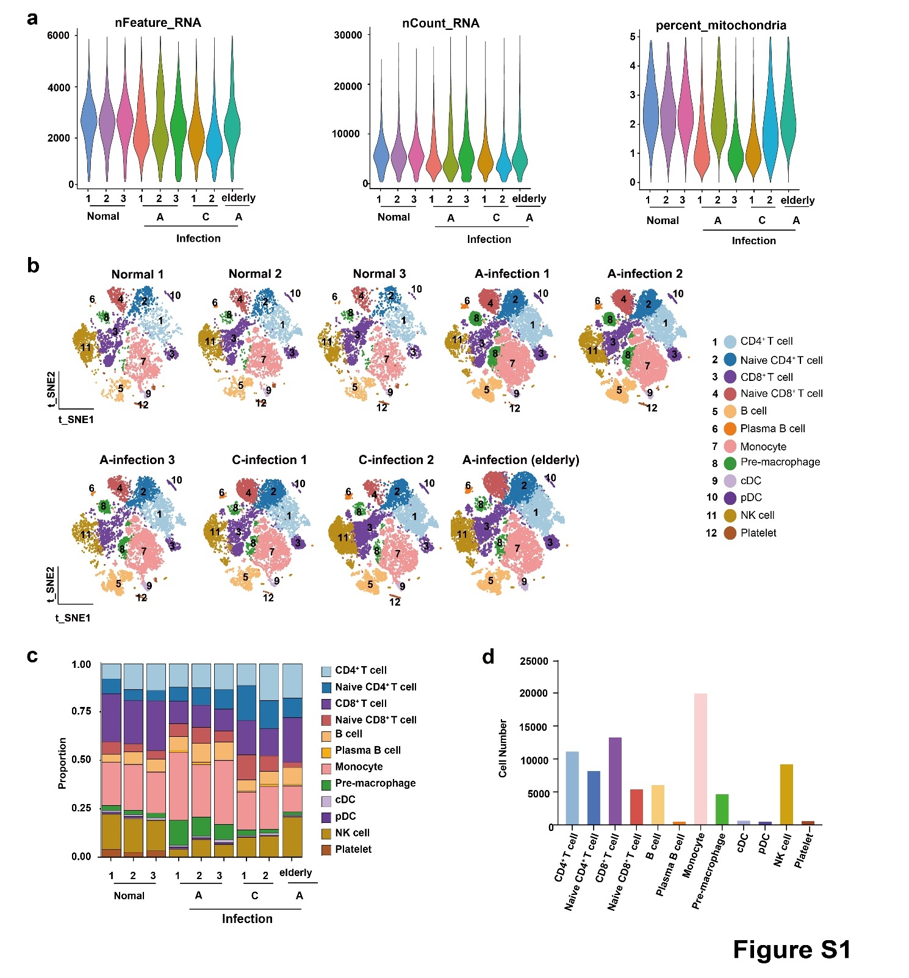
Fig. S1 Quality control and comparative profiling of cell type composition across CHIKV-related cohorts. a Violin plots displaying the distribution of three core scRNA-seq quality control metrics: number of detected genes (nFeature_RNA), total UMI counts (nCount_RNA), and percentage of mitochondrial genes (percent.mt), across experimental groups. b Sample-specific t-SNE plots of single-cell clustering results, with cells colored by the 12 annotated cell types. c Stacked bar plots illustrating the proportion of each annotated cell type in each sample, grouped by cohort status. d Bar plot depicting the total cell count for each annotated cell type, integrated across all samples.
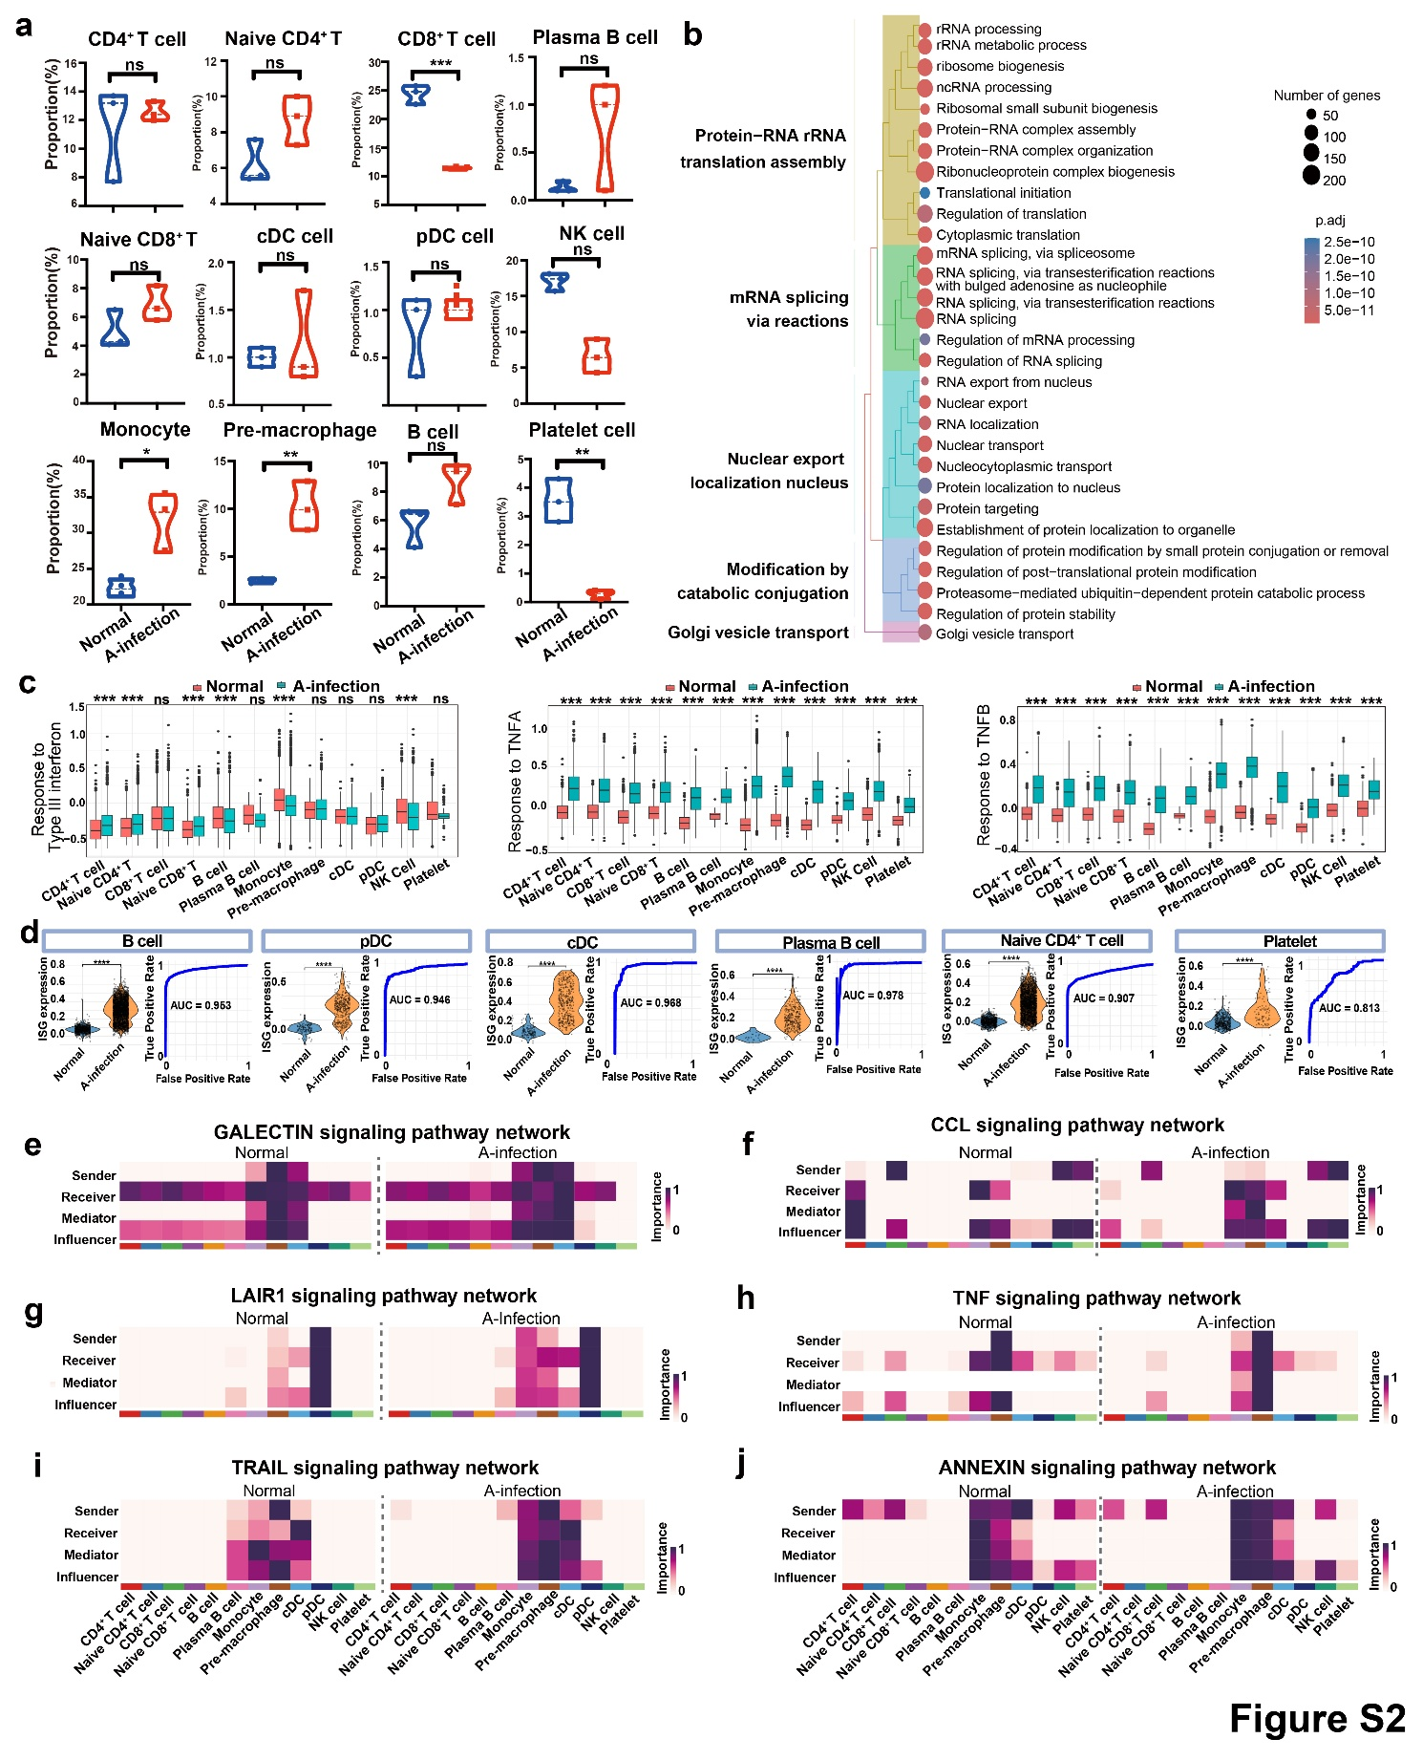
Fig. S2 Immune cell composition, functional enrichment, and signaling network dynamics during CHIKV A-infection. a Violin plots displaying the proportion (%) of 12 distinct immune cell subsets. b Hierarchical tree plot of GO enrichment analysis for down-regulated DEGs. c Box plots illustrating expression patterns of representative GO terms across all cell types (A-infection vs. normal). d ISG expression analysis. e-j Heatmaps showing alterations in cell-cell communication networks of key immune signaling pathways between Normal and A-infection groups. Statistical significance: *p < 0.05, **p < 0.01, ***p < 0.001.
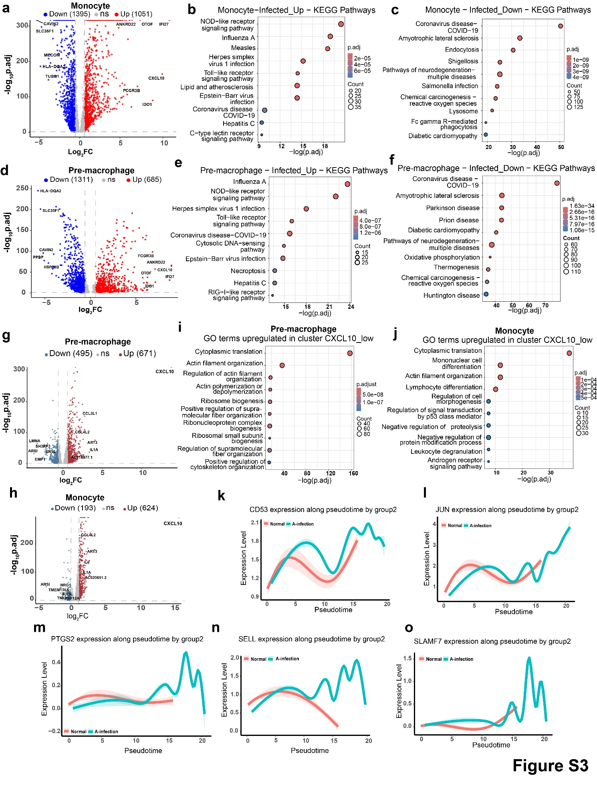
Fig. S3 Differential gene expression and functional enrichment in monocyte and pre-macrophage populations. a Volcano plot of DEGs in monocytes. b-c KEGG pathway enrichment dot plots for monocytes: b up-regulated DEGs; c down-regulated DEGs. d Volcano plot of DEGs in pre-macrophages. e-f KEGG pathway enrichment dot plots for pre-macrophages: e up-regulated DEGs; f down-regulated DEGs. g-h Volcano plots of DEGs in CXCL10_low subclusters: g monocyte CXCL10_low; h pre-macrophage CXCL10_low. i-j GO term enrichment dot plots for up-regulated genes in CXCL10_low subclusters: i monocyte; j pre-macrophage. k-o Pseudotime expression dynamics of genes (CD53, JUN, PTGS2, SELL, SLAMF7) in A-infection vs. normal groups, plotted along reconstructed pseudotime.
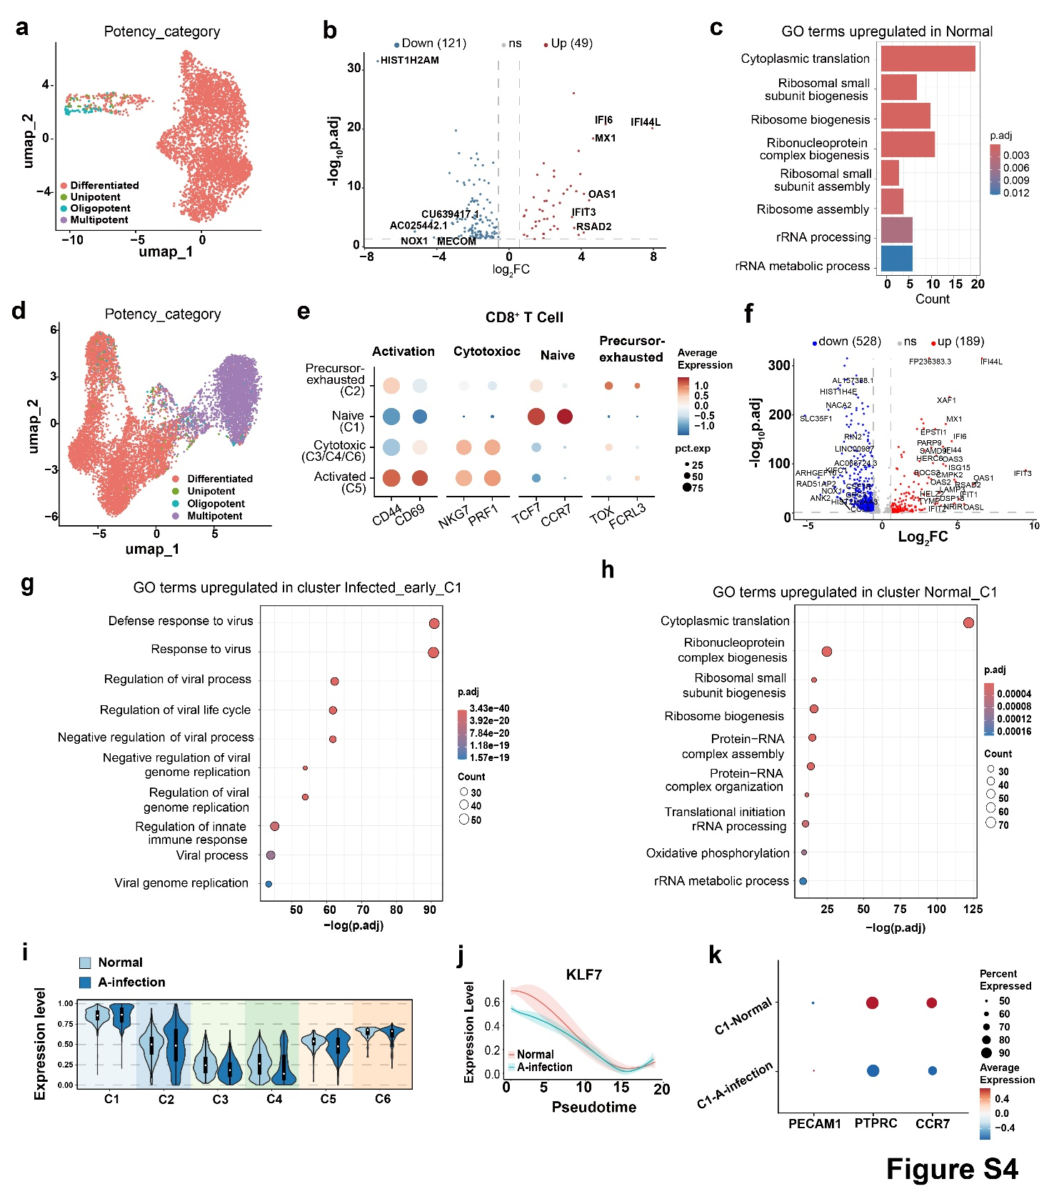
Fig. S4 Functional and transcriptional profiling of cell potency and subcluster-specific responses in NK and CD8⁺ T cells. a UMAP visualization of NK cells colored by potency category in the dataset. b Volcano plot depicting DEGs in NK cells (A-infection vs. normal): 121 down-regulated genes (blue) and 49 up-regulated genes (red); key genes are labeled. c Bar plot of GO terms up-regulated in normal group cells. d UMAP visualization of CD8⁺ T cells colored by potency category. e Dot plot showing marker gene expression across CD8⁺ T cell functional states. f Volcano plot depicting DEGs in CD8⁺ T cell subclusters (A-infection vs. normal): 528 down-regulated genes (blue) and 189 up-regulated genes (red); key genes are labeled. g GO term enrichment dot plot for up-regulated genes in A-infection C1 subcluster. h GO term enrichment dot plot for up-regulated genes in normal C1 subcluster. i Expression level plots (stratified by normal/A-infection) across CD8⁺ T cell subclusters (C1-C6), visualizing inter-group expression differences. j Expression dynamics of KLF7 along reconstructed pseudotime in A-infection vs. normal groups. k Dot plot of marker gene expression in C1 subcluster.
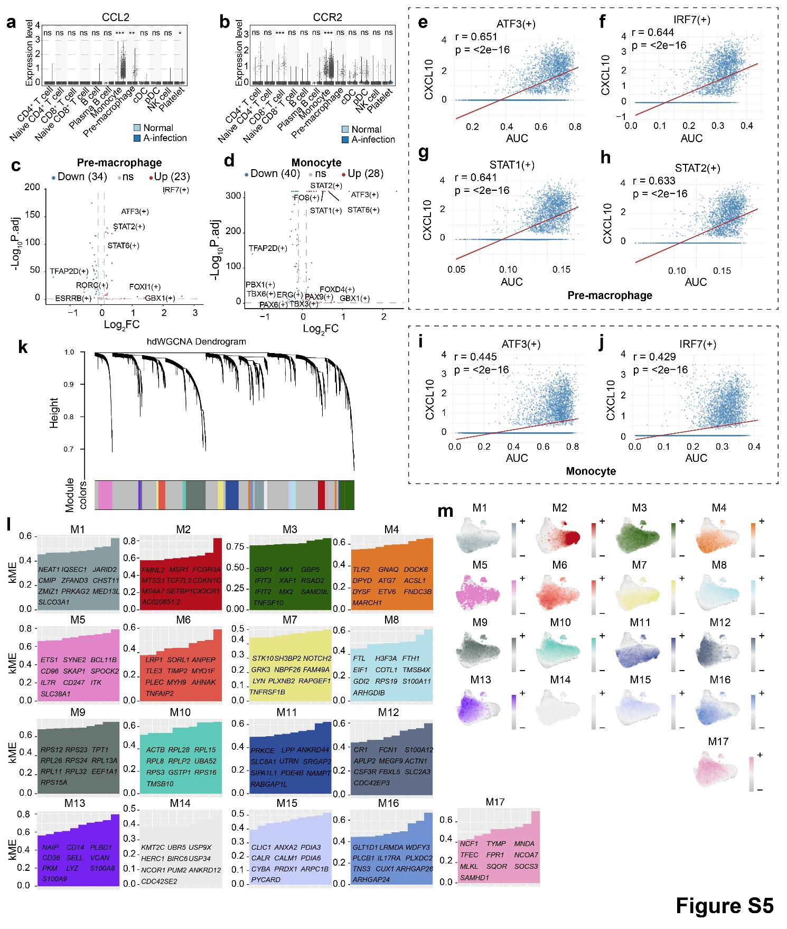
Fig. S5 Molecular responses and regulatory networks of pre-macrophages and monocytes during CHIKV A-infection. a-b Violin plots showing expression levels of CCL2 (a) and CCR2 (b) across distinct cell types，stratified by Normal and A-infection cohorts. c-d Volcano plots illustrating differential regulatory activity of transcription regulators in pre-macrophages (c) and monocytes (d) (A-infection vs. normal). e-h Scatter plots of pre-macrophages: each plot shows the correlation between the AUC of regulator-positive (+) populations (x-axis) and CXCL10 expression (y-axis) for ATF3⁺ (e), IRF7⁺ (f), STAT1⁺ (g), and STAT2⁺ (h) subsets. i-j Scatter plots of monocytes: each plot depicts the correlation between the AUC of regulator-positive (+) populations (x-axis) and CXCL10 expression (y-axis) for ATF3⁺ (i) and IRF7⁺ (j) subsets. k hdWGCNA hierarchical clustering dendrogram of genes: branches represent gene clusters; module colors (right) are assigned to each cluster. l Summary plots for hdWGCNA modules (M1-M17): each plot lists key genes per module, with module membership (MME) values indicating gene-module correlation strength. m Feature plots illustrating the expression pattern of each hdWGCNA module (M1-M17) across the cell population; color intensity denotes module expression level.
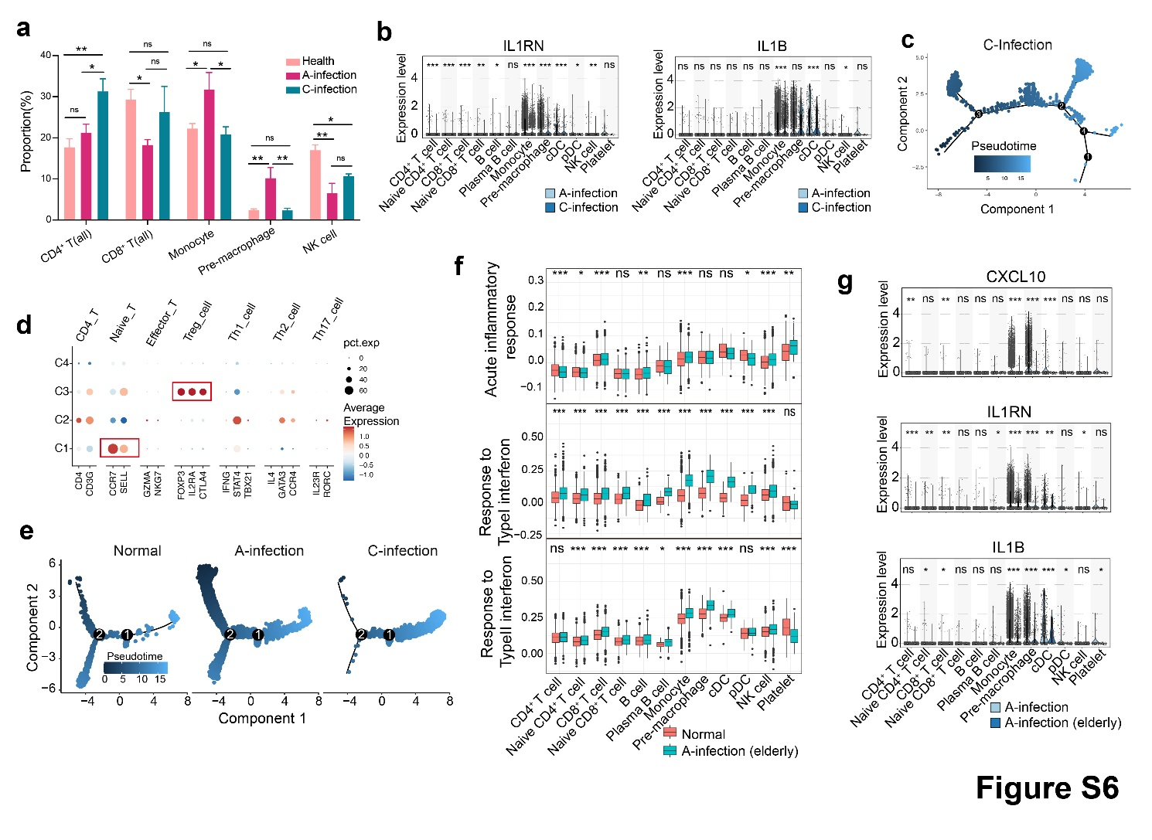
Fig. S6 Immune gene expression and pathway dynamics across CHIKV infection stages. a Bar chart showing the changes in five major immune cell populations across the Normal, A-infection, and C-infection groups. b Violin plot showing IL1RN and IL1B expression levels across distinct immune cell subsets in A-infection and C-infection groups. c The root node selection for CD8⁺ T cells of pseudotime trajectory in the C-infection group. d Dot plot showing the biological annotations of the four CD4⁺ T cell clusters. e Pseudotime trajectory plots illustrating CD4⁺ T cell cellular differentiation dynamics across three groups. f Box plots displaying signaling pathway activity scores (acute inflammatory response, Type I and Type II interferon responses) across immune cell subsets, comparing Normal and A-infection (elderly) groups (ns, not significant; p < 0.05, p < 0.01, *p < 0.001, **p < 0.0001). g Violin plot showing CXCL10, IL1RN and IL1B expression levels across distinct immune cell subsets in A-infection and A-infection (elderly) groups.
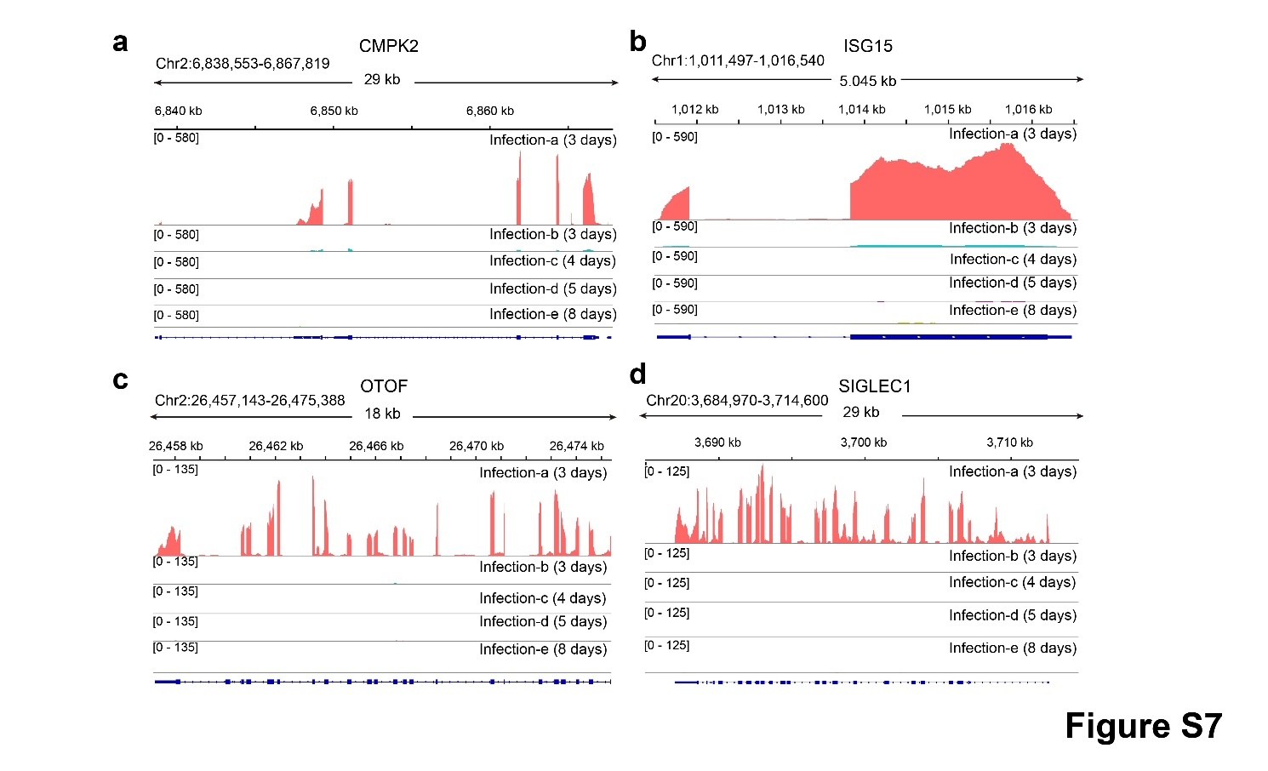
Fig. S7 Integrity analysis of host mRNA in plasma. a-d IGV plot showing normalized read counts of CMPK2, ISG15, OTOF and SIGLEC1 genes in plasma.

