Supporting information for
Metabolic-epigenetic rewiring driven by MCT4-mediated lactate export contributes to resistance to PD-1 blockade in NSCLC

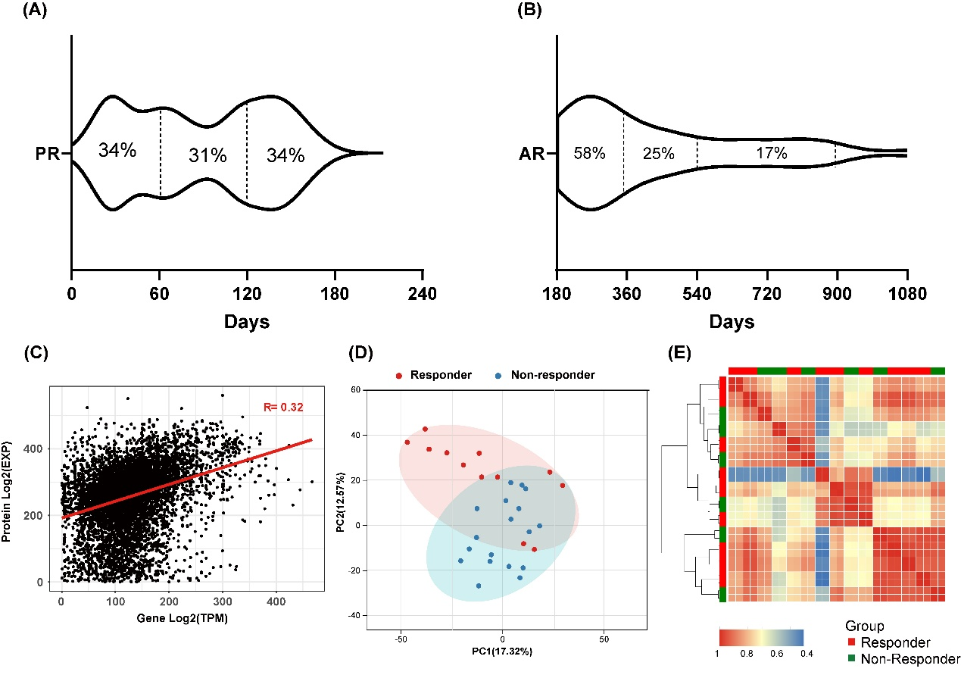
Figure S1. (A) Time to onset of resistance among non-responders (n = 70). (B) Time to onset of resistance among responders (n = 56). (C) Scatterplots comparing the mRNA and proteomics data. (D) Principal components analysis of responder and non-responder sample for mRNA data. (E) Pearson’s correlation of responder and non-responder sample for mRNA data.

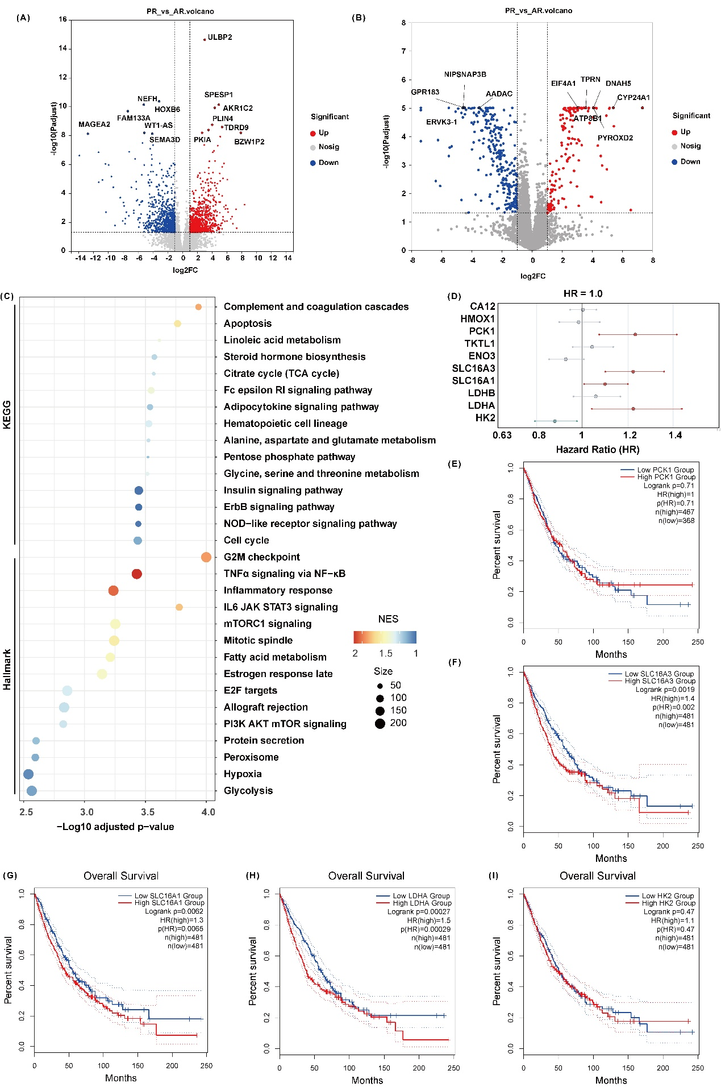
Figure S2. Pathway enrichment and key gene analysis between responder and non-responder groups to PD-1 blockade in NSCLC. Volcano plots showing differentially expressed (A) genes and (B) proteins between responders and non-responders group. (C) Integrated enrichment analysis of hallmark and KEGG pathways based on transcriptomic datasets from responder and non-responder groups. (D) Forest plot showing hazard ratios (HRs) of selected glycolysis signaling-related genes identified from the transcriptomic dataset, evaluated for overall survival in the TCGA NSCLC cohort. (E–I) Kaplan–Meier survival analyses showing the association of PCK1, SLC16A3, LDHA, and HK2 expression levels with overall survival of NSCLC patients. High expression of these genes correlated with poorer prognosis. Statistical significance was determined using the log-rank test; hazard ratios (HR) and p values are indicated.

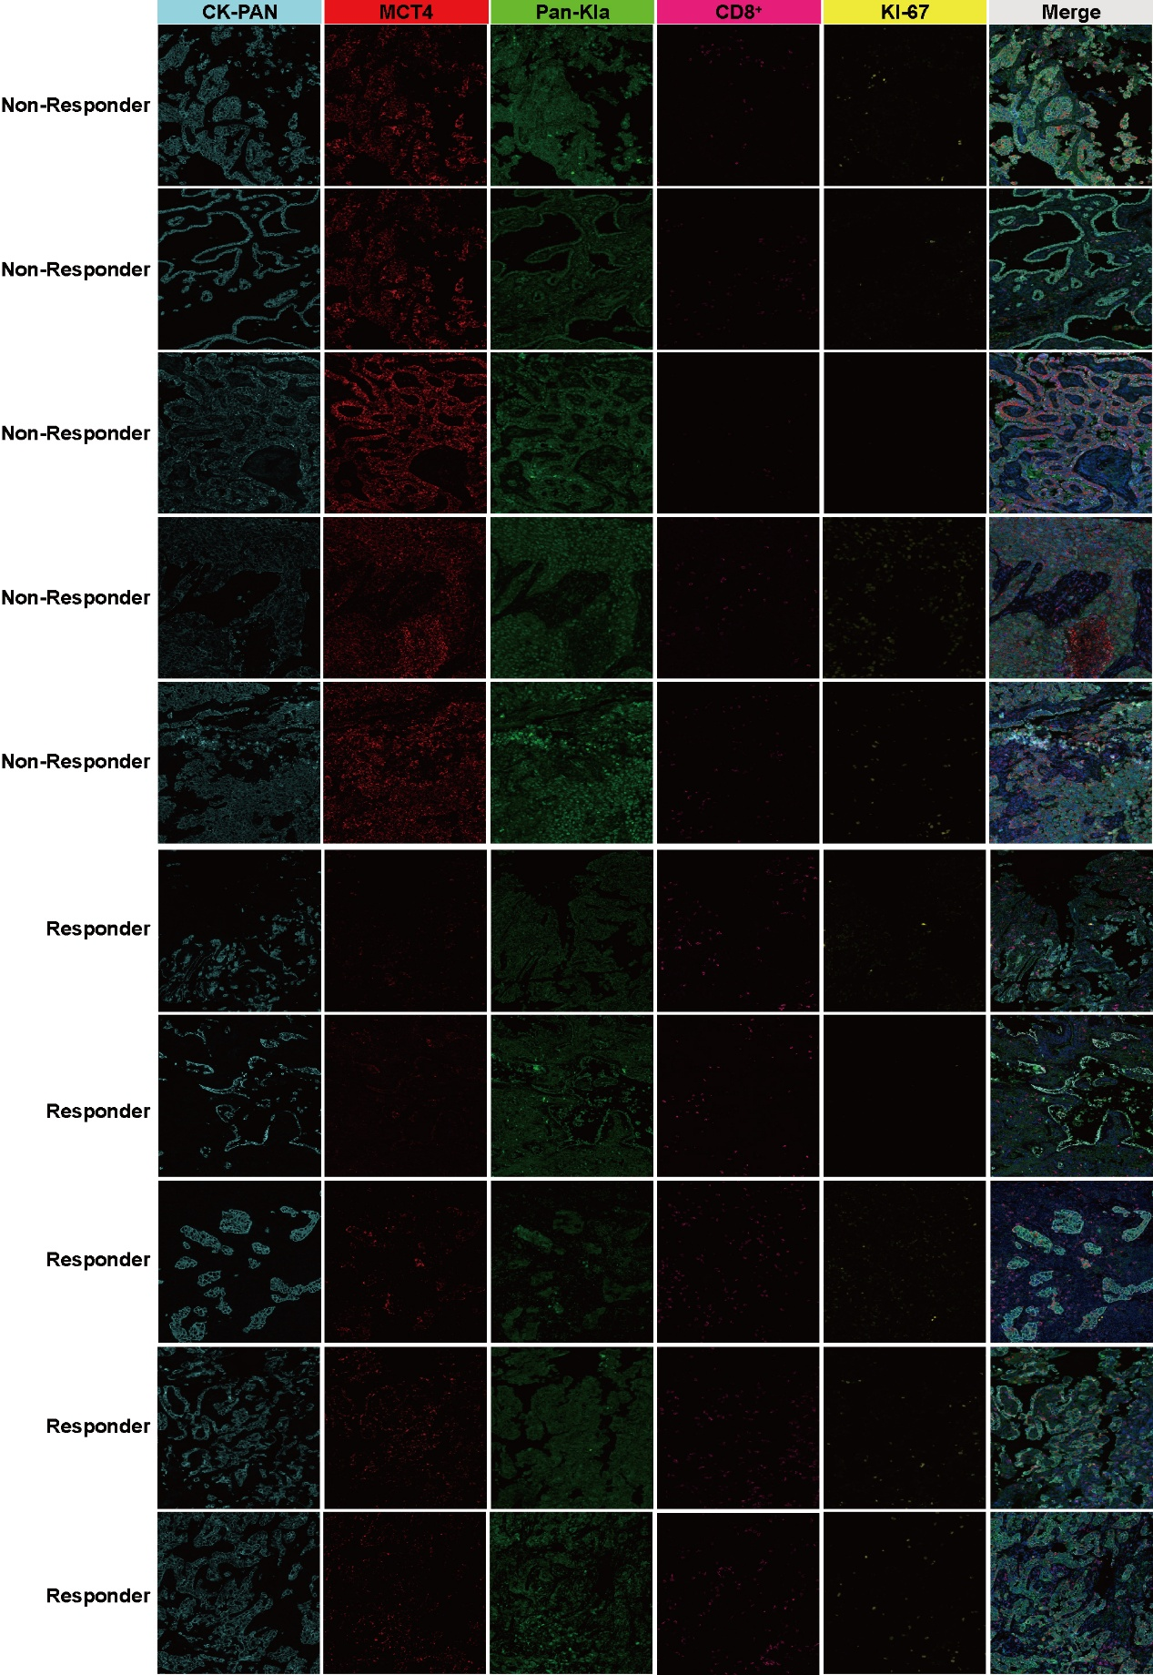
Figure S3. Representative images of the results of immunofluorescence staining of the tumor tissues of immunotherapy induction patients (5 non-responders and 5 responders) for pan-Kla/MCT4/CD8+/KI-67/CK-PAN. Scale bars, 50 μm.

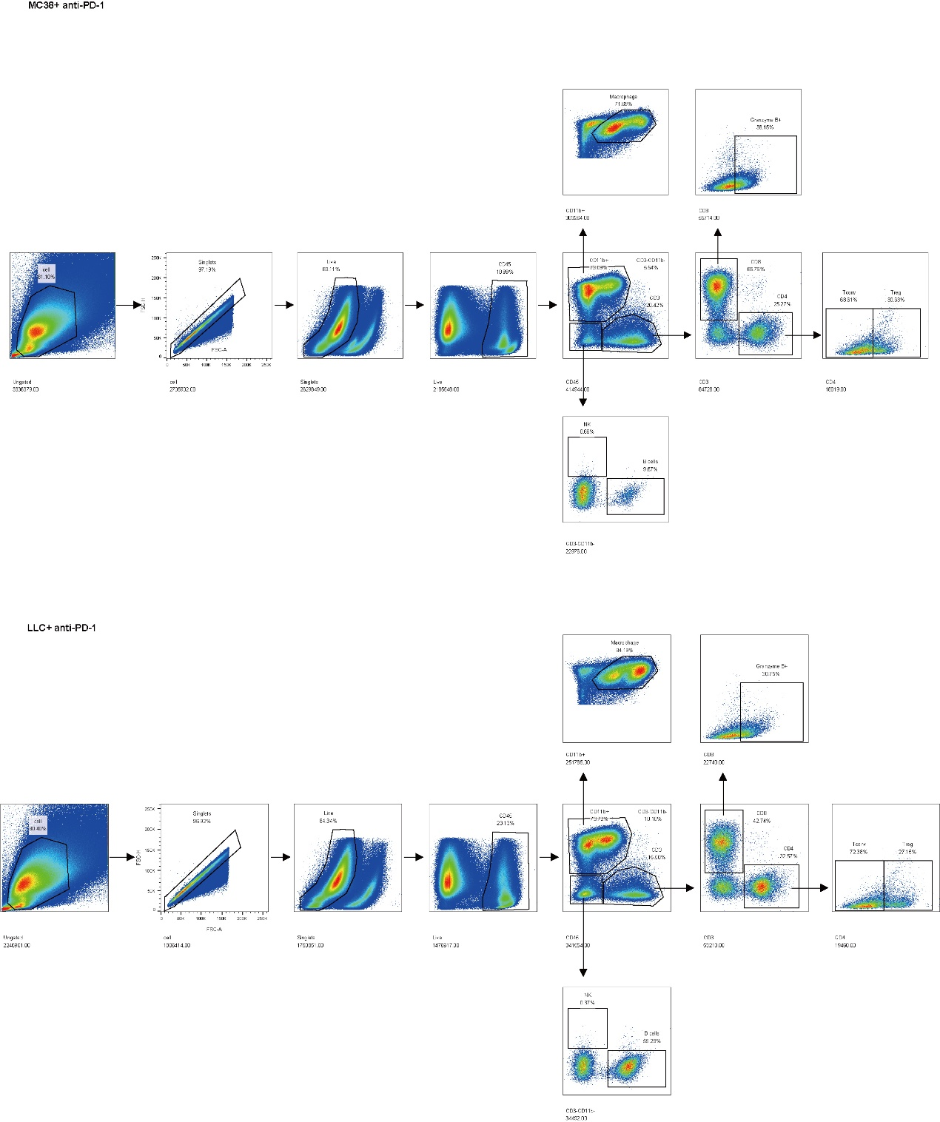
Figure S4 Representative plots showing the gating scheme of M/NK/B/T cells populations in subcutaneous tumors derived from MC38 and LLC cells following anti–PD-1 treatment.
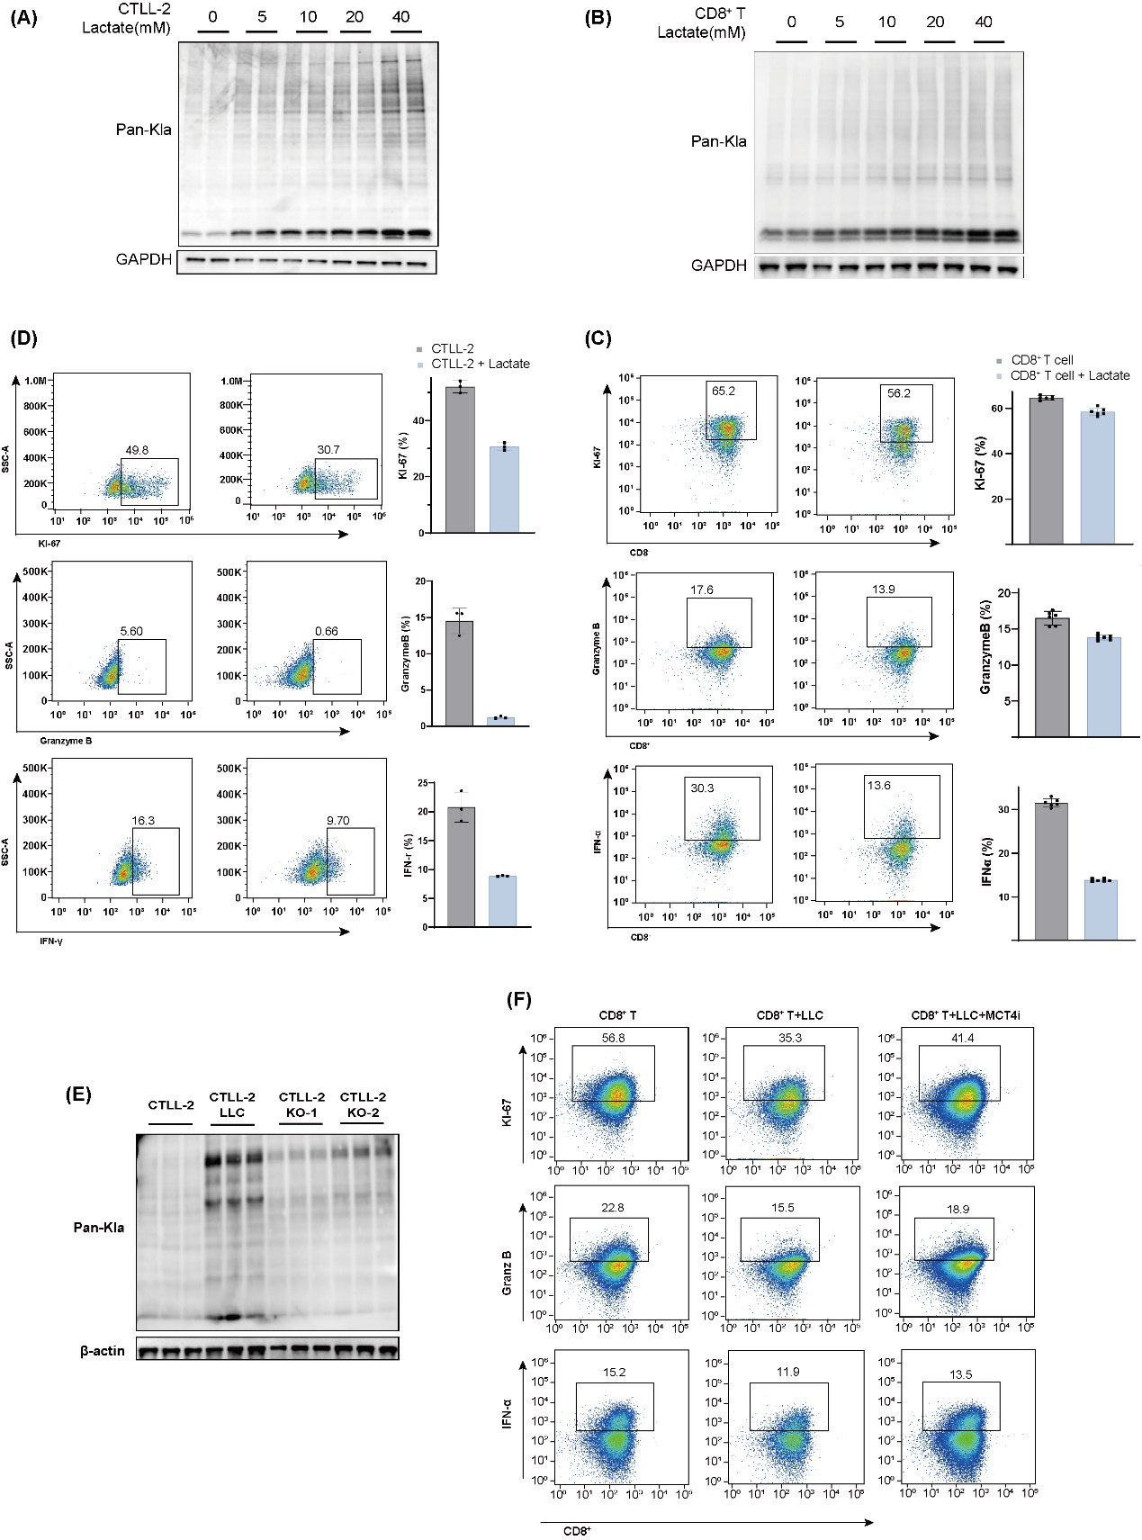
Figure S5. CD8⁺T cell proliferative and effector responses upon lactate stimulation. Western blot analysis of pan-Kla levels in (A) CTLL-2 cells and (B) primary CD8⁺ T cells following 24-hour treatment with different concentrations of lactate. Flow cytometric analysis of Ki-67, IFN-γ, and Granzyme B expression in (C) CTLL-2 cells and (D) primary CD8⁺ T cells after culture with 10mM lactate. (E) Western blot analysis of pan-Kla levels in CTLL-2 cells co-cultured with LLC WT and MCT4 KO cells. (F) Flow cytometric analysis of Ki-67, IFN-γ, and Granzyme B expression in CD8⁺ T cells after co-culture with LLC WT and MCT4 KO cells.
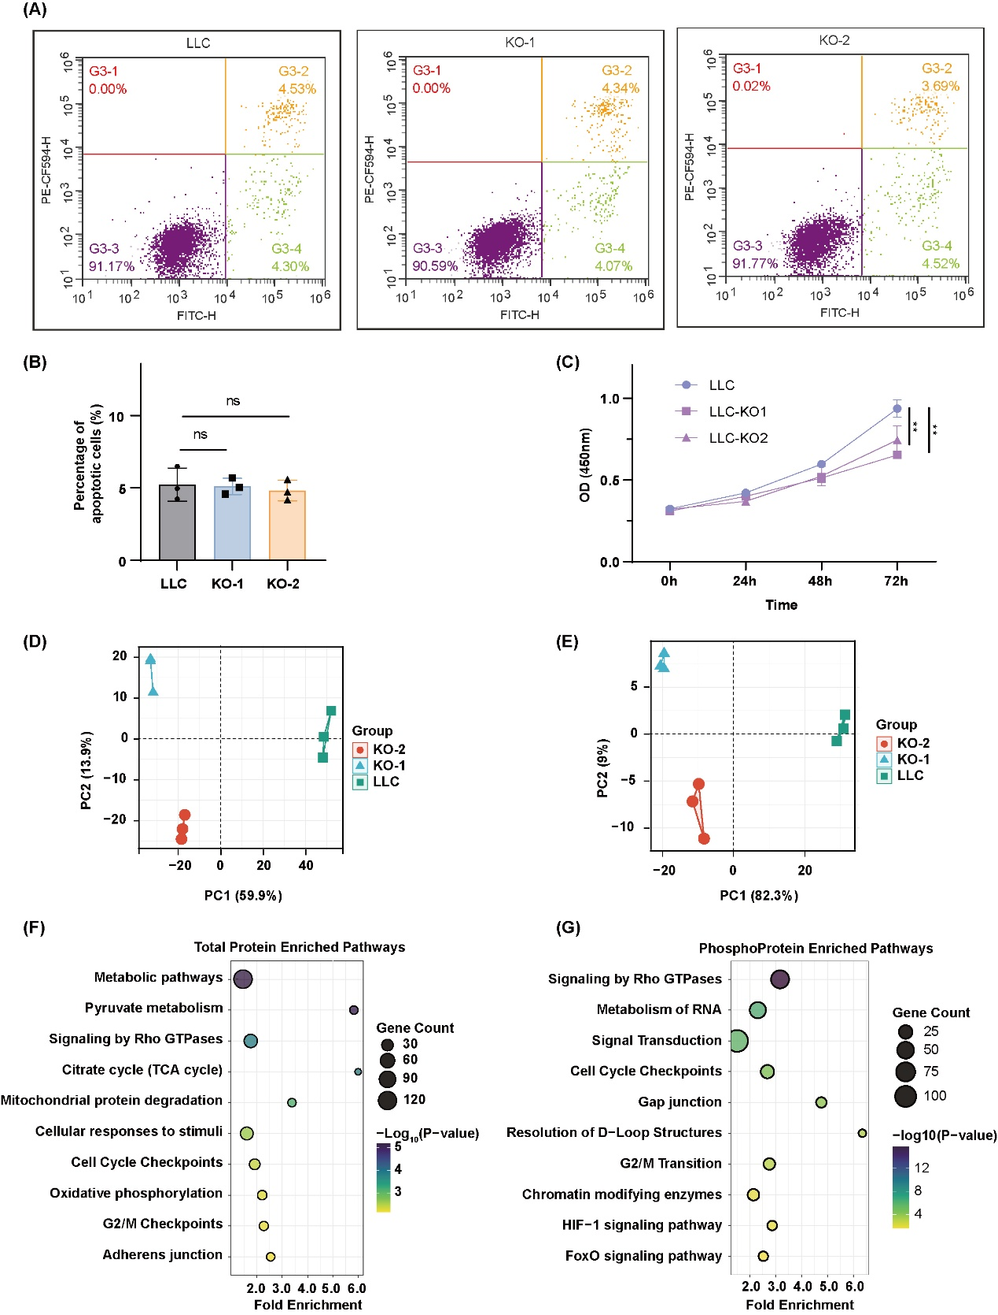
Figure S6. Effects of MCT4 knockout on the cell viability and proteomics analysis. (A) Cell apoptosis of LLC and LLC MCT4-ko cells detection by FACS based on Anexin-V and PI staining. (B) The histogram shows the corresponding quantification data. Each experiment was performed in biological triplicates and results are presented as mean ± S.E.M. (C) CCK-8 assay showing time-dependent proliferation of LLC WT and MCT4-KO cells. Principal component analysis (PCA) of (D) total and (E) phosphoproteomic profiles in LLC WT and MCT4-KO1/2 cells. KEGG pathway enrichment analysis of differentially expressed (F) total and (G) phosphorylated proteins in LLC WT and MCT4-KO cells.
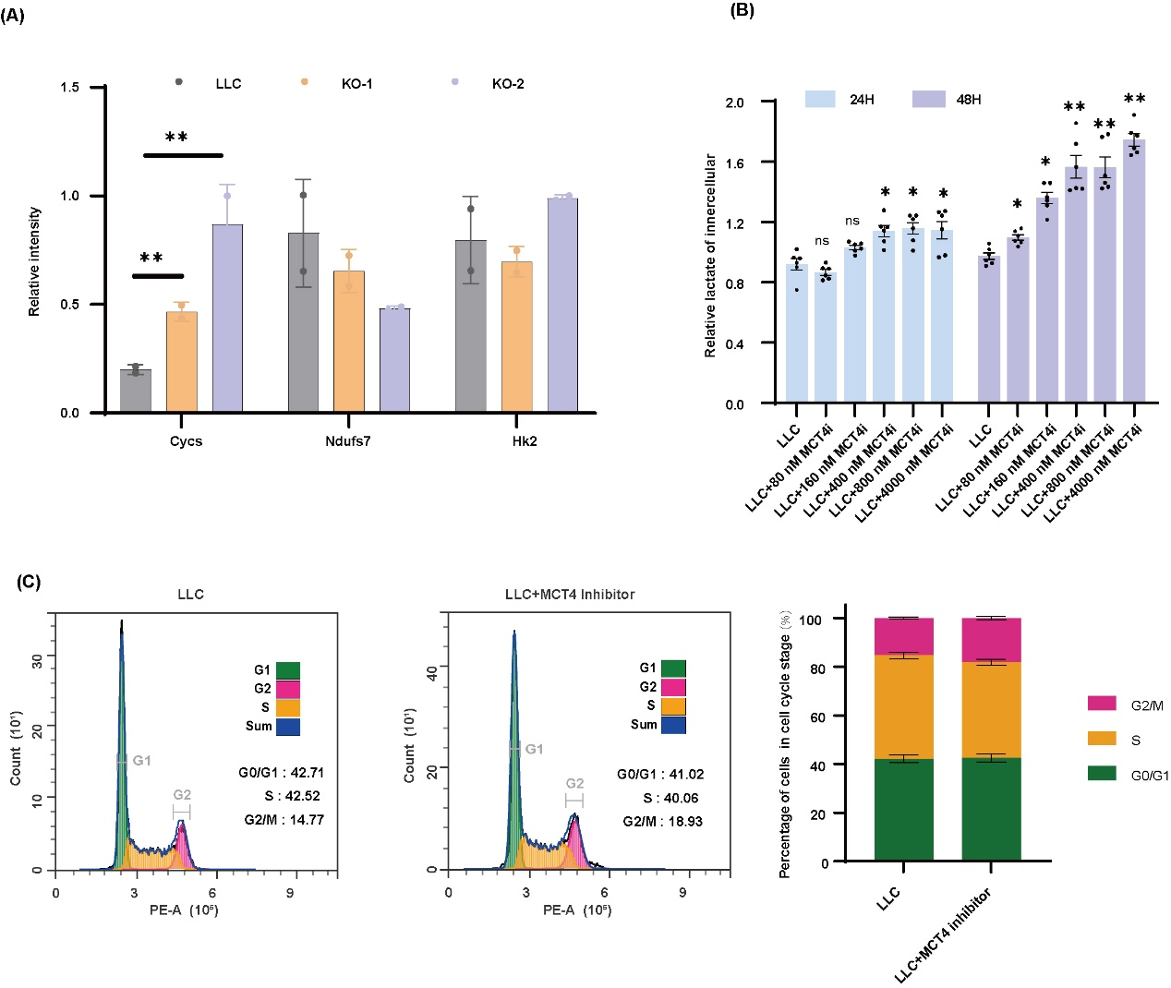
Figure S7. MCT4 perturbs mitochondrial dysfunction and cell cycle regulation. (A) Relative mRNA levels of Cycs, Ndufs, HK2 in different groups determined by RT-qPCR. (B) The innercellular lactate contents of LLC cells after being treated with different concentrations of MCT4 inhibitors for 24 hours and 48 hours. (C) Flow cytometry on cell cycle profiling of the LLC and LLC treated with MCT4 inhibitor, respectively. The percentages of cells in G0/G1, S and G2/M are show by stacked bar plot.
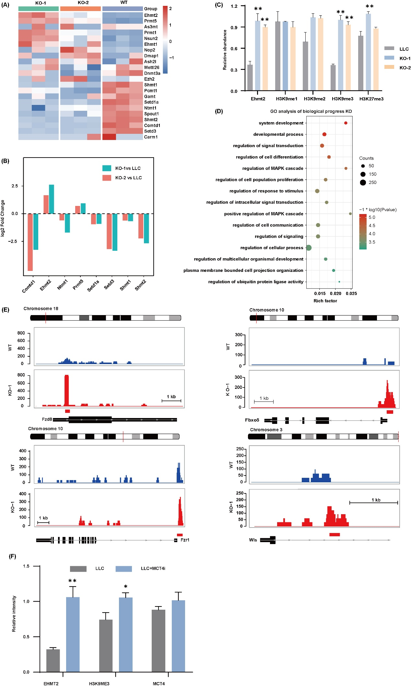
Figure S8. EHMT2/H3K9me3-mediated epigenetic silencing of cell cycle regulatory genes in MCT4-deficient NSCLC cells. (A) Heatmap illustrating expression changes of key proteins involved in the chromatin modifying enzymes. (B) Foldchange of significantly DEP involved in the chromatin modifying pathway. (C) Representative western blots and statistic results of Ehmt2, H3K9me1, H3K9me2, H3K9me3, H3K27me3 in LLC WT and MCT4-KO cells. (D) GO analysis of the upregulated peaks upon the binding of H3K9me3 to the candidate genes. (E) Genome browser track analysis shows the H3K9me3 levels in the Fzd8, Fbxo5, Fzr1, Wls binding region in WT and MCT4-KO cells. (F) Representative western blots and statistic results of Ehmt2, H3K9me3, MCT4 after MCT4 inhibitor treatments.

