Supplement Figure 1：
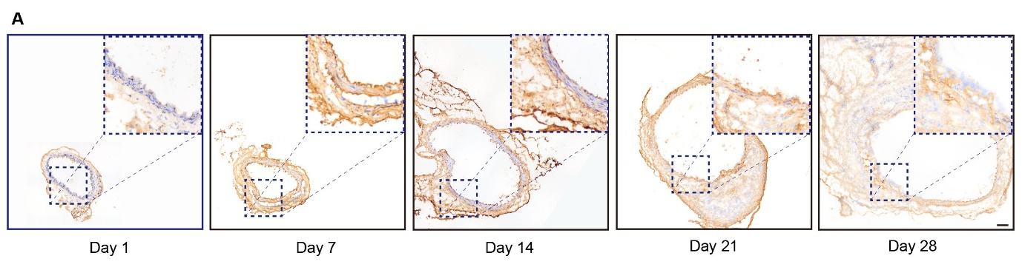
Supplementary Figure 1: Temporal regulation of TSP2 expression in Ang II-induced mouse AAA.
IHC staining of TSP2 in Ang II -induced murine AAA tissue sections at different time points (Day 1, 7, 14, 21, and 28). Scale bar = 100 μm.

Supplement Figure 2：
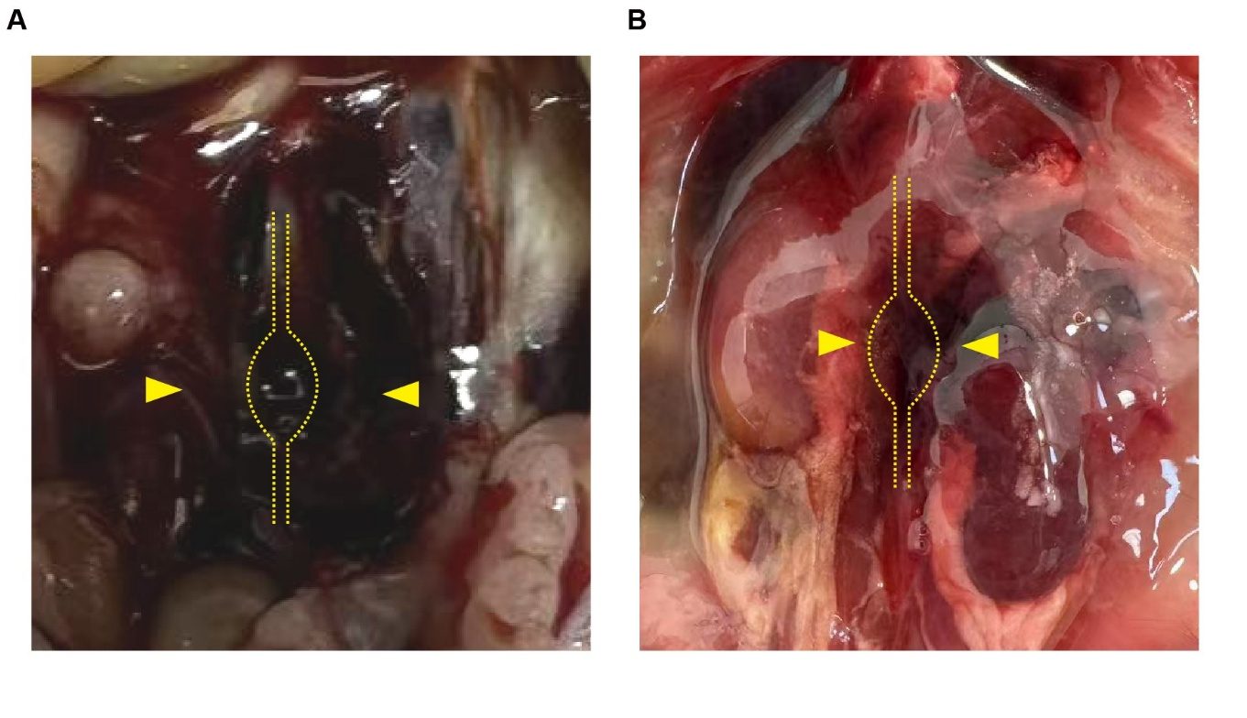
Supplementary Figure 2: Representative image of aneurysm rupture in mouse with elastase-perfusion-induced AAA. The yellow arrow indicates the site of abdominal aortic aneurysm rupture.

Supplement Figure 3：
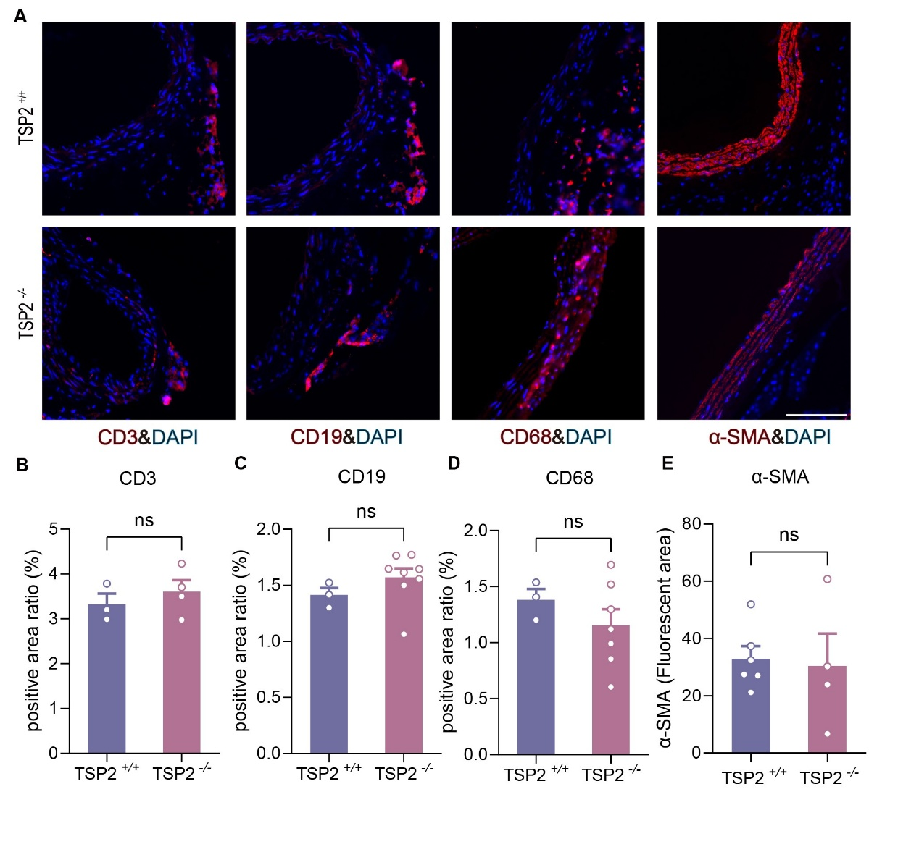
Supplementary Figure 3: Immune cell infiltration and smooth muscle cell content in aortic tissues of TSP2^{+/+} and TSP2^{−/−} mice. (A) IF staining for CD3 (T cell marker), CD19 (B cell marker), CD68 (macrophage marker), and α-SMA (smooth muscle cell marker) in aortic tissue sections from TSP2^{+/+} and TSP2^{-/-} mice. Scale bars = 100 μm. (B–D) Quantification of the percentage of CD3⁺, CD19⁺, and CD68⁺ positive staining areas relative to the total vessel area, respectively. (E) Quantitative analysis of α-SMA positive area.No statistically significant differences were observed in any of the quantified parameters between the groups. Data are presented as mean ± SEM. Statistical significance was determined by unpaired Student's t-test (B, C, D and E). *P < 0.05, **P <0.01, ***P < 0.001, ****p < 0.0001, ns= not significant.

Supplement Figure 4：
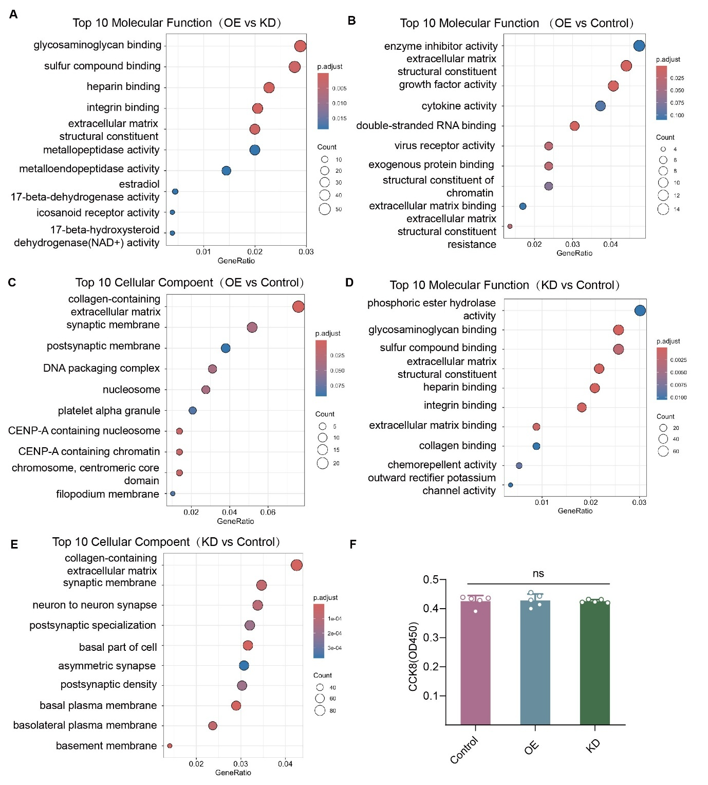
Supplementary Figure 4: Functional Enrichment and Proliferation Analysis of TSP2-Modulated Fibroblasts
(A) GO Molecular Function analysis of DEGs in fibroblasts treated with Ang II, comparing the TSP2 overexpression (OE) and TSP2 knockdown (KD). (B) GO Molecular Function analysis of DEGs between Ang II-treated TSP2 overexpressing (OE) fibroblasts and control group. (C) GO Cellular Component analysis of DEGs between Ang II-treated TSP2 overexpressing (OE) fibroblasts and control group. (D) GO Molecular Function analysis of DEGs between Ang II-treated TSP2 knockdown (KD) fibroblasts and control group. (E) GO Cellular Component analysis of DEGs between Ang II-treated TSP2 knockdown (KD) fibroblasts and control group. (F) CCK-8 cell proliferation assay of fibroblasts treated with Ang II. No significant differences in proliferation were observed between the control, TSP2 overexpression (OE) and TSP2 knockdown (KD) groups (n=5). Data are presented as mean ± SEM. Statistical significance was determined by ordinary one-way analysis of variance (ANOVA) with Tukey's multiple comparisons correction (F). *P < 0.05, **P <0.01, ***P < 0.001, ****p < 0.0001, ns= not significant.

Table S1. Baseline Demographic and Clinical Characteristics of AAA Patients and Healthy Controls

 | Gender | Age (years) | Ethnic | AAA diameter (mm) | Aorta thickness (mm) | TSP2 concentration (pg/ml) | Smoke | Hypertension | Hyperlipidemia | Diabetes | Nephropathy
AAA patient 1 | M | 79 | Asian | 5.268 | 1.49425 | 439.453867 | N | N | Y | N | Y
AAA patient 2 | M | 61 | Asian | 6.853 | 1.9745 | 464.074133 | N | Y | Y | N | N
AAA patient 3 | M | 80 | Asian | 4.834 | 2.36125 | 468.8584 | Y | Y | Y | N | Y
AAA patient 4 | M | 76 | Asian | 7.132 | 2.607 | 542.841467 | N | Y | Y | Y | Y
AAA patient 5 | F | 82 | Asian | 4.082 | 2.4965 | 556.292933 | Y | Y | Y | N | Y
AAA patient 6 | M | 83 | Asian | 6.377 | 2.265625 | 563.018667 | U | U | U | U | U
AAA patient 7 | M | 73 | Asian | 5.914 | 2.590125 | 581.514433 | Y | Y | Y | N | Y
AAA patient 8 | M | 74 | Asian | 4.938 | 2.202125 | 596.647333 | Y | Y | Y | N | Y
AAA patient 9 | M | 68 | Asian | 5.258 | 2.94075 | 613.3345 | Y | Y | Y | Y | Y
AAA patient 10 | M | 59 | Asian | 3.742 | 2.024125 | 616.412033 | Y | Y | Y | N | Y
AAA patient 11 | M | 75 | Asian | 4.183 | 2.8415 | 626.913133 | Y | Y | Y | N | Y
AAA patient 12 | M | 65 | Asian | 4.742 | 2.281625 | 628.594567 | N | Y | Y | N | Y
AAA patient 13 | M | 80 | Asian | 3.623 | 2.732625 | 673.3464 | Y | Y | Y | N | Y
AAA patient 14 | M | 83 | Asian | 4.308 | 2.3845 | 673.3464 | N | Y | Y | Y | Y
AAA patient 15 | M | 79 | Asian | 7.328 | 2.980125 | 692.489033 | Y | N | N | N | Y
AAA patient 16 | M | 75 | Asian | 3.389 | 2.784375 | 699.505433 | Y | Y | Y | Y | Y
AAA patient 17 | M | 73 | Asian | 3.854 | 2.8795 | 722.586933 | N | Y | Y | N | Y
AAA patient 18 | F | 82 | Asian | 4.581 | 3.161 | 724.1257 | N | Y | Y | Y | Y
AAA patient 19 | M | 71 | Asian | 3.061 | 3.212 | 741.052133 | U | U | U | U | U
AAA patient 20 | M | 59 | Asian | 5.343 | 2.84275 | 894.261033 | Y | N | Y | Y | Y
AAA patient 21 | M | 50 | Asian | 4.967 | 3.202625 | 937.9783 | Y | Y | Y | N | Y

 | Gender | Age (years) | Ethnic | AAA diameter (mm) |  | TSP2 concentration (pg/ml) | Smoke
Healthy control 1 | F | 65 | Asian | 2.4 |  | 62.728 | N
Healthy control 2 | M | 79 | Asian | 2.15 |  | 71.9606 | N
Healthy control 3 | M | 67 | Asian | 2.1 |  | 607.4514 | Y
Healthy control 4 | M | 78 | Asian | 2 |  | 0 | N
Healthy control 5 | M | 67 | Asian | 1.9 |  | 335.0897 | N
Healthy control 6 | M | 60 | Asian | 1.85 |  | 159.6703 | N
Healthy control 7 | M | 78 | Asian | 2 |  | 0 | N
Healthy control 8 | M | 78 | Asian | 1.9 |  | 501.2765 | N
Healthy control 9 | M | 83 | Asian | 2.15 |  | 7.3324 | N
Healthy control 10 | M | 55 | Asian | 2.25 |  | 178.1355 | N
Healthy control 11 | M | 66 | Asian | 2.2 |  | 0 | N
Healthy control 12 | M | 74 | Asian | 1.9 |  | 418.1831 | U
Healthy control 13 | M | 80 | Asian | 2 |  | 21.1813 | U
Note : M =Male, F=Female, Y = presence of disease, N = absence of disease, U = unknown

Table S2. Antibodies used for immunofluorescence, immunohistochemistry， immunocytochemistry, Chip-qPCR and western blot.

Primary Antibodies | Source | Company | Catalog No. | Dilution
Anti-Thrombospondin 2 | Rabbit pAb | Abcam | ab84469 | 1µg/ml WB
 |  |  |  | 10µg/ml ICC/IF/IHC-P
 |  | ABclonal | A8561 | 1:500 WB
 |  | santa | sc-136238 | 1:500 WB  1:50 IF
Anti- COL1A1 | Rabbit mAb | CST | 72026 | 1:1000 WB
 |  |  |  | 1:200 IF
Anti-Collagen III | Rabbit mAb | Abcam | 184993 | 1:1000 WB
 |  |  |  | 1:100 IF
Anti-Fibronectin | Rabbit mAb | Abcam | 45688 | 1:1000 WB
 |  |  |  | 1:500 IF
Anti-ER-TR7 | Rat mAb | Invirtrogen | MA1-40076 | 1:50 IF
Anti-p-Stat3 | Rabbit mAb | CST | 9145 | 1:2000 WB
 |  |  |  | 1:100 ChIP
Anti-Stat3 | Rabbit mAb | CST | 4904 | 1:2000 WB
 |  |  |  | 1:100 ICC
 |  |  |  | 1:50 ChIP
Anti -DYKDDDDK Tag | Rabbit mAb | CST | 14793 | 1:1000 WB
Anti-PRELP | Rabbit pAb | Proteintech | 23783 | 1:1000 WB
 |  |  |  | 1:250 IF
Anti-TGM2 | Rabbit mAb | CST | 3557 | 1:1000 WB
 |  |  |  | 1:100 IF
Anti-CD3 | Rabbit mAb | CST | 78588 | 1:400 IF
Anti-CD19 | Rabbit mAb | CST | 90176 | 1:3200 IF
Anti-CD68 | Rabbit mAb | CST | 97778 | 1:200 IF
Anti-α-SMA | Rabbit mAb | CST | 19245 | 1:400 IF
Anti-β-Actin | Rabbit mAb | CST | 4970 | 1:1000 WB
Anti-α-Actin | Mouse mAb | Abcam | ab7817 | 1 µg/ml ICC
Anti-α-Tubulin | Rabbit mAb | CST | 2125 | 1:1000 WB
Anti-GAPDH | Rabbit mAb | CST | 2118 | 1:1000 WB
Secondary Antibodies | Source | Company | Catalog No. | Dilution
Goat Anti-Rabbit IgG-HRP | Goat pAb | CST | 7074 | 1:2000
Goat Anti-Mouse IgG-HRP | Goat pAb | CST | 91196 | 1:2000
Goat anti-Rabbit IgG (H&L) (Alexa Fluor® 555) | Goat pAb | CST | 4413 | 1:1000 IF/ICC
Goat anti-Rat IgG  (H&L) (Alexa Fluor® 647) | Goat pAb | CST | 4418 | 1:1000 IF/ICC
Goat anti-mouse IgG (H&L) (Alexa Fluor® 488) | Goat pAb | CST | 4408 | 1:1000 IF/ICC
Abbreviations: WB (Western blot), IF (Immunofluorescence), IHC-P (Immunohistochemistry- Paraffin), ICC(immunocytochemistry), CST (Cell Signaling Technology).

Table S3. Primers used for genotyping, transfection, RT- qPCR and ChIP-qPCR.
genotyping
Mouse
Thbs2: | forward | 5’-CTTCCTCACAGCCCAACTGAAG-3’
 | reverse | 5’-GCTGATTGCCTTCTACCCAGTAG-3’
ChIP-qPCR
Mouse
Positive-STAT3: | forward | 5’-TGGTTAAGAACAGGAAGCCCG-3’
 | reverse | 5’-TGGTGTCTGCAAGGTAAAGGTGA-3’
STAT3: | forward | 5’-CCTGAGAAAAATGCACCGAGTTTA-3’
 | reverse | 5’-AGACTCTGGAAAGGCTTCTTTGT-3’
RT- qPCR
Mouse
Thbs2: | forward | CTGGGCATAGGGCCAAGAG
 | reverse | GCTTGACAATCCTGTTGAGATCA
β-actin: | forward | 5’-GGCTGTATTCCCCTCCATCG-3’
 | reverse | 5’-CCAGTTGGTAACAATGCCATGT-3’
transfection
Human
si-Thbs2: | sense | 5’-CGUCAGAUGUGCAACAAGA(dT)(dT) -3’
 | antisense | 5’-UCUUGUUGCACAUCUGACG(dT)(dT) -3’

