Materials and Methods
Cells
SH-SY5Y, HEK293, MCF-10A, MCF-7, BT474, SKBR3, MDA-MB-231, HCC1937 and HCC1143 cells were obtained from the ATCC (Manassas, USA). SH-SY5Y cells were maintained in DMEM/F12-1:1 (HyClone, USA), HEK293, MCF-10A and MCF-7 cells were cultured in Dulbecco's Modified Eagle Medium (DMEM) (HyClone, USA), BT474, HCC1937 and HCC1143 was cultured in RPMI 1640 medium (Gibco/BRL, NY), SKBR3 was cultured in McCoy’s 5a medium (Gibco/BRL, NY), MDA-MB-231 was cultured in L-15 medium (Gibco/BRL, NY), supplemented with 10% Fetal Bovine Serum (LONSERA, China). We tested and confirmed all used cell lines were mycoplasma negative.
Reagents
Cyclic and linear β-hairpin peptides were synthesized by QYAOBIO (ChinaPeptides Co., Ltd., Shanghai, China). The compounds MG132, CCCP, MPP⁺, HCQ, VER-155008 and MKT-077 were obtained from Selleck Chemicals (Houston, TX, USA). Oligomycin, Antimycin A and Rotenone were obtained from Sigma. Compound S1g-10 was synthesized by our group (Dalian, China) as previously reported method. All the chemicals were dissolved in dimethylsulfoxide (DMSO) to a concentration of 10 mM. To obtain the final concentration, stock solutions were diluted in a culture medium. The following primary antibody were used: anti-HA (Proteintech, 51064-2-AP), anti-FLAG (Protein-tech, 66008-4-Ig), anti-Myc (CST, #9402), anti-Ub (Proteintech, 10201-2-AP), anti-GFP (Protein-tech, 50430-2-AP), anti-PGK (abcam, 113687), anti-POR1 (abcam, 110326), anti-UBR1 (Santa, sc-515753), anti-UBR2 (abcam, 217069), anti-p62(CST, #88588), anti-PDH, anti-COX IV(Abclonal, A28231), anti-TOM20 (Abclonal, A19403), anti-Actin (Proteintech, 66009-1-Ig), anti-GAPDH (Protein-tech, 60004-1-Ig), anti-Parkin (CST, #2132), anti-Hsp70 (Sigma, SAB4200714), anti-VDAC1 (Abclonal, A19707). We also used the following secondary antibodies: anti mouse-IgG (CST, #68860) or anti-rabbit-IgG (CST, #2729) antibody conjugated to horseradish peroxidase for immunoblotting.
Immunostaining of cells
For colocalization of p62, PDH and Ub, cells were plated onto the cover slip. Slides were fixed in 3.7% formaldehyde; permeabilized with 0.05% Triton X-100; stained with rabbit anti-p62 (Abclonal, A7758), mouse anti-PDH (Sigma, ABS2082), and goat anti-Ub (Gentaur, AB0144), secondary Fluor 488 goat anti-rabbit (CST, #4412), Fluor 647 goat anti-mouse (CST, #4410), and Fluor 594 donkey anti-goat (Invitrogen, 10590523). For colocalization of Hsp70 and UBR1, rabbit anti-Hsp70 (Abclonal, A23457) and mouse anti-UBR1 (Santa, sc-515753) primary antibody was used. Images were captured using a Nikon A1 Confocal Laser Microscope System (100x oil immersion objective). Colocalization percentage was determined in a blinded manner using ImageJ software.
In vivo xenograft tumor model
A total of 5 × 10⁶ MDA-MB-231 cells were subcutaneously inoculated into the right flank of nude mice (male, 6-week-old) (Liaoning Changsheng Biotechnology Co. LTD, LiaoNing, China). Following tumor establishment (tumor volumes ∼100 mm³), mice were randomly assigned to one of three groups (n = 7 per group): (a) control group (vehicle), (b) doxorubicin (5 mg/kg body weight every 4 days, i.v.), or (c) doxorubicin + Clozapine (10mg/kg body weight every day, i.p.). Neither exclusion criteria nor randomization was performed. The investigator was blinded to the group allocation. Tumor volume and body weight of mice were measured every 3 days. Tumor volume was determined by using calipers for measurement of the longest (Length) and shortest (Width) dimensions and calculated as (Length × Width²)/2. Mice were sacriﬁced on day 21 and the excised tumors were frozen in liquid nitrogen. All experiments were conducted in accordance with the Ethical Principles and Guidelines for the Use of Animals for the care and use of animals for scientiﬁc purposes.
Immunofluorescence
Cells were fixed with 4% paraformaldehyde for 20 min at RT, washed with PBS and permeabilized for 20 min in PBS containing 0.5% Triton X-100. The cells were then blocked with FBS for 30 min followed by staining with the indicated primary and secondary antibodies at RT for 1 h. Fluorescence images were taken on the Nikon A1 Confocal Laser Microscope System.
CRISPR/Cas9-mediated generation of UBR1 and Parkin knockout cell
UBR1 or Parkin knockout SH-SY5Y cells were generated using an RNA-guided CRISPR/Cas9 endonuclease. For this, SH-SY5Y cells were transfected with episomal vectors expressing both a human codon-optimized Cas9 and a guide RNA (gRNA): ATGCCAGACGCTGAGGGGTC for UBR1. To knockout Parkin, gRNA: CGACGACCCCAGAAA CGCGG was used. SH-SY5Y cells were transfected with lipofectamine transfection reagent (Invitrogen, Carlsbad, CA, USA). Two days after transfection, cells were treated with 1 μg/ml of puromycin (Sigma) for three days. After two weeks, single colonies were isolated. The resulting cell clones were expanded and assayed for mutations in both alleles by western blotting and by PCR and DNA sequencing.
Construction of fusion proteins of β-hairpin with TOM20
The β-hairpin segments of VDAC1 were generated by PCR using the plasmid pGEM4-VDAC1 as template. The N-terminal peptide was generated by PCR as a control peptide (Ctrl peptide). The PCR product was then cloned into the previously generated pGEM4-TOM20 expressing vector using KpnI and EcoRI as restriction sites.
Lentiviral particles expressing UBR1, Parkin, PINK1, or small hairpin RNA against UBR1, UBR2, ATG12, Parkin, and transfection
Lentiviral plasmids expressing GFP-UBR1, HA-UBR1, GFP-Parkin, HA-Parkin, HA-PINK1 or mCherry-TOM20 were generated by Genechem company (Shanghai, China). Lentivirus-shRNA plasmids were constructed based on vector LV10N or LV3 containing a short RNA sequence targeting the objective gene. The sequences are shUBR1_1: GGGAAGAGTATATGCAGTAAT; shUBR1_2: GCCTCCTGAACTCC AGATAAG; shUBR2_1: CCAGCATTTAGCCCACTATGT; shUBR2_2: GCCCA GGGCAGATTTCAGTTT; shParkin: GGTCAAGAAATGAATGCAACT; shATG12: TGTTGCAGCTTCCTACTTCAA.
For transfection, lentiviruses were packaged in HEK293 cells. Specifically, HEK293 cells cultured in 10 cm dishes were transfected with a mixture containing shRNA plasmid, pSPAX2, and PMD2.G in medium without antibiotic and sera. When two plasmids were co-transfected, the required mass of each plasmid was halved. Lentivirus-containing supernatant was collected at 48 h post-transfection, and used to infect objective cells for another 48 h in the presence of polybrene or hygromycin. Cells were selected by puromycin (2 μg mL⁻¹) or hygromycin (500 μg mL⁻¹).
Yeast strains and constructs
The experiments were conducted in Saccharomyces cerevisiae strain BY4742 (MATα his3Δ1 leu2Δ0 lys2Δ0 ura3Δ0). The BY4742-Om45-GFP strain were constructed as our previously described^{37, 38} and confirmed through western blot analysis and polymerase chain reaction (PCR). The BY4742-ΔAtg8 strain was generously provided by Guangdong Medical University. Deletion of Ubr1 in BY4742 was constructed by using the CRISPR-Cas9 system described previously³⁹. The expressing plasmids for Ubr1 or Ubr1 mutant C122S were cloned into the pRS423-HA vector. The expressing plasmids for POR1 or SAM50 were cloned into the pRS425-3×FLAG vector. The plasmids for Atg8 were cloned into the pRS426-Myc vector. Transformations were performed using the PEG-lithium acetate method.
Yeast starvation, GFP cleavage, fluorescent imaging and isolation of yeast mitochondria
Yeast cells were first cultured in lactate medium (YPL; 1% yeast extract, 2% peptone, 2% lactate, pH 5.5) and were then switched to synthetic minimal medium lacking nitrogen (SD-N) for indicated times. For GFP-cleavage assays, mitophagy substrate are GFP tagged (OM45-GFP), and their vacuolar degradation upon starvation is monitored by the accumulation of the released GFP moiety. For fluorescent imaging, BY4742-Om45-GFP strain was transfected with vph1-mCherry, which is used to label the yeast vacuolar membrane. Cells were cultured in YPL followed by 6 h SD-N treatment. Cells were then observed using Nikon A1 Confocal Laser Microscope System. Yeast mitochondria from WT and ΔAtg8 strains were isolated as previously described⁴⁰. Briefly, the harvested cells were digested by incubating the cells with zymolase-20T (MP Biomedicals, # 320921). The resulting spheroplasts were disrupted with a Dounce homogenizer. The lysed cell ere centrifuged at 1700 x g at 4 °C for 5 min, and the supernatant was centrifuged at 8500 x g at 4 °C for 20 min. The pellet was loaded onto a 15-60% sucrose gradient and centrifuged at 111,000 x g at 4 °C for 90 min. The mitochondrial layer was aspirated, flash frozen with liquid nitrogen and stored at -80 °C.
Isolation of mitochondria in HEK293 cells
Mitochondria were obtained using a mitochondria extraction kit for use with animal tissue according to the manufacturer’s instructions (Genmed Scientifcs Inc., Shanghai, China). The protein concentration was measured using a BCA kit (Pierce, Rock-ford,IL). The isolated organelle fraction was collected for Western blot assay.
Transmission electron microscopy (TEM)
Yeast cells were collected after 0 or 6 h of SD-N treatment, washed with ice-cold phosphate-buffered saline (PBS) and fixed in 2.5% glutaraldehyde overnight at 4 °C. After centrifugation, the pellet was cut into 1 mm³ blocks under fixative and kept in fresh fixative overnight at 4 °C. The following day, samples were rinsed with cold 0.1 M phosphate buffer (3 × 10 min) and dehydrated in an ethanol series. Subsequent infiltration with HM-20 resin was performed at 4 °C: 2:1 ethanol/resin 1 h, 1:1 3 h, 1:2 17-20 h, followed by two changes of pure resin (17-20 h and 1 h each). Specimens were placed in BEEM capsules, evacuated for 30-60 min, and polymerised under UV light at -20°C for 48 h, then gradually warmed to room temperature. Ultrathin sections (70-80 nm) were cut and mounted on Formvar-coated nickel grids.
For immunogold labeling, grids were re-hydrated with ultrapure water (5 min), blocked with 1% BSA in TBS (30 min, RT), and incubated with anti-ubiquitin antibody overnight at 4 °C. After washing in TBS (3 × 5 min), grids were treated with 10 nm gold-conjugated secondary antibody (1:25; 20 min RT, 1 h 37°C, 30 min RT), followed by extensive washes (TBS 5 × 5 min, water 5 × 5 min). Sections were contrast-stained with 2% uranyl acetate in 70% ethanol (15 min, dark), rinsed in 70% ethanol and water (3 × each), blotted, and dried at 37 °C for 10 min. Imaging was performed with a 120 kV transmission electron microscope.
For TEM of mammalian cells, Control shRNA or shUBR1&UBR2-transfected HEK293 cells were treated with 20 μM CCCP while simultaneously adding 200 nM BafA1 for 6 h. Control shRNA or shUBR2-transfected DOX-resistant MDA-MB-231 cells were used. Cells were washed with PBS and fixed in 2.5% glutaraldehyde overnight at 4 °C. The subsequent experimental procedure was as described above. Imaging was performed with a 120 kV transmission electron microscope.
mKeima mitophagy analysis
HEK293 cells and SH-SY5Y cells were stably transfected with mKeima (pHAGE-CMV-mt-mKeima-EF1a-Puro) (Miaolingbio, Hubei, China) and then analyzed by flow cytometry as previously reported⁴¹. Measurements of lysosomal mKeima were made using dual-excitation ratiometric pH measurements at 488 nm (pH 7) and 532 nm (pH 4) lasers with 670/30 nm and 583/40 nm emission filters, respectively.
mtDNA abundance
Cells were incubated overnight in 360 µl of buffer ATL and 40 μL proteinase (Qiagen) at 55 °C in a thermomixer set at 300 r.p.m. Cell debris was removed by centrifugation. DNA was extracted with the QIAsymphony DNA Mini kit (Qiagen, catalogue no. 937236) following the manufacturer’s procedures. The real-time PCR data were analyzed using the Linear Derivative baseline correction and User (detector) Ct threshold method on the Fluidigm Biomark software (v.4.1.3). Quantification of mtDNA was performed using two customized Taqman assays targeted against a nuDNA sequence (18S) and a conserved region of mtDNA (MTND1). Relative mtDNA copy number was determined comparing MTND1 to 18S signal. All quantifications were determined using the 2^{-∆∆Ct} method and the mean Ct of the technical triplicates.
Sample preparation for ubiquitinome of starved yeast lysates, LC-MS analysis and MS data processing
Yeast cells were cultured in YPL followed by 3 h SD-N treatment. Collected cells was first grinded with liquid nitrogen, then the powder was transferred to a 5-mL centrifuge tube and sonicated three minutes on ice using a high intensity ultrasonic processor (Scientz) in lysis buffer (including 1% TritonX-100, 10 mM dithiothreitol, and 1% protease inhibitor cocktail, 50 μM PR-619, 3 μM TSA, 50 mM NAM, 2 mM EDTA, and 1% phosphatase inhibitor for phosphorylation.). An equal volume of Tris-saturated phenol (pH 8.0) was added. Then, the mixture was further vortexed for 5 min. After centrifugation (4 °C, 10 min, 5500g), the upper phenol phase was transferred to a new centrifuge tube. Proteins were precipitated by adding at least four volumes of ammonium sulfate-saturated methanol and incubated at -20 °C for at least 6 h. After centrifugation at 4 °C for 10 min, the supernatant was discarded. The remaining precipitate was washed with ice-cold methanol, followed by ice-cold acetone for three times. The protein was redissolved in 8 M urea and the protein concentration was determined with BCA kit according to the manufacturer’s instructions. Then, the sample was slowly added to the final concentration of 20% (m/v) TCA to precipitate protein, then vortexed to mix and incubated for 2 h at 4 °C. The precipitate was collected by centrifugation at 4500 g for 5 min at 4 °C. The precipitated protein was washed with pre-cooled acetone for 3 times and dried for 1 min. The protein sample was then redissolved in 200 mM TEAB and ultrasonically dispersed. Trypsin was added at 1:50 trypsin-to-protein mass ratio for the first digestion overnight. The sample was reduced with 5 mM dithiothreitol for 30 min at 56 °C and alkylated with 11 mM iodoacetamide for 15 min at room temperature in darkness. Finally, the peptides were desalted by Strata X SPE column. To enrich modified peptides, tryptic peptides dissolved in NETN buffer (100 mM NaCl, 1 mM EDTA, 50 mM Tris-HCl, 0.5% NP-40, pH 8.0) were incubated with pre-washed antibody beads at 4°C overnight with gentle shaking. Then, the beads were washed for four times with NETN buffer and twice with H₂O. The bound peptides were eluted from the beads with 0.1% trifluoroacetic acid. Finally, the eluted fractions were combined and vacuum-dried. For LC-MS/MS analysis, the resulting peptides were desalted with C18 ZipTips (Millipore) according to the manufacturer’s instructions. The tryptic peptides were dissolved in solvent A, directly loaded onto a home-made reversed-phase analytical column (25 cm length, 100 μm i.d.). The mobile phase consisted of solvent A (0.1% formic acid, 2% acetonitrile/in water) and solvent B (0.1% formic acid in acetonitrile). The peptides were subjected to capillary source followed by the timsTOF Pro mass spectrometry. The electrospray voltage applied was 1.6 kV. Precursors and fragments were analyzed at the TOF detector. The timsTOF Pro was operated in data independent parallel accumulation serial fragmentation (dia-PASEF) mode. The DIA data were processed using Spectronaut (v.18) software. Tandem mass spectra were searched against the Saccharomyces_cerevisiae_strain_ATCC_204508_559292_PR_20250224.fasta (6066 entries) concatenated with reverse decoy database. Trypsin/P was specified as cleavage enzyme allowing up to 4 missing cleavages. Carbamidomethyl on Cys was specified as fixed modification. Acetylation on protein N-terminal, oxidation on Met and ubiquitylation were specified as variable modifications. False discovery rate (FDR) of protein, peptide and PSM was adjusted to < 1%.
Sample preparation for POR1 interactome, LC-MS analysis and MS data processing
Yeast cells transfected with FLAG-POR1 expressing plasmids were cultured in YPL followed by 3 h SD-N treatment. The collected yeast cells were grinded with liquid nitrogen, then the powder was transferred to a 5-mL centrifuge tube and treated with lysis buffer (50 mM Tris-HCl pH 7.5, 150 mM NaCl, 0.5 mM EDTA, Roche EDTA-free protease inhibitor cocktail and NEM). The cell lysates were incubated with anti-FLAG beads overnight at 4 °C on a rotating platform. Protein-bound beads were washed three times with lysis buffer and three times in the same buffer without detergents before on-bead trypsin digestion. Samples were incubated with 25 μl SDC
buffer (2% sodium deoxycholate, 1 mM TCEP, 4 mM chloroacetamide and 50 mM Tris-HCl pH 8.5) and heated to 60 °C for 30 min. We then added 500 ng trypsin in 25 μl 50 mM Tris-HCl (pH 8.5) to each sample and incubated overnight at 37 °C. Peptides were extracted with 50% acetonitrile/5% formic acid, followed by 100% acetonitrile. Peptides were dried to completion and resuspended in 2% acetonitrile/0.1% formic acid. For LC-MS analysis and MS data processing, the experimental procedure was as described above.
Protein expression and purification
The plasmid containing S. Cerevisiae Ubr1 (FLAG-Ubr1) was obtained from Addgene (plasmid, 24506). Yeast Ubr1 were expressed as previously described¹². In brief, FLAG-Ubr1 plasmid transformed yeast strain BY4741 were grown in SD medium at 30 °C until an OD 600 of around 1.0. The cells were pelleted at 5,000g, washed once with cold phosphate-buffered saline (PBS) and grinded with liquid nitrogen. The powder was further thawed and centrifuged at 11,200g at 4 °C for 30 min. The supernatant was loaded onto anti-DYKDDDDK (FLAG) affinity resin (Thermo Fisher Scientific, A36803), followed by extensive wash. Finally, the FLAG-tagged Ubr1 was eluted with 1 mg ml⁻¹ Flag peptide and further purified using the Superose 6 size-exclusion column (GE Healthcare) equilibrated in a buffer captaining 50 mM HEPES, pH 7.5, and 150 mM NaCl.
Constructs of full-length hHSP70 and hVDAC1 cDNA were subcloned into the pHis vector, and the resulting proteins with an N-terminal 6× His-tag were produced in Escherichia coli strain BL21 (DE3) containing the corresponding plasmid. The proteins were purified on an AKTAprime plus system (Cytiva, Uppsala, Sweden) using a Ni-NTA affinity column (Cytiva, Uppsala, Sweden) followed by Sephadex G-75 size exclusion chromatography (Cytiva, Shanghai, China).
Isothermal Titration Calorimetry (ITC)
Protein-protein and protein-peptide interactions were analyzed at 25 °C using a MICROCAL PEAQ-ITC instrument (MicroCal, Northampton, MA, USA). The experiments included interactions between VDAC1, Ubr1, Hsp70 and the β-hairpin peptide. For titration of VDAC1 or β-hairpin peptide into Hsp70-Ubr1 complex, the complex was purified by Sephadex G-75 size exclusion chromatography to excluding unbound Hsp70 or Ubr1. In each titration, 19 consecutive injections of the titrant (150-400 μM) were added into the ITC cell containing the binding partner at a concentration of 10-30 μM (total volume ~238.4 μL). All samples were prepared in the same buffer to ensure consistency and reduce background heat. Data were processed using MicroCal PEAQ-ITC Analysis Software, and thermodynamic parameters, including binding stoichiometry (N) and dissociation constant (K_{d}), were obtained by fitting the integrated heat data to a one-site binding model.
BioLayer interferometry (BLI)
The binding kinetics of yeast Ubr1 to Hsp70 was determined by the BLI method using an Octet RH16 system (Sartorius, Gottingen, Germany). All of the experiments were performed at 25°C under buffer conditions of 10 mM PBS pH 7.4, 0.1% tween-20. The His-tagged Hsp70 proteins were immobilized onto Ni-NTA biosensors with at least 4 nm response, which were subsequently used in baseline, association and dissociation measurements each performed for a time window of 80 s. The interference patterns from the Hsp70-coated biosensors with no Ubr1 and the uncoated biosensors with Ubr1 at corresponding concentrations were measured as two sets of controls. After double referencing corrections, the subtracted binding interference data were applied to the calculations of kinetics binding constants using the Octet Analysis Studio 13.0 software provided with the instrument.
In vitro pull-down assay
Purified recombinant FLAG-tagged Ubr1(40 μg) was incubated with purified His-tagged Hsp70 at varying molar ratios in equilibration buffer (50 mM Tris, 0.15 M NaCl, pH 7.4 protease inhibitor cocktail (Roche), 1 mM PMSF and 10% glycerol). The total reaction volume was adjusted to uniformity using the same buffer. The mixture was incubated at 4°C with rotation for 2 hours to facilitate protein complex formation. Simultaneously, 40 µl of Anti-DYKDDDDK (FLAG) Affinity Beads slurry (Smart-Lifesciences SA042001) was transferred to a 1.5 ml microcentrifuge tube and centrifuged at 5000 g for 1 min. The supernatant was aspirated and discarded. The resin was resuspended in 0.5 ml of equilibration buffer, followed by centrifugation at 5000 g for 1 min and supernatant removal. This washing procedure was repeated once to complete bead equilibration. Following equilibration, the protein mixture was added to the prepared beads and incubated at 4°C with continuous rotation for 2 hours. Post-incubation, the beads were collected by centrifugation at 5000 g for 1 min, and the supernatant was discarded. The beads were subsequently washed three times with 0.5 ml of wash buffer (50 mM Tris, 0.15 M NaCl, pH 7.4) to eliminate nonspecifically bound proteins. Each wash cycle consisted of resuspension, gentle mixing, centrifugation at 5000 g for 1 min at 4°C, and careful supernatant aspiration. After the final wash, bound protein complexes were eluted using 100 µl of competitive elution buffer (50 mM Tris, 0.15 M NaCl, 500 μg flag peptide/ml, pH7.4) through incubation at 4°C for 1 h. The eluate was collected by centrifugation at 5000 g for 1 min. Finally, 20 µl of 2×loading buffer was added to each sample, followed by denaturation at 100°C for 10 min, brief centrifugation at 5000 g for 1 min, and collection of the supernatant for subsequent SDS-PAGE analysis.
Western blotting and co-immunoprecipitation
Cells were lysed in RIPA buffer (Cell Signaling Technology, MA, USA) containing complete mini protease inhibitor (Roche, Basel, Switzerland). Lysates were centrifuged at 14,000 3 g for 10 min, and the supernatants were collected. Protein concentrations were determined by the Bradford method. Proteins were separated by SDS-PAGE and transferred onto Immobilon-FL (Millipore, Darmstadt, Germany). After blocking in
3%BSA/PBS/Tween-20 for 1 h at room temperature, the blots were incubated with primary antibodies. Immunocomplexes were visualized by appropriate secondary antibodies conjugated with HRP. Proteins were visualized using a Super Signal West Pico Chemiluminescent Substrate (Pierce Biotechnology, Rockford, IL, USA) and detected on a Kodak Image Station 4000MM Pro (Kodak, New Haven, CT, USA). Band intensity was determined using NIH ImageJ software.
For co-immunoprecipitation, cells were washed twice with ice-cold PBS and lysed on ice in IP buffer (10 mM HEPES, pH 7.4, 50 mM NaCl, 5 mM MgCl₂, 1 mM EGTA, 5% glycerol, and 0.5% Triton X-100) supplemented with a 1% protease/phosphatase inhibitor for 30 min. After centrifugation (15 min, 12,000g, 4 °C), supernatants were collected and normalized to the protein content. 1-2 μg of antibody was added to an input volume of 1000 μL with 0.1-0.5 mg/mL protein. After shaking overnight at 4 °C, 20 μL protein G sepharose beads (GE Healthcare, Madison, WI, USA) were added, and the samples were incubated for 2 h at 4 °C with constant rotation. Immunocomplexes were washed three times with IP buffer and solved by heating for 5 min at 100 °C by WB analysis.
Thermal shift assay
MDA-MB-231 cells were lysed using lysis buffer and centrifuged at 12,000 rpm for 10 min at 4 °C. PBS, Clozapine (10 µM), Olanzapine (10 µM) or Risperidone (10 µM) were added to cell lysates, heated to graded temperatures (58-70 °C, 3 min) and centrifuged at 12,000 rpm for 10 min at 4 °C. Soluble proteins were extracted and analysed by immunoblotting.
Statistical analysis
All data were analyzed using GraphPad Prism (v.8.3.0) or Excel, with n ≥ 3 biological replicates unless otherwise specified. Data are presented as mean ± s.d. All statistical tests were two-tailed. Statistical parameters, including scale bars and statistical significance, are shown in the figures and the figure legends. Two-group comparisons were analyzed using unpaired t-tests. Multiple comparisons among more than two groups were performed using one-way ANOVA. A two-way ANOVA was used when two categorical variables were analyzed. P < 0.05 was considered to be statistically significant.

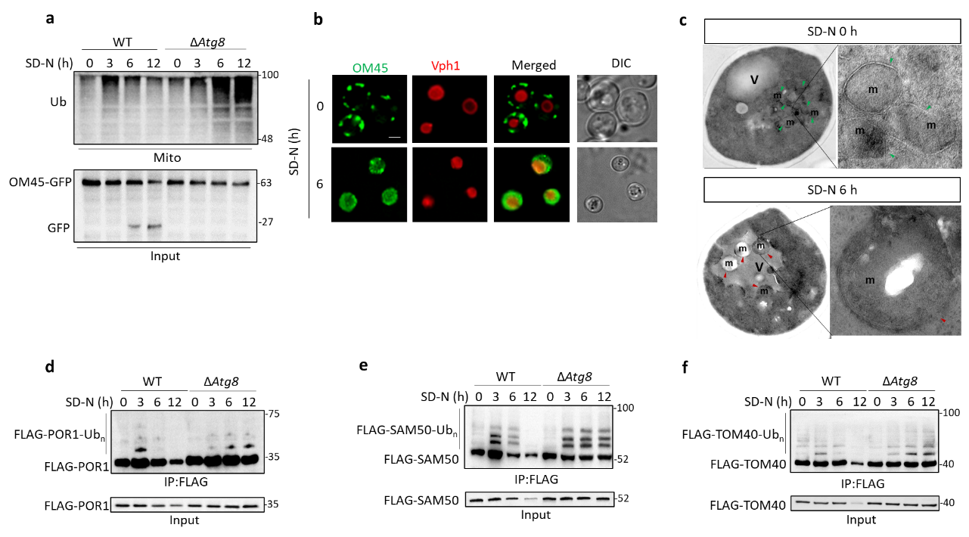
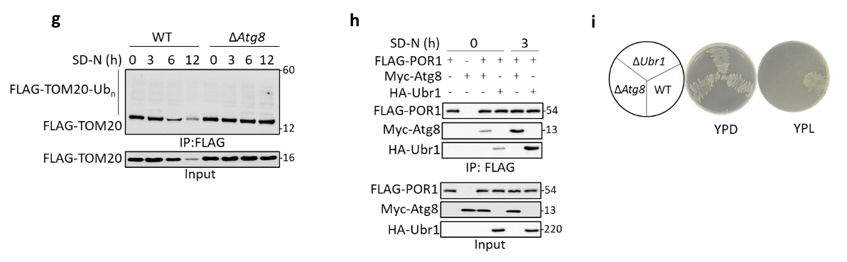
Supplementary Fig. 1 Ubiquitin-dependent mitophagy pathway exists in yeast, and POR1, SAM50 and TOM40 is validated as mitophagy substrates.
a, Wild-type (WT) and Atg8-deficient (ΔAtg8) yeast cells expressing OM45-GFP were cultured in YPL medium for 12 h and then subjected to nitrogen starvation (SD-N) for indicated times. Top: Mitochondria were isolated and subjected to western blotting with anti-ubiquitin (Ub) antibody. Bottom: Cells were analyzed for mitophagy via western blot by detecting GFP fusion protein cleavage. b, Yeast cells co-expressing OM45-GFP with Vph1-mCherry were cultured in YPL for 12 h and then starved for 0 or 6 h. Images of cells were obtained using fluorescence microscopy. Scale bars, 1 μm. c, Transmission electron microscopy (TEM) of yeast cells starved for 0 or 6 h. m, mitochondria, v, vacuole, Scale bars, 1 μm. Mitochondria within the vacuoles are indicated by red arrowheads and those out of the vacuoles by green arrowheads. d-g, WT or ΔAtg8 yeast cells transfected with FLAG-POR1 (d), FLAG-SAM50 (e), FLAG-TOM40 (f) or FLAG-TOM20 (g) were cultured in YPL and then starved for 3, 6, or 12 h. Cell lysates were immunoprecipitated using anti-FLAG agarose beads and western blotting for a ladder of high molecular weight ubiquitinated proteins with anti-FLAG antibody. The expression level of the POR1, SAM50 or TOM40 protein was analyzed by western blotting with anti-FLAG antibody in cell lysates. h, Yeast cells co-expressing FLAG-POR1 with either HA-Ubr1 or the Myc-Atg8 were starved for 0 or 3 h, followed by co-IP with anti-FLAG antibody and analyzed by western blotting with anti-HA or anti-Myc antibody. i, WT, ΔAtg8 or ΔUbr1 yeast cells were starved for 6 days, and then inoculated onto YPD and YPL agar plates, respectively at 30 ℃ for 3 days. Data are expressed as mean ± s.d. (n = 3 biological replicates). The data presented in a-i are representative of three independent experiments.
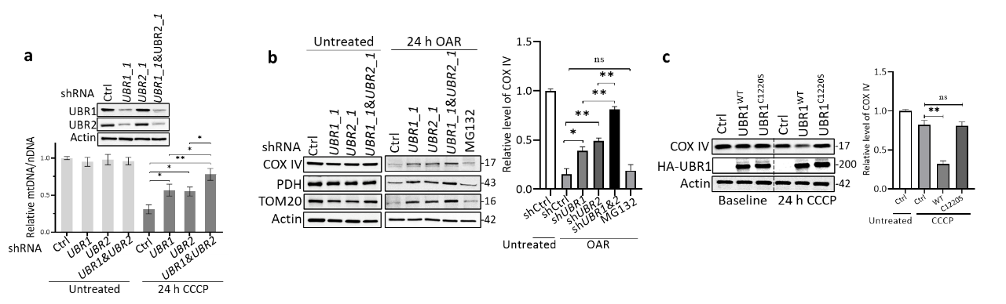
Supplementary Fig. 2 UBR1/2 and its E3 ligase activity is required for mitophagy. a, HEK293 cells transduced with lentiviral control shRNA, UBR1 and UBR2 shRNA alone or in combination were treated with 20 μM CCCP for 24 h. Then, mitochondrial DNA (mtDNA) and nuclear DNA (nDNA) were extracted for real-time quantitative PCR. b, Control shRNA, UBR1 shRNA, UBR2 shRNA, UBR1&UBR2 shRNA-transfected HEK293 cells were treated with cocktail of 3 μg/mL Oligomycin, 3 μg/mL Antimycin A and 100 nM Rotenone for 24 or in the presence of 0.3 μM MG132, followed by western blotting for mitochondrial proteins in the outer membrane (TOM20), inner membrane (COX IV), or matrix (PDH). c, HEK293 cells transfected with empty vector (Ctrl), UBR1 or UBR1^{C1220S} were treated with 10 μM CCCP (low induction of mitophagy in HEK293 cells) for 24 h, followed by western blotting for COX IV. Two-way ANOVA test was performed for a-c. **P < 0.01, *P < 0.05. ns indicates no significance. The data presented in a-c are representative of three independent experiments.
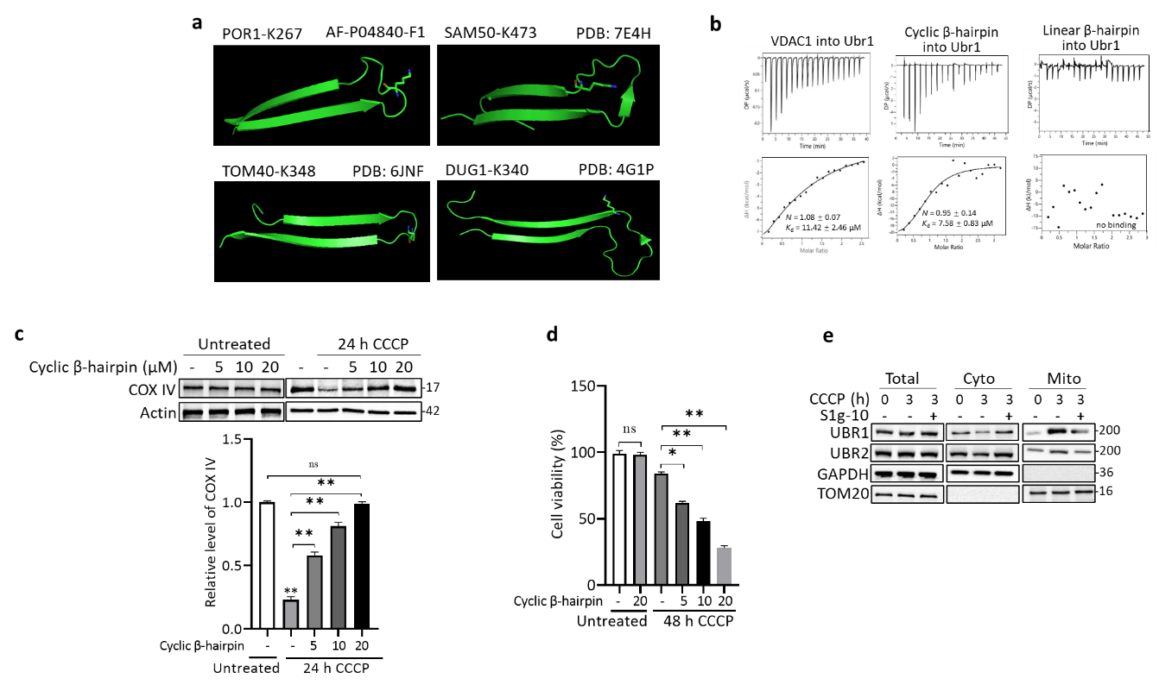
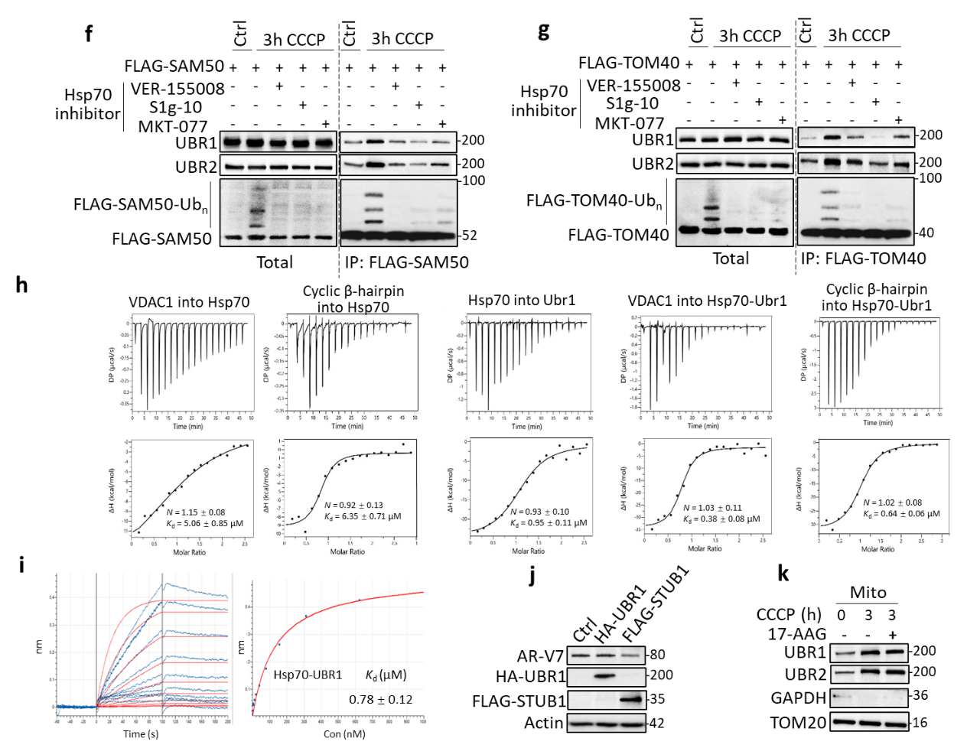
Supplementary Fig. 3 β-hairpin with a loop-located lysine underlies Hsp70-Ubr1-VDAC1 ternary complex and UBR1/2-mediated mitophagy. Related to Fig. 3.
a, The spatial positions of the ubiquitinated lysine and the β-hairpin strand in yeast POR1, SAM50, TOM40 and DUG1. b, ITC analysis of protein interactions involving VDAC1, Cyclic β-hairpin, Linear β-hairpin, and Ubr1. Top: Raw ITC thermograms showing heat flow versus time for the titration experiments of the following protein pairs: VDAC1 into Ubr1, Cyclic β-hairpin into Ubr1, and Linear β-hairpin into Ubr1. Bottom: Corresponding plots of integrated heat versus molar ratio. Binding stoichiometry (N) and dissociation constant (K_{d}) values were determined by fitting the data to a one-site binding model. c, UBR1-transfected HEK293 cells were treated with the indicated concentration of cyclic β-hairpin peptides alone or in combination with 10 μM CCCP for 24 h, followed by western blot analysis for COX IV reduction. d, UBR1-transfected HEK293 cells were treated with indicated concentration of cyclic β-hairpin peptides alone or in combination with 20 μM CCCP for 48 h. Cell viability was assayed by CCK-8. e, Western blot analysis of UBR1 and UBR2 in total cell lysates, cytosolic fractions and isolated mitochondria from HEK293 cells treated with 20 μM CCCP for 3 h in the absence or presence of 5 μM S1g-10. The purity of subcellular fractionation was confirmed by western blotting with anti-GAPDH and anti-TOM20 antibodies. f, g, HEK293 cells transfected with FLAG-SAM50 (f) or FLAG-TOM40 (g) were treated with 20 μM CCCP for 3 h in the absence or presence of 5 μM VER-155008, 2 μM S1g-10, or 5 μM MKT-077. Cell lysates were immunoprecipitated using anti-FLAG antibody and western blotting with anti-UBR1 and anti-UBR2 antibodies, and for a ladder of high molecular weight ubiquitinated FLAG-VDAC1 with anti-FLAG antibody. h, ITC analysis of protein interactions involving VDAC1, Ubr1, Hsp70 and Cyclic β-hairpin. Top: Raw ITC thermograms showing heat flow versus time for the titration experiments of the following protein pairs: VDAC1 into Hsp70, Cyclic β-hairpin into Hsp70, Hsp70 into Ubr1, VDAC1 into Hsp70-Ubr1 complex purified using gel filtration, and Cyclic β-hairpin into Hsp70-Ubr1 complex. Bottom: Corresponding plots of integrated heat versus molar ratio. Binding stoichiometry (N) and dissociation constant (K_{d}) values were determined by fitting the data to a one-site binding model. i, Purified His-tagged Hsp70 were loaded onto SSA biosensors for BLI analysis and incubated with gradient concentrations of yeast Ubr1. The raw binding curves at different concentrations ae shown in blue, and red curves are the best fits to the data used to calculate the K_{d} values. j. CWR22Rv1 cells were transfected with HA-UBR1 or FLAG-SATUB1 followed by western blotting for AR-V7. k. HEK293 cells were treated with 20 μM CCCP for 3 h in the absence or presence of 0.1 μM 17-AAG followed by mitochondrial isolation and western blotting for UBR1 and UBR2. The purity of subcellular fractionation was confirmed by western blotting with anti-GAPDH and anti-TOM20 antibody. Data are expressed as mean ± s.d. (n = 3 biological replicates). One-way ANOVA test was performed for c and d. **P < 0.01, *P < 0.05. ns indicates no significance. The data presented in b, e, f, i-k are representative of three independent experiments.
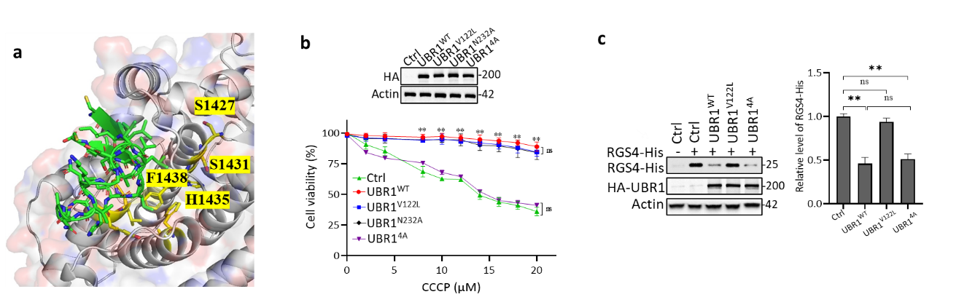
Supplementary Fig. 4 UBR1 mediates mitophagy independently of N-end rule. Related to Fig. 4.
a, The β‑hairpin motif of VDAC1 (green) docks into a hydrophobic groove within the CHD domain of UBR1. Residues Ser1427, Ser1431, His1435 and Phe1438 are shown in yellow sticks. b, HEK293 cells transfected with HA-UBR1^{WT}, HA-UBR1^{V122L}, HA-UBR1^{N232A} or HA-UBR1^{4A} were treated with indicated concentration of CCCP for 48 h, followed by cell viability assay by CCCK-8. c, RGS4-His were transfected into HEK293 cells (for overexpression of N-degron proteins) along with HA-UBR1, HA-UBR1^{V122L}, or HA-UBR1^{4A}, followed by western blotting for RGS4-His. Two-way ANOVA test was performed for b and One-way ANOVA test was performed for c. **P < 0.01, *P < 0.05. ns indicates no significance. The data presented in b and c are representative of three independent experiments.
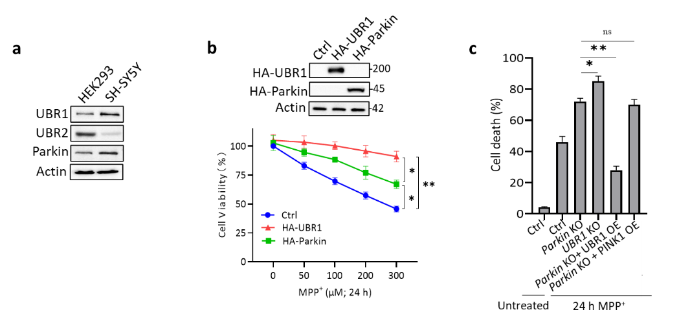
Supplementary Fig. 5 UBR1 has stronger neuroprotective effects than Parkin.
a, Western blotting for UBR1, UBR2 and Parkin in HEK292 and SH-SY5Y cells. b, SH-SY5Y cells transfected with UBR1 or Parkin were treated with the indicated concentration of MPP⁺ for 48 h, followed by a cell viability assay using CCCK-8. c. Parkin KO SH-SY5Y cells transfected with UBR1 or PINK1 expressing vector, UBR1 KO SH-SY5Y cells or control vector transfected SH-SY5Y cells were treated with 200 μM MPP⁺ for 48 h, followed by CCK-8 assays. Data are expressed as mean ± s.d. (n = 3 biological replicates). Two-way ANOVA test was performed for b, and one-way ANOVA test was performed for c. **P < 0.01, *P < 0.05. ns indicates no significance. The data presented in a are representative of three independent experiments.
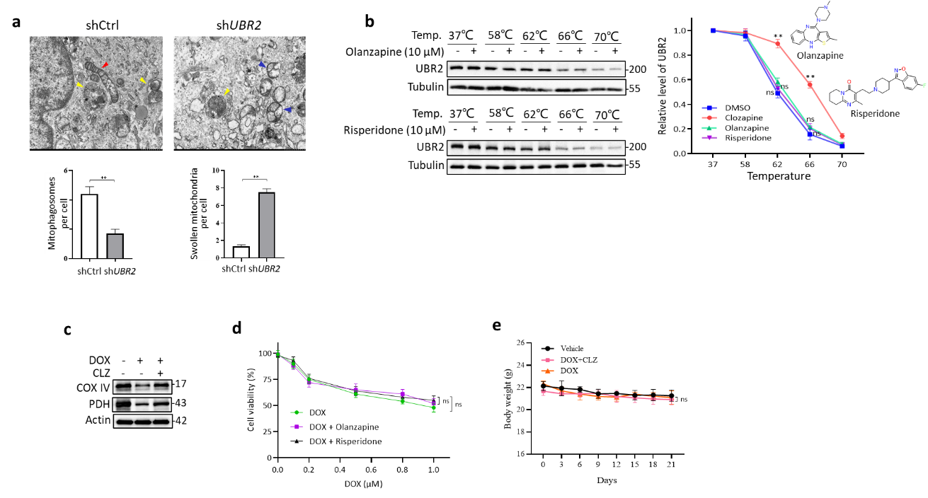
Supplementary Fig. 6 UBR2 knockdown or CLZ treatment inhibited DOX-induced mitophagy in TNBC cell lines.
a, MDA-MB-231 cells transduced with lentiviral control shRNA or UBR2 shRNA were treated with 0.5 μM DOX in combination with 200 nM BafA1 for 3 h, and then TEM was used to visualize the mitochondrial ultrastructure (scale bar, 1 μm). Yellow arrowheads indicate mitophagosomes. Red arrowheads indicate the healthy mitochondria with intact cristae. Blue arrowheads indicated swollen mitochondria with disrupted cristae. b, MDA-MB-231 cell lysates were incubated with 10 μM Olanzapine or Risperidone at 37 ℃ for 2 h for each sample, and then subjected to heat at the indicated temperature for 3 min, followed by western blotting for UBR2 and Tubulin. c, MDA-MB-231 were treated with 0.5 μM DOX alone or in combination with 10 μM CLZ for 24 h, followed by western blotting for COX IV and PDH. d, MDA-MB-231 cells were treated with the indicated concentration of DOX alone or in combination with 10 μM Olanzapine and Risperidone respectively for 48 h, followed by CCK-8 assays. e. The mouse body weight during the treatment period. Data are expressed as mean ± s.d. (n = 3 biological replicates). Unpaired t-test was performed for a, and two-way ANOVA test was performed for b, d and e. **P < 0.01. ns indicates no significance. The data presented in a-c are representative of three independent experiments.

