Supplementary Methods
- General Methods and Materials
Compounds used in standard organic synthesis were purchased from Sigma-Aldrich, Acmec, or Shanghai Haohong Bio-pharmaceutical Technology Co., Ltd. Extra-dry THF and EtOH were purchased from Sigma-Aldrich and used in acetal-formation reactions without further purification. Dulbecco's modified Eagle's medium (DMEM), RPMI 1640 medium, FluoroBrite DMEM, penicillin (10,000 U/ml), streptomycin (10 mg/ml), fetal bovine serum (FBS), trypsin–EDTA (0.25%), and PBS were purchased from Gibco (California, USA). DOPE, DSPC, DOTAP, 1,2-dimyristoyl-rac-glycero-3-methoxypolyethylene glycol-2000 (DMG-PEG2000), cholesterol, and 1,2-Dioleoyl-sn-glycero-3-phosphoethanolamine (DOPE) were supplied by Avanti Polar Lipids (Alabaster, USA). The Firefly Luciferase mRNA and Cy5 Firefly Luciferase mRNA were obtained from Vazyme (Nanjing, China), and IL-10 mRNA were obtained from APExBIO Technology LLC.
NO production analysis
RAW264.7 cells were isolated and plated into 96-well plates (5×10⁴ cells/well, Costar, USA). For anti-inflammatory evaluation, RAW264.7 were pretreated with G9 or G9-1 at different doses for 1 hour at 37°C, then stimulated with 1 μg/mL LPS for 24 h to induce NO production. Cell super-natant (100 μL) was mixed with 100 μL Griess reagent (equal volumes of 0.1% N-1-naphthylethylenediamine and 1% sulfanilamide) and incubated for 10 min at room temperature in the dark. Absorbance at 570 nm was measured using a microplate reader (Agilent BioTek Synergy H1) and NO content was calculated from a sodium nitrite standard curve.
Encapsulation efficiency
The encapsulation efficiency of mRNA within the G9-1 LNPs was determined using the Quant-iT™ RiboGreen® RNA Assay Kit (Invitrogen). To quantify the total mRNA, 2 μL LNP samples were lysed in 1×TE buffer supplemented with 4% (v/v) Triton X-100 and incubated at 37 °C for 10 min to ensure complete disruption of the lipid bilayer. Also, 2 μL LNP samples were diluted in 1×TE buffer to measure the free mRNA. Following the addition of the RiboGreen working solution, the mixtures were incubated in the dark at room temperature for 5 min. Fluorescence intensity was measured using a microplate reader (Agilent BioTek Synergy H1) at an excitation wavelength of 480 nm and an emission wavelength of 520 nm. The mRNA concentrations were determined using a standard curve generated from the provided RNA standard.
NOS2 Enzymatic Activity Assay
The direct inhibitory effect of G9 on NOS2 activity was evaluated in vitro using a Nitric Oxide Synthase (NOS) Activity Assay kit (Solarbio, Beijing, China). Firstly, recombinant NOS2 enzyme was diluted in the provided reaction buffer. The enzyme solution was then incubated with G9 (10 μM). An equal volume of the reaction buffer lacking the compound served as control. The enzymatic reaction was initiated by the addition of the substrate mixture and followed by a continuous incubation at 37 °C for 2 hours. After the 2 h reaction period, colorimetric detection reagents were added and absorbance at 550 nm was measured using a microplate reader (Agilent BioTek Synergy H1). The enzymatic activity of NOS2 was calculated based on a sodium nitrite standard curve and expressed as units per milliliter (U/mL).

2. Chemical synthesis and Characterization Data
2.1 The general method for the synthesis of ionizable guanidine motifs:
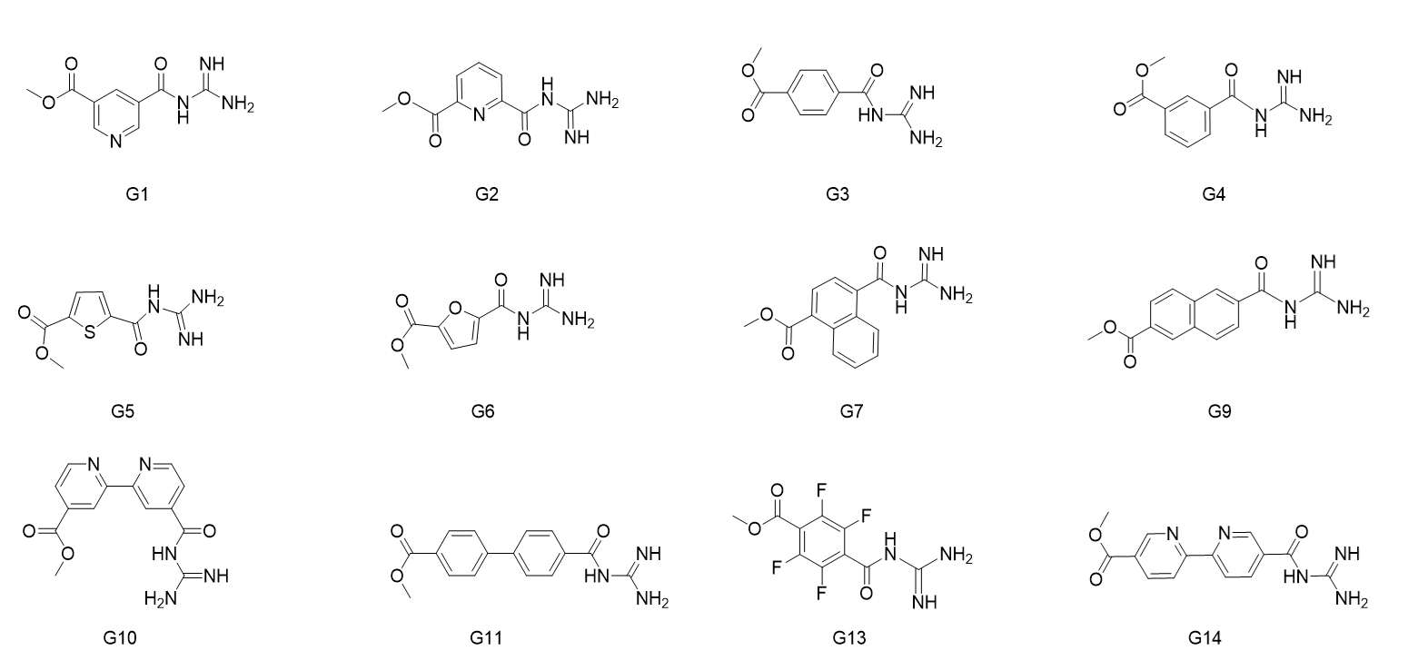
Compound R-OH (1.00 eq, 4.0 mmol) was dissolved in anhydrous DMF, EDCI (1.20 eq, 4.8 mmol), HOBT (1.20 eq, 4.8 mmol), and DIPEA (3.00 eq, 12.0 mmol) were added. After 5 minutes, Boc-Gua (1.00 eq) was added to the mixture. The reaction mixture was stirred at room temperature for 12 hours.
After the reaction was complete, the mixture was diluted with water and extracted with ethyl acetate (3 times). The combined organic extracts were then washed with water (5 times) to remove DMF. A saturated sodium bicarbonate (NaHCO3) solution was added dropwise to the organic phase to adjust the pH to 9-10. The organic phase was subsequently washed with water (3 times).
Subsequently, the aqueous phase was acidified to pH 4-5 by dropwise addition of 1 M hydrochloric acid (HCl) solution. The resulting aqueous phase was separated and further extracted with ethyl acetate (3 times). The combined organic phases were dried over anhydrous sodium sulfate (Na2SO4), filtered, and concentrated under reduced pressure to yield the crude product G(Boc)-OH.
To a solution of starting material G(Boc)-OH (1.0 equiv.) in anhydrous MeOH (0.5M) was added SOCl₂ (5.0 equiv.) dropwise at 0°C. The reaction mixture was then heated to reflux and stirred for 6 h. Upon completion of the reaction (monitored by TLC), the solvent was removed under reduced pressure. The residue was further dried under high vacuum to afford the desired product G-OMe, which was typically obtained as an HCl salt.
2.2 Synthesis of G9-1
2.2.1 Synthesis of N(Boc)-C22-1
To a stirred solution of erucic acid (2.5 g, 5.40 mmol) dissolved in 30 ml of DCM, DIPEA (1.8 ml, 10.6 mmol), EDCI (1.1 g, 5.80 mmol), DMAP (65 mg, 0.53 mmol) and the solution of compound DEA(Boc) (500 mg, 2.40 mmol, dissolved in 10 ml of DCM) was added. After stirred 12h, the reaction was quenched with the addition of 50 ml water, and the organic layer was separated, while the water phase was extracted with DCM (30 ml×3). The combined organic phase was concentrated and the residue was subjected to column chromatography (eluent: PE: EA = 20: 1) on silica gel to give compound N(Boc)-C22-1 as a yellow oil (1 g, 48.5 %).
2 .2.2 Synthesis of G9-1
To a stirred solution of compound G(Boc)9-OH (80 mg, 0.22 mmol) dissolved in 10 ml of anhydrous DMF, PYBOP (97 mg, 0.19 mmol), DIPEA (97.4 ul, 0.60 mmol) and compound N-C22-1 (139 mg, 0.19 mmol, dissolved in 5 ml of DCM) was added. After stirred overnight at room temperature, the mixture was diluted with 50 ml of water and extracted with ethyl acetate (10 ml×5). The combined organic phase was concentrated and the residue was subjected to column chromatography (eluent: PE: EA = 3: 1) on silica gel to give compound G(Boc)9-C22-1 as a yellow oil (80 mg, 39.5 %).
G(Boc)9-C22-1 (80 mg, 0.07 mmol) was dissolved in 2 ml of TFA, 2 ml of DCM and stirred at room temperature for 2 h. The reaction mixture was concentrated under reduced pressure. The crude material was purified by preparative thin-layer chromatography (PTLC) (eluent: DCM: MeOH = 10: 1) to give G9-1 as a white film (31 mg, 43.1 %).
G1: ¹H NMR (400 MHz, DMSO) δ 8.62 (d, J = 29.1 Hz, 6H), 8.47 (dd, J = 9.0, 3.6 Hz, 1H), 7.87 (dd, J = 36.0, 3.7 Hz, 1H), 3.88 (s, 3H).
G2: ¹H NMR (400 MHz, MeOD) δ 9.37 (d, J = 2.0 Hz, 1H), 9.16 (d, J = 2.1 Hz, 1H), 8.97 (t, J = 2.0 Hz, 1H), 3.97 (s, 3H).
G3: ¹H NMR (400 MHz, MeOD) δ 8.66 (dd, J = 6.9, 2.1 Hz, 1H), 8.58 – 8.49 (m, 2H), 8.31 (d, J = 7.5 Hz, 1H), 3.34 (s, 3H).
G4: ¹H NMR (400 MHz, MeOD) δ 8.69 (t, J = 1.8 Hz, 1H), 8.22 (ddt, J = 36.5, 7.8, 1.4 Hz, 2H), 7.57 (t, J = 7.8 Hz, 1H), 3.93 (s, 3H).
G5: ¹H NMR (600 MHz, CDCl₃) δ 7.72 (q, J = 2.2 Hz, 1H), 7.69 (dd, J = 4.0, 2.2 Hz, 1H), 3.89 (d, J = 2.2 Hz, 3H).
G6: ¹H NMR (400 MHz, DMSO) δ 7.30 (d, J = 3.6 Hz, 1H), 7.02 (d, J = 3.5 Hz, 1H), 3.83 (s, 3H).
G7: ¹H NMR (400 MHz, DMSO) δ 8.76 – 8.69 (m, 1H), 8.63 – 8.55 (m, 1H), 8.09 (d, J = 7.5 Hz, 1H), 7.80 (d, J = 7.6 Hz, 1H), 7.61 (dddd, J = 19.5, 8.3, 6.8, 1.5 Hz, 2H), 3.95 (s, 3H).
G9: ¹H NMR (600 MHz, MeOD) δ 8.64 (s, 2H), 8.20 – 8.02 (m, 4H), 3.98 (s, 3H).
G11: ¹H NMR (600 MHz, MeOD) δ 8.22 – 8.03 (m, 4H), 7.85 – 7.72 (m, 4H), 3.93 (s, 3H).
G12: ¹H NMR (400 MHz, MeOD) δ 8.20 (s, 1H), 4.45 (q, J = 7.1 Hz, 2H), 1.42 (t, J = 7.1 Hz, 3H).
G13: ¹H NMR (600 MHz, MeOD) δ 3.31 (p, J = 1.6 Hz, 3H).
G14: ¹H NMR (400 MHz, DMSO) δ 9.30 (s, 1H), 9.19 (s, 1H), 8.58 (d, J = 8.3 Hz, 1H), 8.53 – 8.42 (m, 3H), 3.93 (s, 3H).
N-C22-1:¹H NMR (400 MHz, Chloroform-d) δ 5.41 – 5.28 (m, 4H), 4.43 – 4.36 (m, 4H), 3.40 – 3.33 (m, 4H), 2.34 (m, 4H), 2.01 (q, J = 6.4 Hz, 8H), 1.59 (p, J = 7.1, 6.6 Hz, 5H), 1.41 – 1.18 (m, 56H), 0.92 – 0.84 (m, 6H). LC-MS (ESI+) m/z: 746.8 ([M + H] ⁺, C₄₈H₉₁NO₄).
G9-1 ¹H NMR (400 MHz, Chloroform-d) δ 8.73 (s, 1H), 8.27 (d, J = 8.6 Hz, 1H), 7.97 (d, J = 8.5 Hz, 1H), 7.88 (d, J = 8.5 Hz, 2H), 7.50 (d, J = 8.4 Hz, 1H), 5.34 (t, J = 4.9 Hz, 3H), 4.42 (s, 2H), 4.12 (s, 2H), 3.87 (s, 2H), 3.65 (s, 2H), 2.41 – 2.21 (m, 4H), 2.01 (q, J = 6.4 Hz, 7H), 1.62 (tt, J = 18.8, 13.2, 10.5 Hz, 6H), 1.28 (dd, J = 20.1, 9.8 Hz, 64H), 0.88 (t, J = 6.5 Hz, 6H). ESI-MS (positive) m/z: calculated for C₆₁H₁₀₀N₄O₆ [M + H] ⁺: 985.7643, found 985.7737.

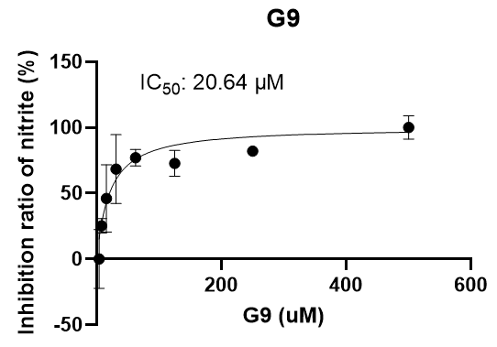
Figure S1. The IC₅₀ of G9 on nitrite inhibition. RAW264.7 macrophages were stimulated with LPS and co-treated with various concentrations of G9. The IC₅₀ for the inhibition of NO production is 20.64 μM.

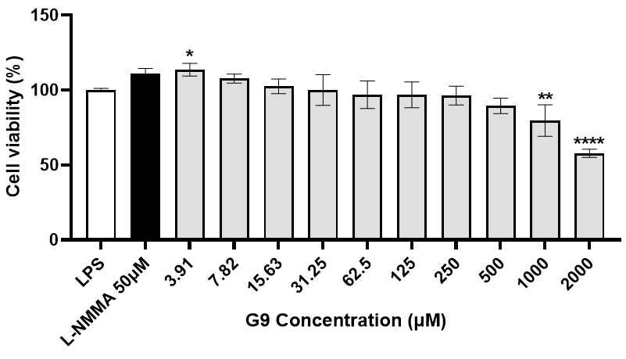
Figure S2. Cytotoxicity evaluation of G9. The viability of RAW264.7 cells after treatment with different concentrations of G9 for 24h, assessed by CCK-8 assay.

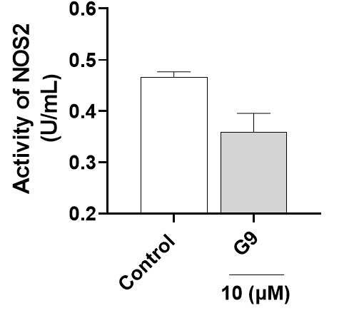
Figure S3. Inhibitory effect of G9-1 on recombinant NOS2 activity. Recombinant NOS2 protein was incubated with G9-1 (10 μM). The specific activity of NOS2 is expressed as U/mL.

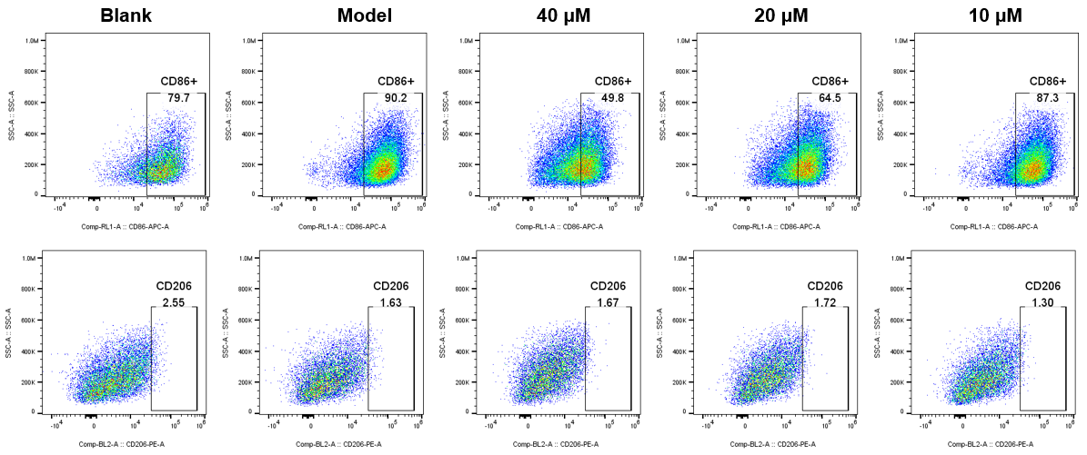
Figure S4. Representative flow cytometry plots showing the percentage of CD86 and CD206 in peritoneal macrophages.

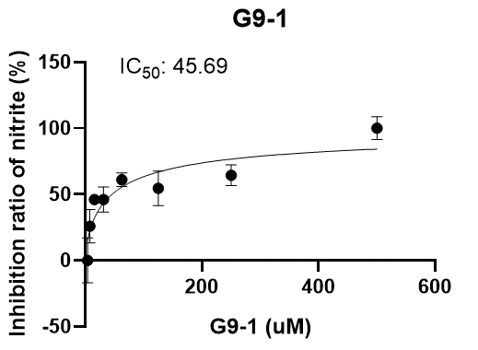
Figure S5. The IC₅₀ of G9-1 on nitrite inhibition. RAW264.7 macrophages were stimulated with LPS and co-treated with various concentrations of G9-1. The IC₅₀ for the inhibition of NO production is 45.69 μM.

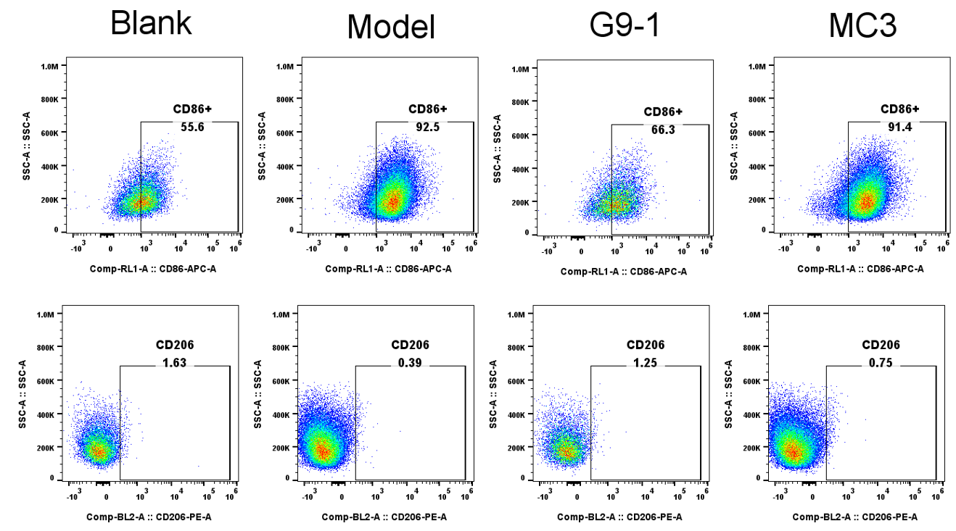
Figure S6. Representative flow cytometry plots showing the percentage of CD86 and CD206 in peritoneal macrophages.

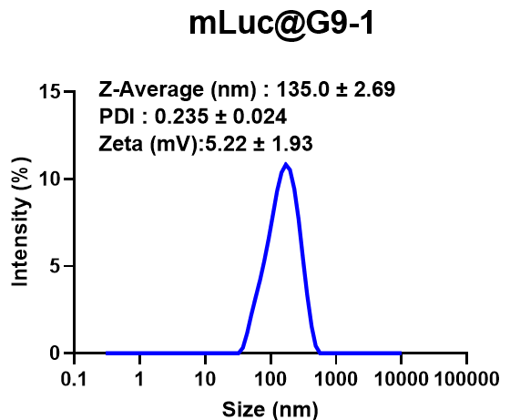
Figure S7. Particle size and zeta potential of mLuc@G9-1 LNPs.

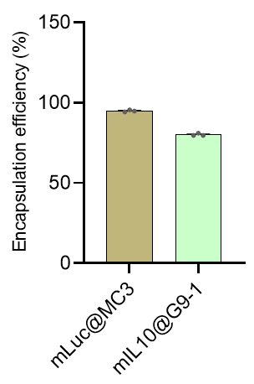
Figure S8. The encapsulation efficiency of mLuc@MC3 and mIL10@G9-1 LNPs.

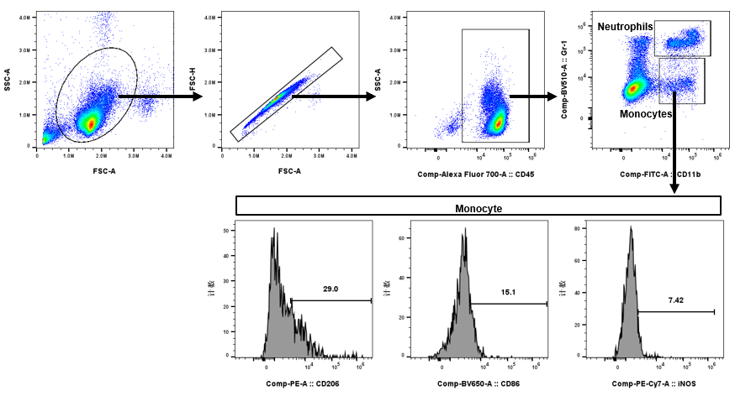
Figure S9. The FACS gating strategy for analysis of peripheral blood immune cells of the PBS group. C57BL/6J mice were administered with mLuc@MC3 or mLuc@G9-1 LNPs (0.5 mg/kg), and peripheral blood immune cells were analyzed at 24h post injection. CD45⁺ was used to gate total immune cells, while neutrophils and monocytes were defined as CD11b⁺/Gr-1ʰⁱ and CD11b⁺/Gr-1ⁱⁿᵗ, respectively. The expression level of iNOS and CD86 were subsequently shown within the monocyte population.

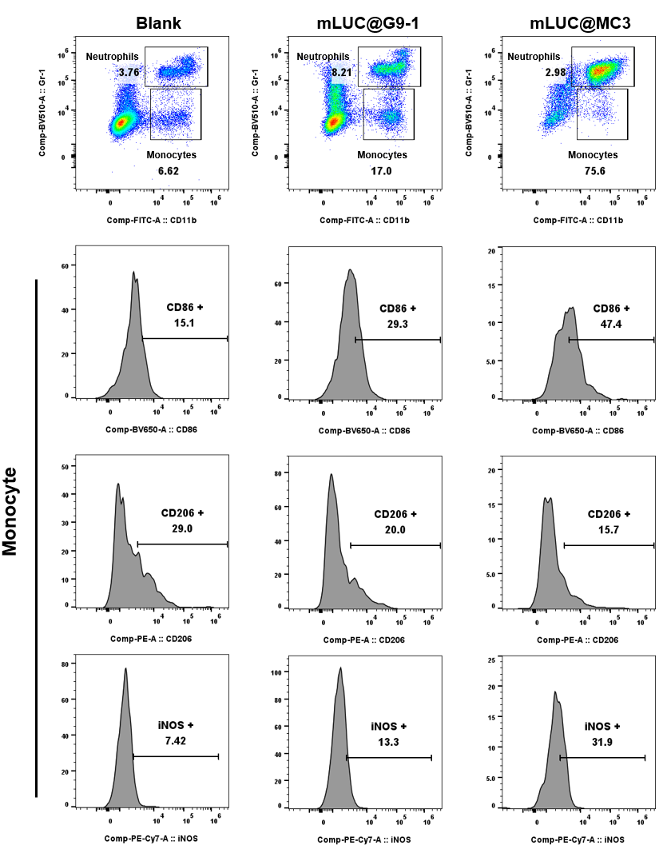
Figure S10. Representative flow cytometry plots showing the percentages of neutrophils and monocytes. The proportions of CD86+, CD206+, and iNOS+ cells within the monocyte gate are also shown.

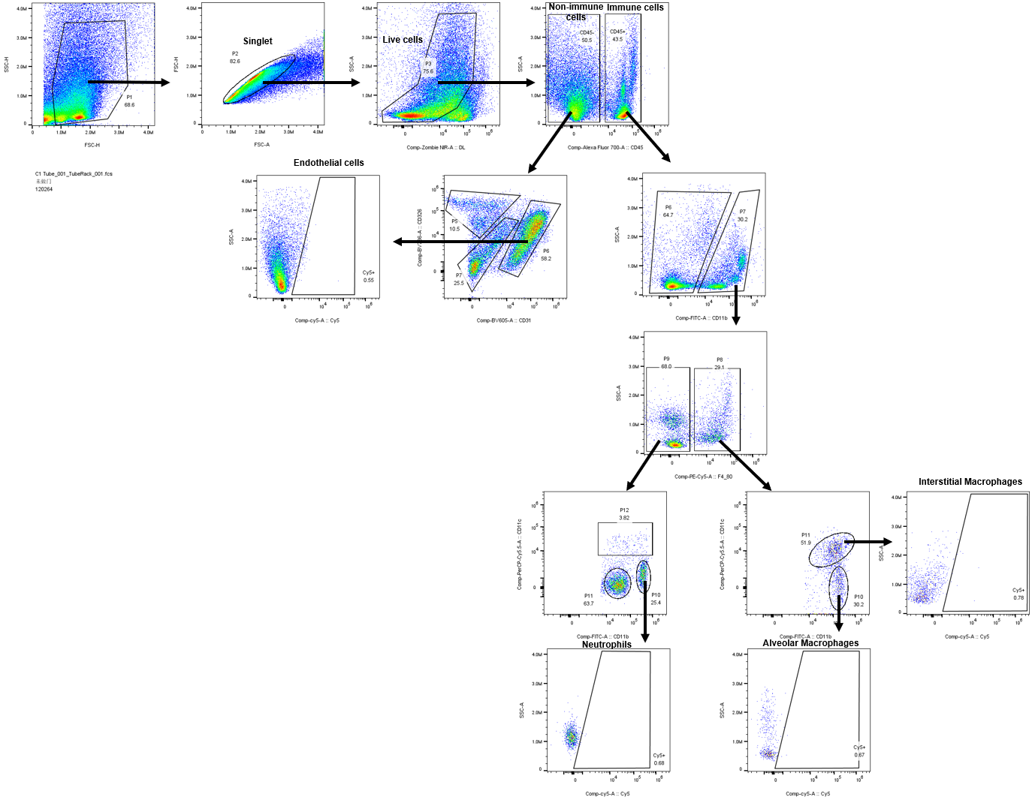
Figure S11. The FACS gating strategy for analysis of Cy5⁺ cell populations in the lung of the PBS group. C57BL/6J mice were administered with Cy5-mLuc@G9-1 LNPs (0.4 mg/kg), and the lung cells were harvested and analyzed at 3h post injection. CD45⁺ was used to gate total immune cells, endothelial cells were defined as CD45⁻/CD31⁺/CD326⁻, neutrophils were defined as CD45⁺/CD11b⁺/F4/80⁻/CD11c⁻, while interstitial macrophages and alveolar macrophages were defined as CD45⁺/CD11b⁺/F4/80⁺/CD11c⁺ and CD45⁺/CD11b⁺/F4/80⁺/CD11c⁻, respectively.

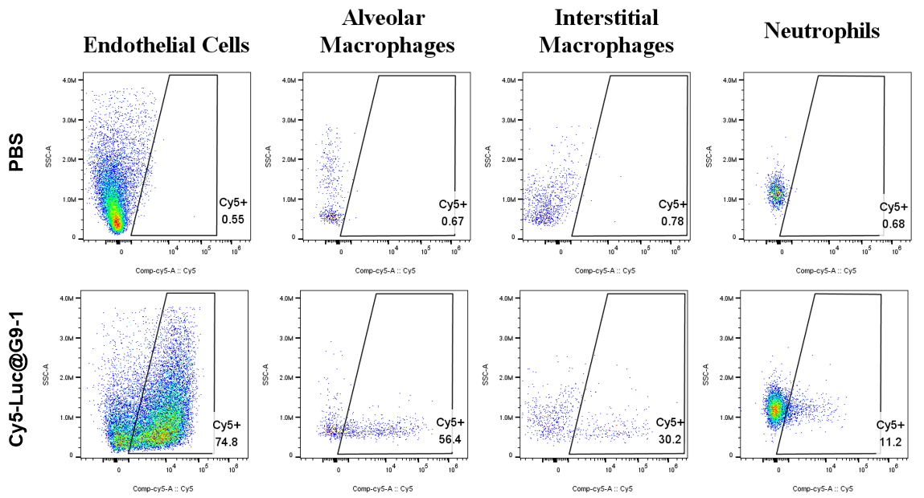
Figure S12. Representative flow cytometry plots showing the percentage of Cy5⁺ cells among endothelial cells, alveolar macrophages, interstitial macrophages, and neutrophils.

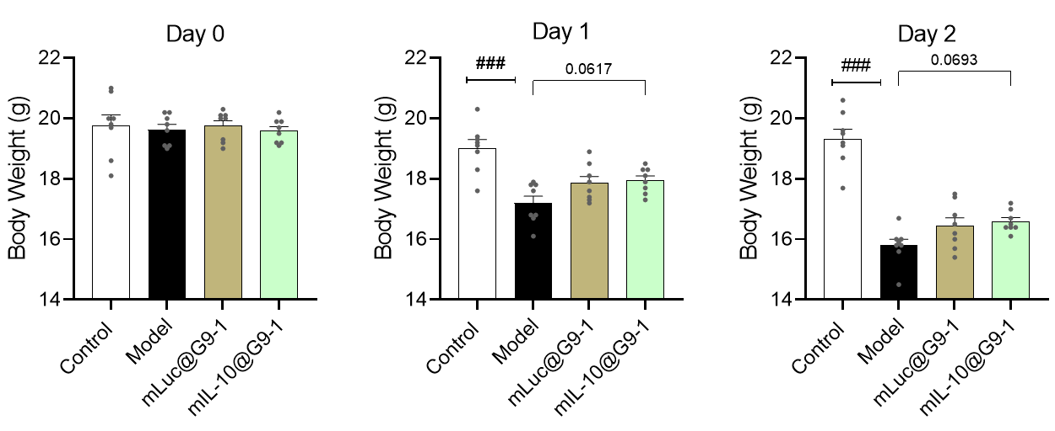
Figure S13. Body weight changes in ALI model mice following LNP treatment. The body weights of mice in the Control, Model, mLuc@G9-1, and mIL-10@G9-1 groups were monitored on Day 0 (baseline), Day 1, and Day 2.

G1:
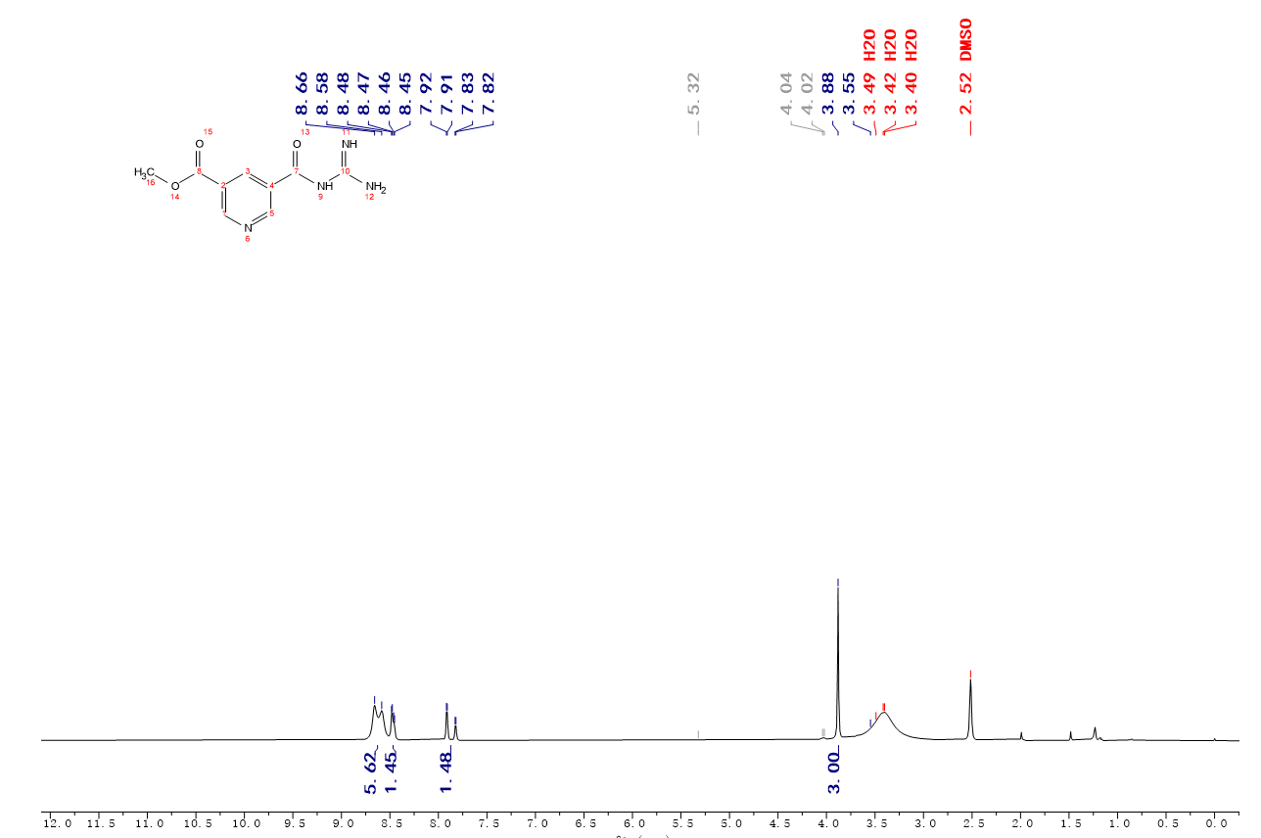
G2:
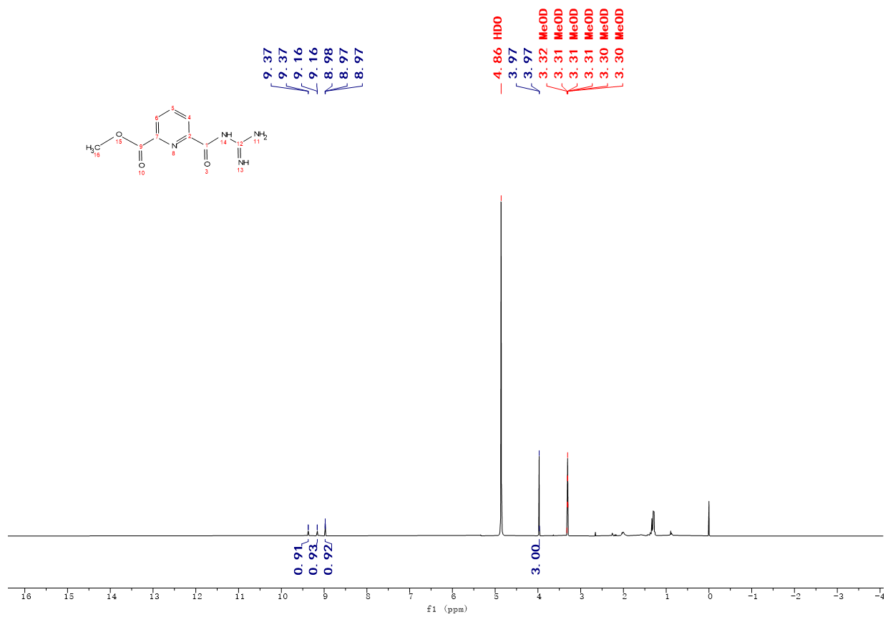

G3:
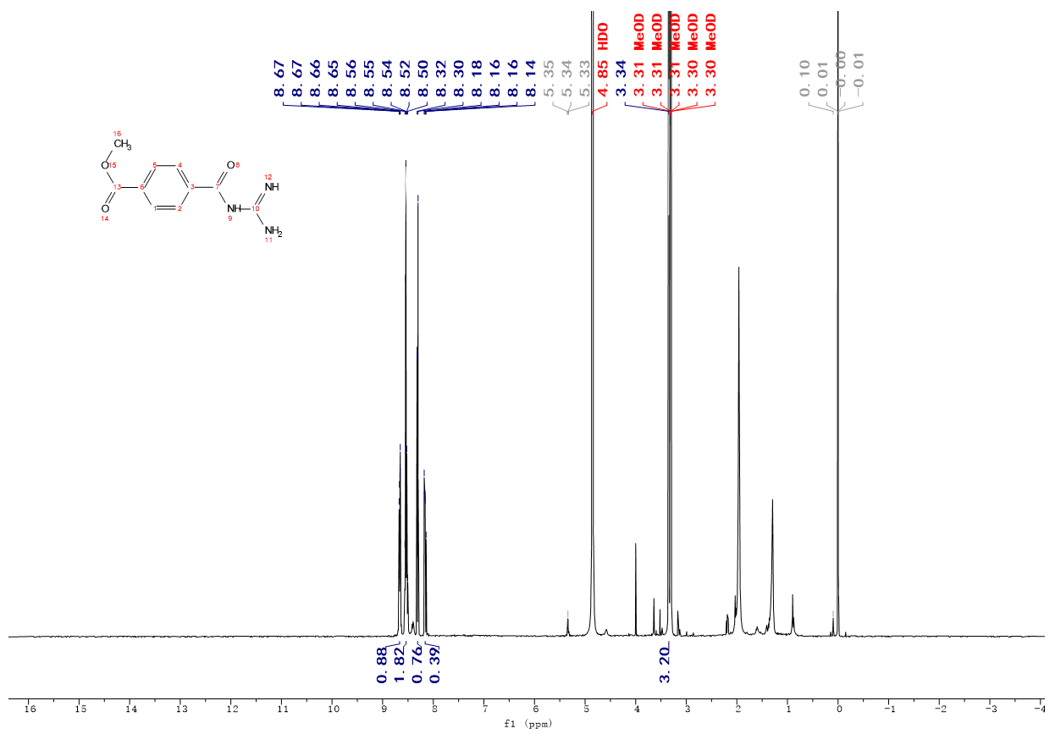
G4:
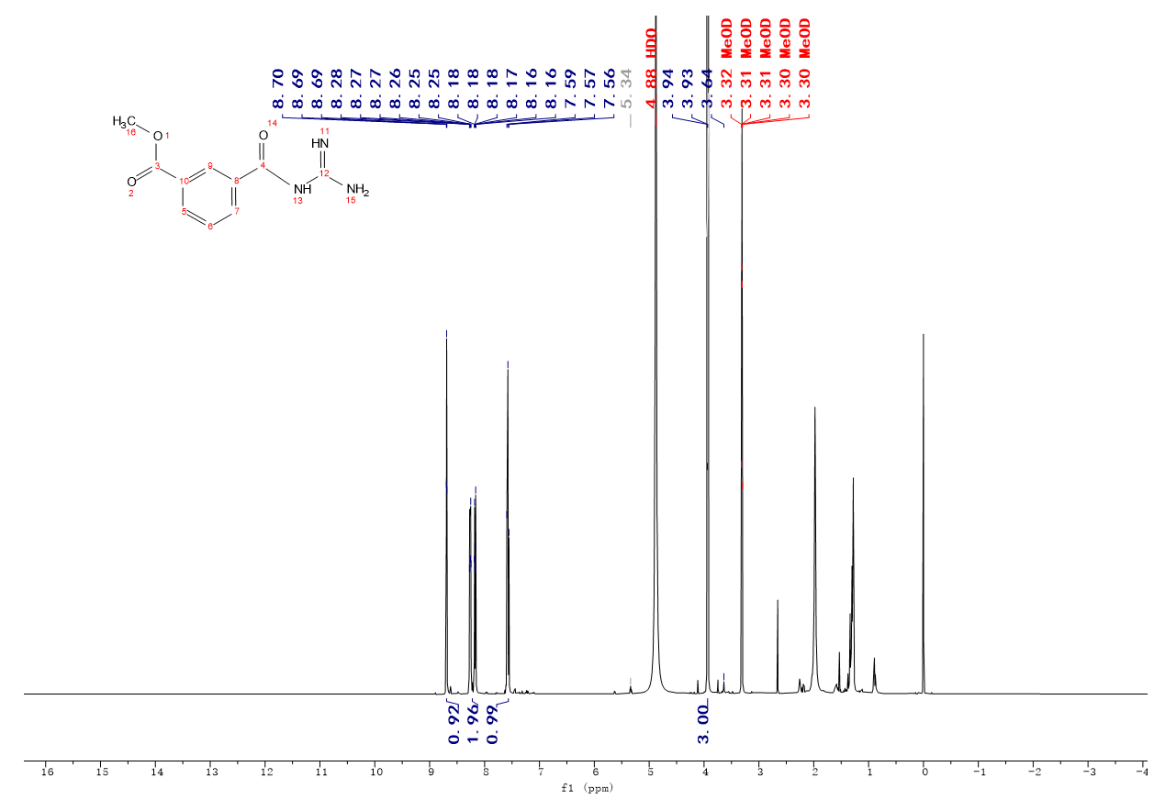

G5:
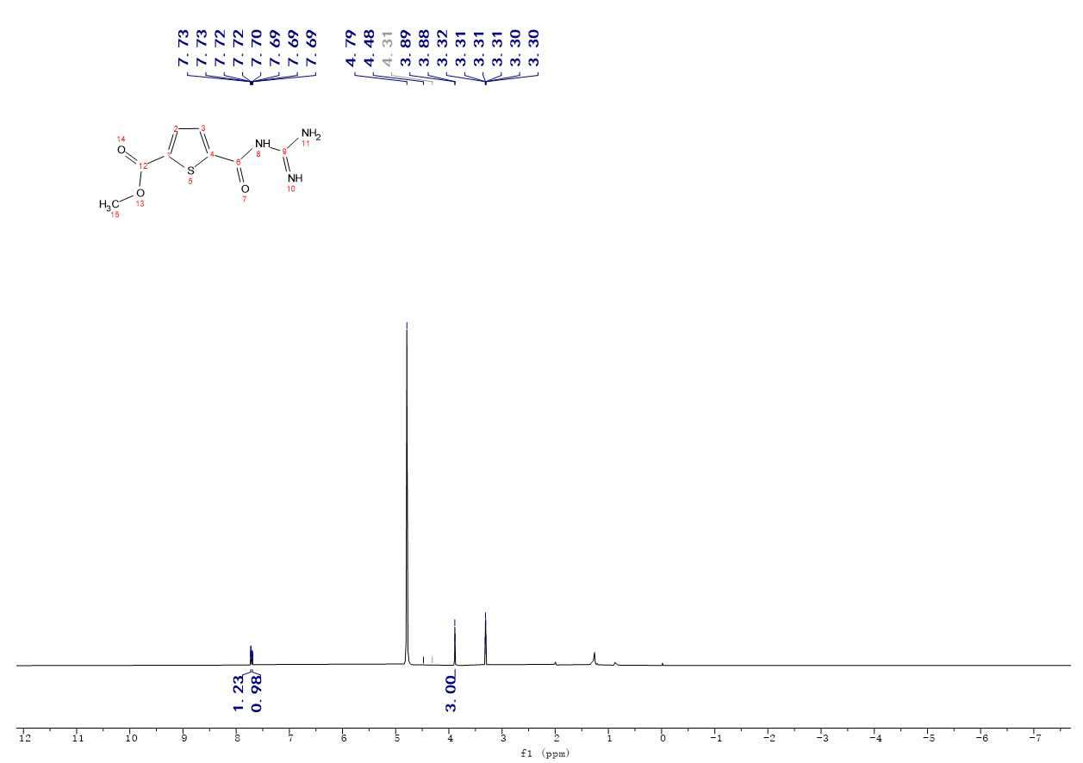
G6:
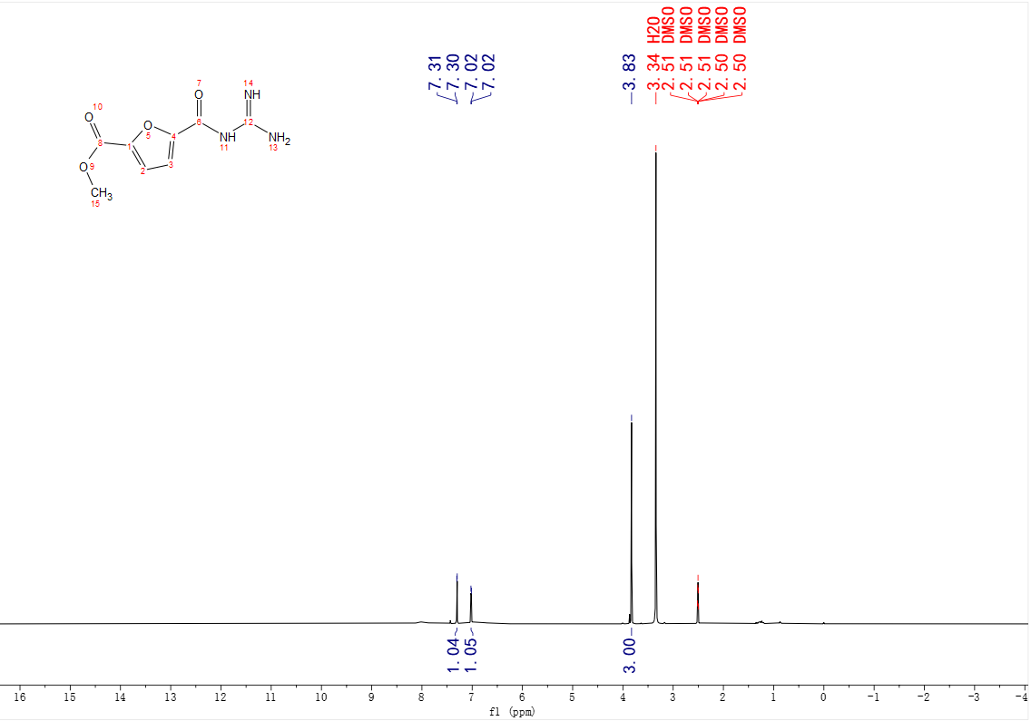

G7:
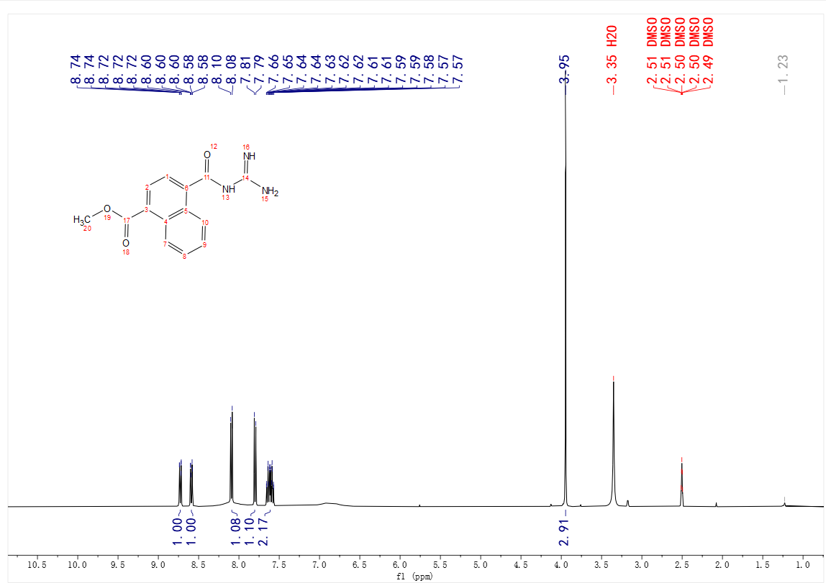
G9:
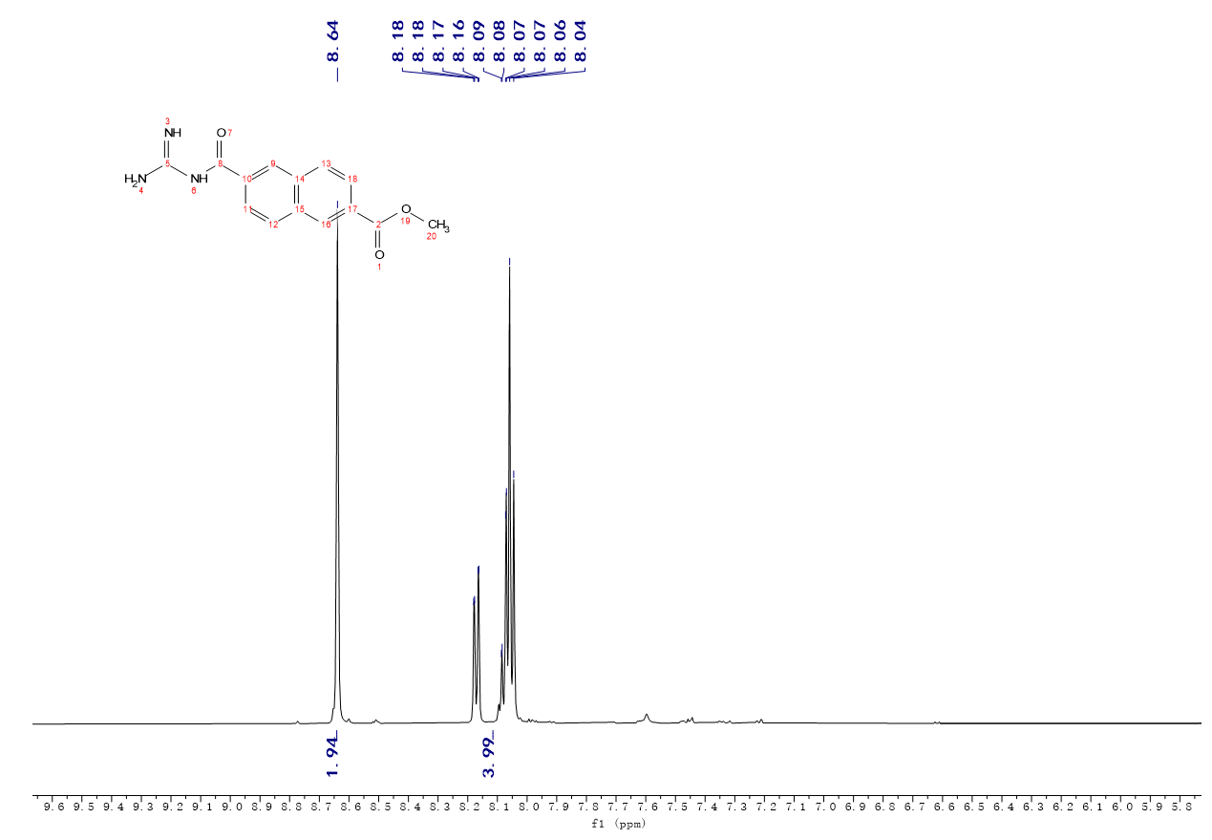

G10:
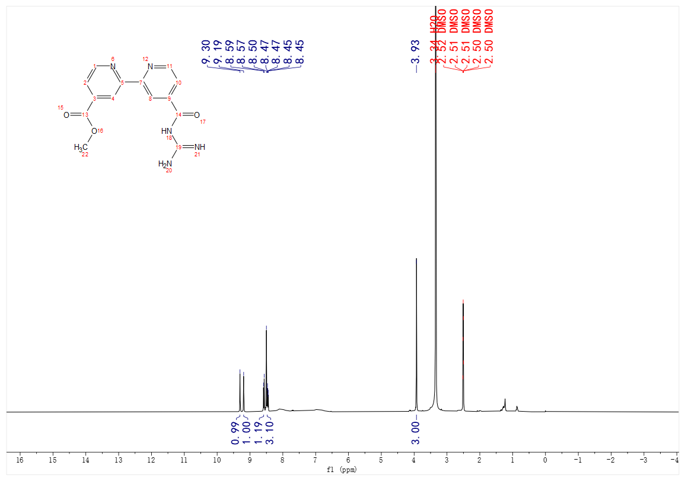
G11:
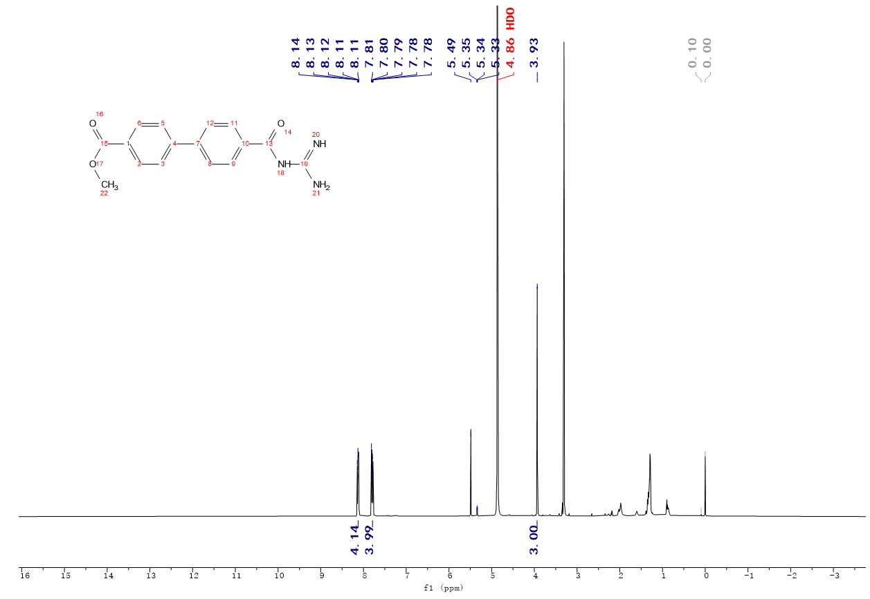

G12:
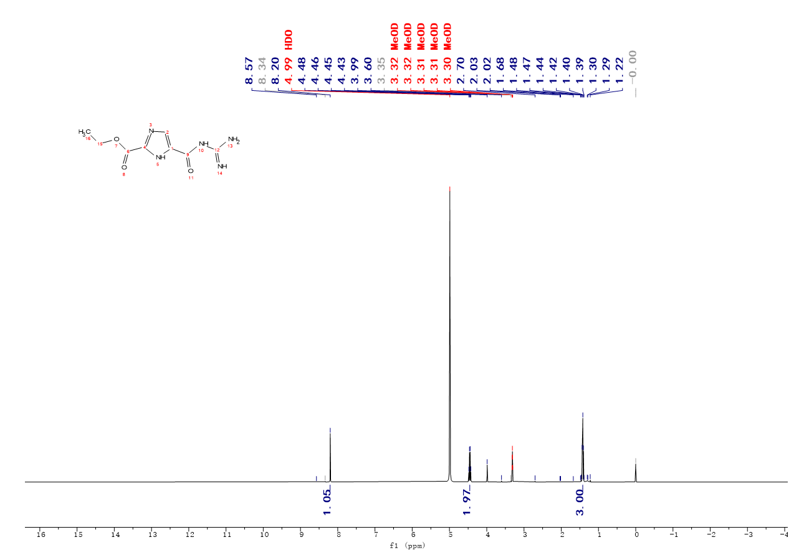
G13:
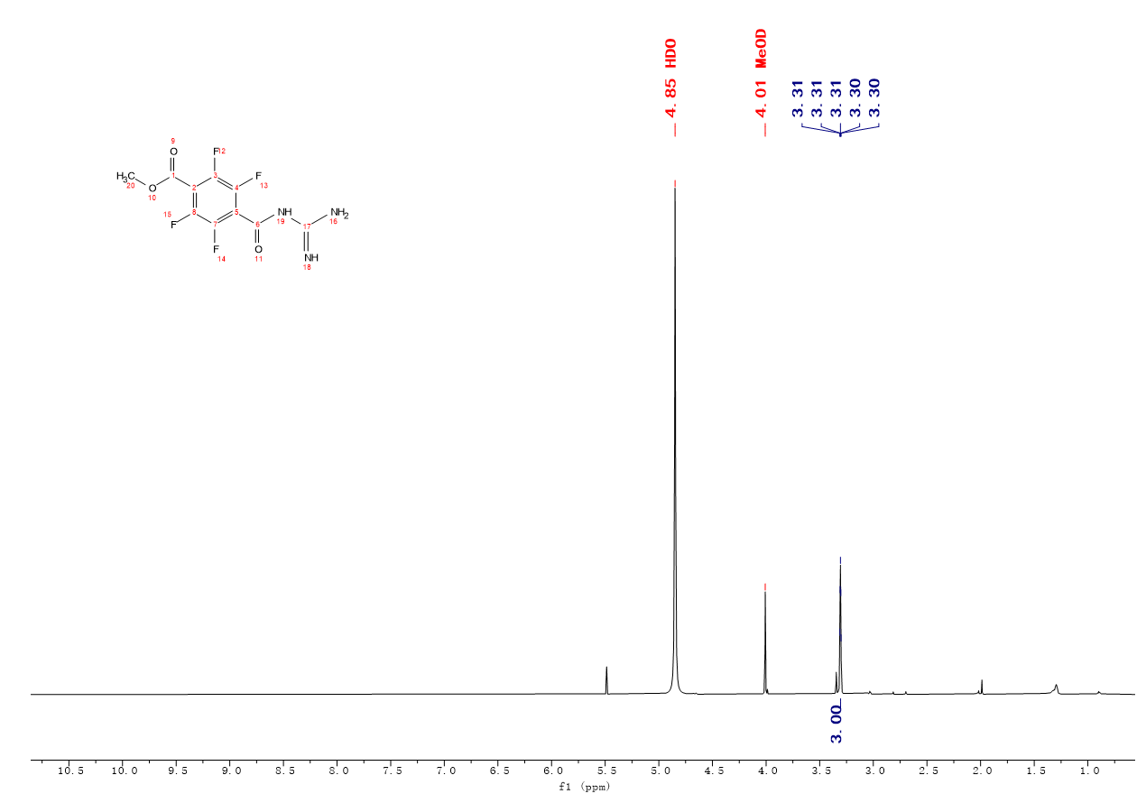

G14:
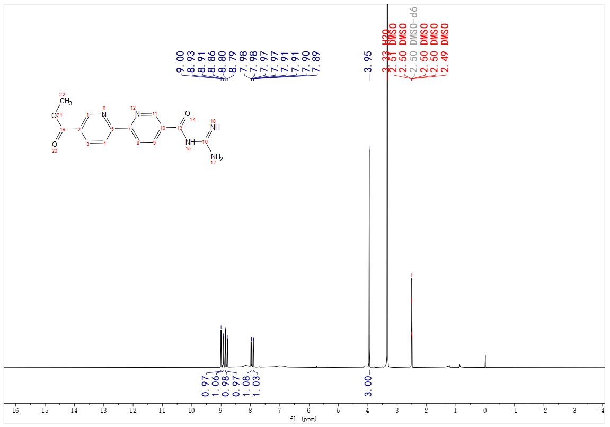
N-C22-1:

G9-1：

