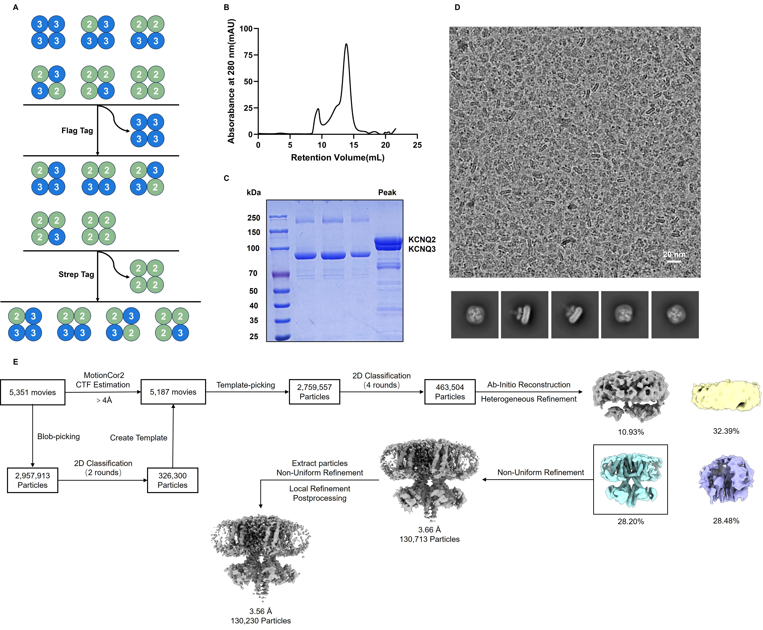Figure S1. Purification and data processing of full-length KCNQ2/3 heteromers. (A) Schematic diagram of tandem affinity purification steps: first purify the protein with Flag tag, and then purify the protein with Strep tag. Flag-KCNQ2 (green); Strep-KCNQ3 (blue). (B) KCNQ2/3 heteromer size exclusion chromatography (SEC) trace obtained using an FPLC equipped with Superose 6 Increase 10/300 column. (C) Corresponding SDS-PAGE Coomassie-stained gel of the collected sample off the column. (D) Cryo-EM raw images of KCNQ2/3 heteromer and typical particles of KCNQ2/3 heteromer. (E) Summary of the image processing procedures of KCNQ2/3 heteromer.
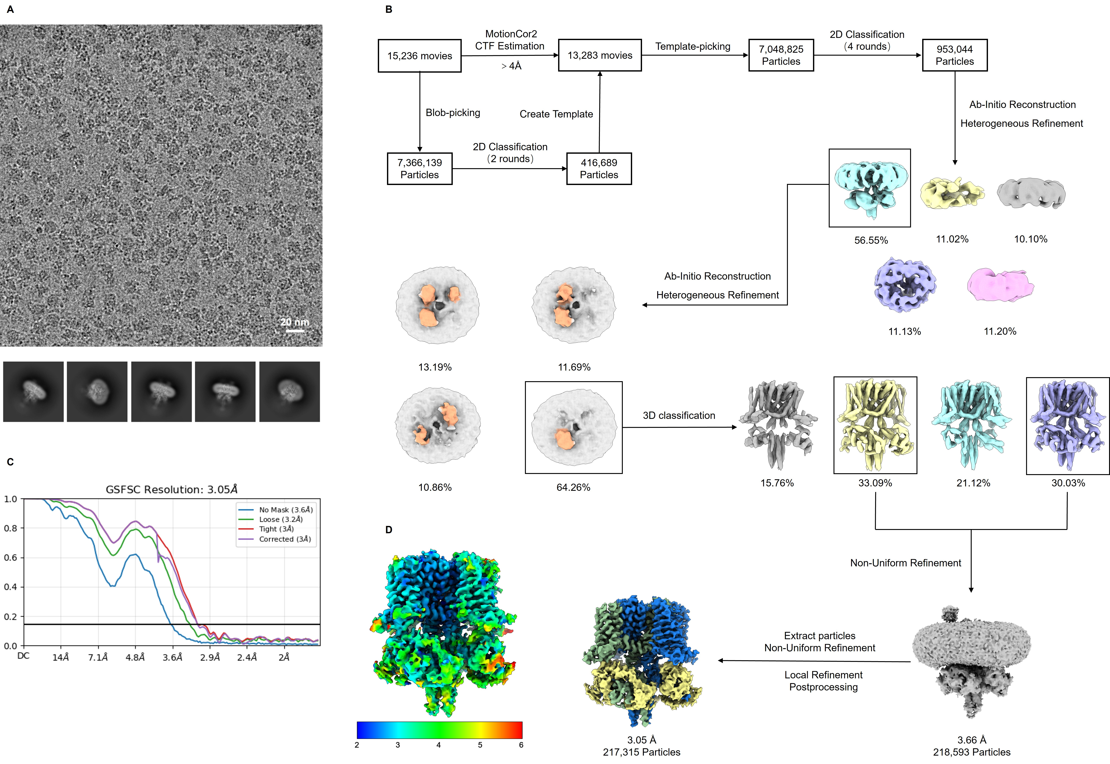Figure S2. Cryo-EM and data processing of KCNQ2/3/3/3_{APO}. (A) Cryo-EM raw images of KCNQ2/3/3/3 and typical particles of KCNQ2/3/3/3. (B) Summary of the image processing procedures of KCNQ2/3/3/3. (C) Fourier shell correlation (FSC) curves of the final reconstruction from cryoSPARC for KCNQ2/3/3/3. (D) Local resolution estimation map using cryoSPARC for KCNQ2/3/3/3.

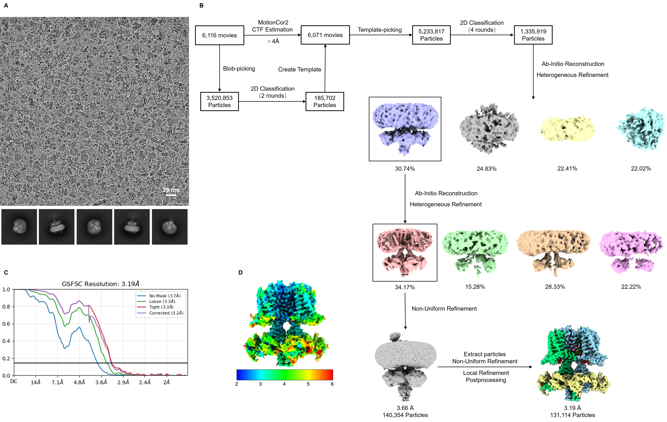Figure S3. Cryo-EM and data processing of KCNQ2/3-XEN1101-PIP₂. (A) Cryo-EM raw images of KCNQ2/3-XEN1101-PIP₂ and typical particles of KCNQ2/3-XEN1101-PIP₂. (B) Summary of the image processing procedures of KCNQ2/3-XEN1101-PIP₂. (C) Fourier shell correlation (FSC) curves of the final reconstruction from cryoSPARC for KCNQ2/3-XEN1101-PIP₂. (D) Local resolution estimation map using cryoSPARC for KCNQ2/3-XEN1101-PIP₂.

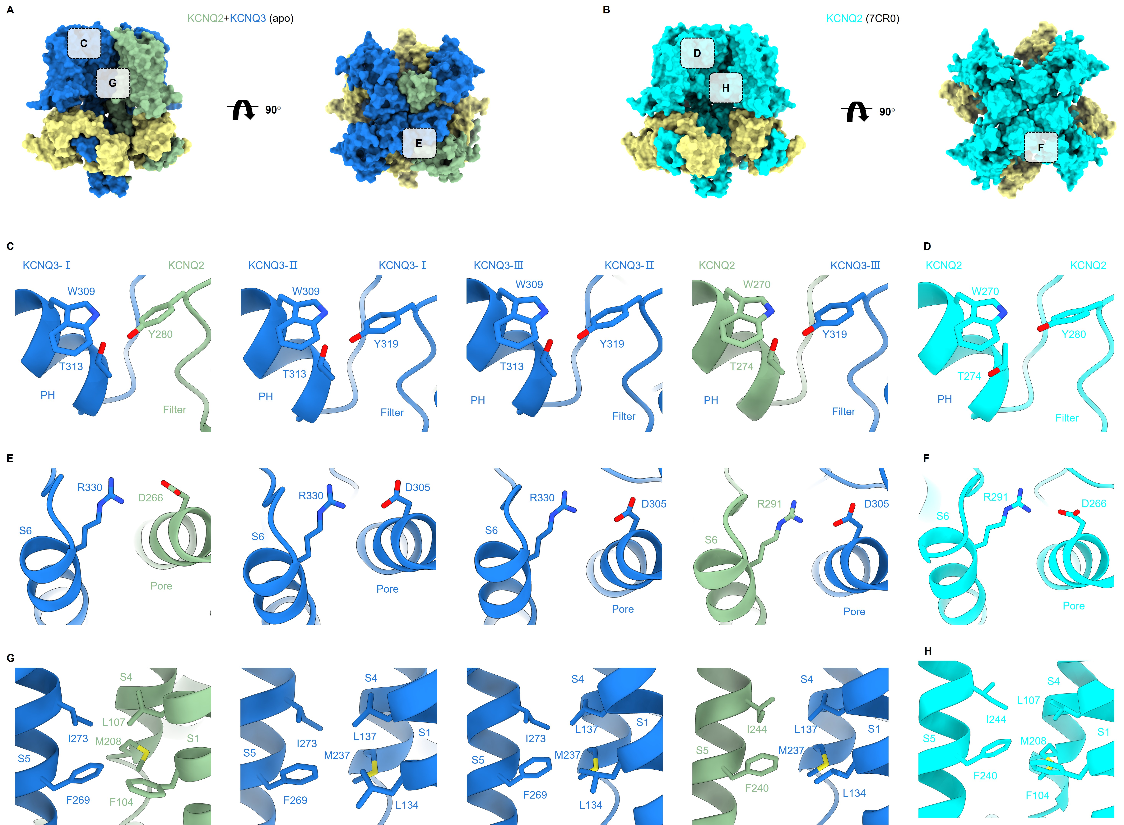Figure S4. Intersubunit interactions. (A) Atomic surface representations of the KCNQ2/3/3/3 viewed from the side (left) and top (right). (B) Atomic surface representations of the KCNQ2 homomer viewed from the side (left) and top (right). Dotted boxes indicate intersubunit junctions expanded in C-H. Close-up views of the pore of the KCNQ2/3/3/3 (C) and KCNQ2 homomer (D). Close-up views of S6 and pore of the KCNQ2/3/3/3 (E) and KCNQ2 homomer (F). Close-up views of the VSD of the KCNQ2/3/3/3 (G) and KCNQ2 homomer (H).

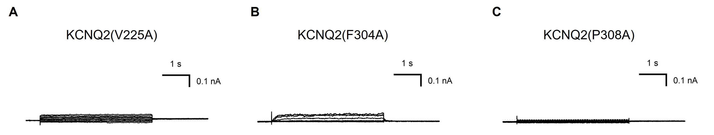
Figure S5. Non-detectable currents mutation in KCNQ2. (A) Representative activation currents of V225A (KCNQ2). (B) Representative activation currents of F304A (KCNQ2). (C) Representative activation currents of P308A (KCNQ2).
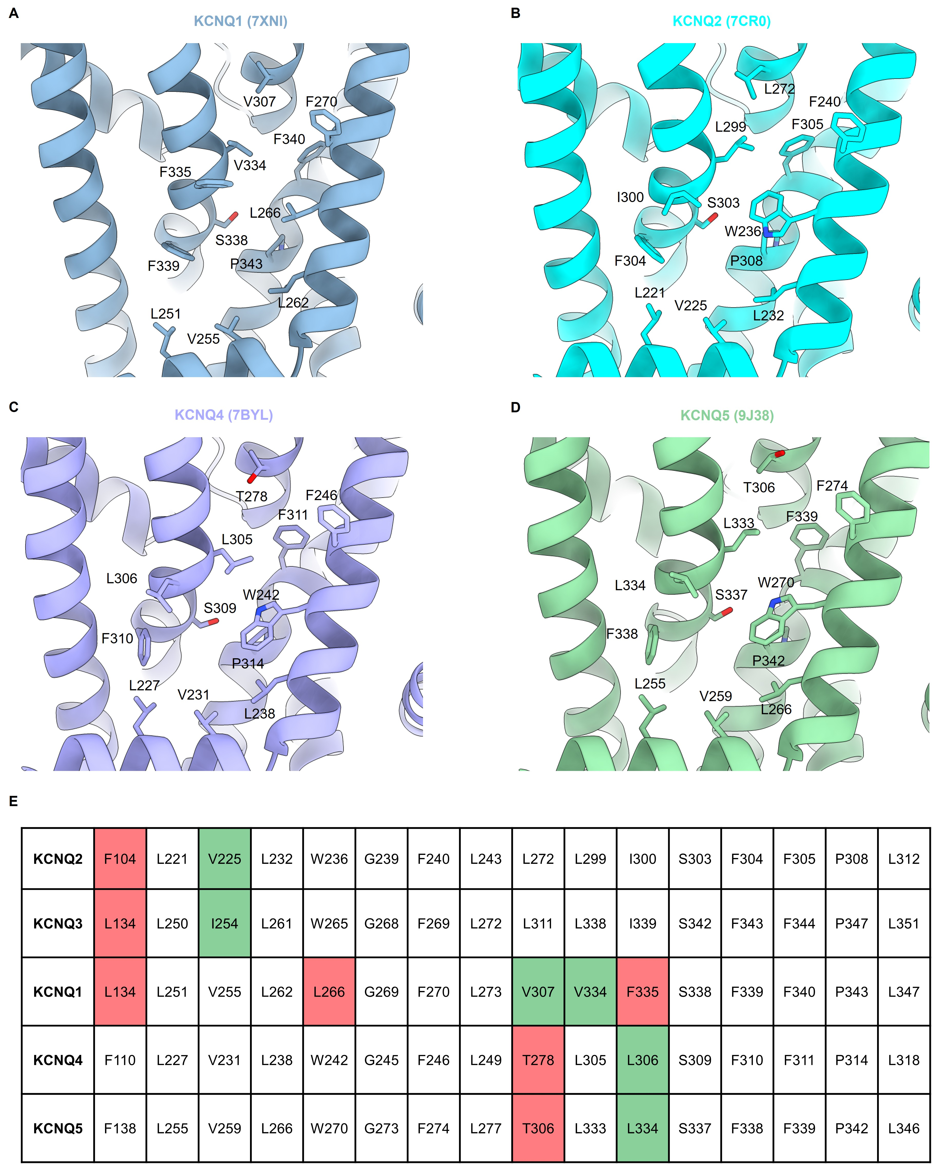Figure S6. The XEN1101 binding site in KCNQs. (A) Local magnified image of the XEN1101 binding site in KCNQ1 (7XNI) (1). (B) Local magnified image of the XEN1101 binding site in KCNQ2 (7CR0) (2). (C) Local magnified image of the XEN1101 binding site in KCNQ4 (7BYL) (3). (D) Local magnified image of the XEN1101 binding site in KCNQ5 (9J38) (4). (E) Sequence alignment results of all amino acids that may interact with XEN1101 in the binding pocket of KCNQ1-5. Green marks indicate similar amino acids, red marks indicate non-conserved amino acids, and identical amino acids are not marked.

Table S1. Cryo-EM data collection, refinement and validation statistics.
Structure  EMDB accession code  PDB accession code | KCNQ2/3_{apo}  EMDB-66589  9X5J | KCNQ2/3-XEN1101-PIP₂  EMDB-66607  9X65
Data collection and processing
Magnification | 130,000 | 130,000
Voltage (kV) | 300 | 300
Electron exposure (e–/Å²) | 50.44 | 50.52
Defocus range (μm) | -1.0 ~ -2.0 | -1.0 ~ -2.0
Pixel size (Å) | 0.891 | 0.891
Symmetry imposed | C1 | C1
Initial particle images (#) | 7,366,139 | 5,233,817
Final particle images (#) | 217,315 | 131,114
Map resolution (Å)  FSC threshold | 3.05  0.143 | 3.19  0.143
Refinement
Initial model used (PDB code) | AlphaFold-KCNQ3, 7CR3 | 9X5J (this paper)
Model resolution (Å)  FSC threshold | 3.60  0.143 | 3.05  0.143
Model composition  Non-hydrogen atoms  Protein residues  Ligands | 15,300  1900  4 | 15,192  1864  11
B factors (Å²)  Protein  Ligand | 44.06  32.44 | 51.80  13.57
r.m.s. deviations  Bond lengths (Å)  Bond angles (°) | 0.004  0.586 | 0.004  0.597
Validation  MolProbity score  Clashscore  Poor rotamers (%) | 1.71  12.44  0.12 | 1.64  12.93  0.13
Ramachandran plot  Favored (%)  Allowed (%)  Disallowed (%) | 97.47  2.53  0.00 | 97.92  2.08  0.00

References
1. D. Ma et al., Structural mechanisms for the activation of human cardiac KCNQ1 channel by electro-mechanical coupling enhancers. Proc Natl Acad Sci U S A 119, e2207067119 (2022).
2. X. Li et al., Molecular basis for ligand activation of the human KCNQ2 channel. Cell Res 31, 52-61 (2021).
3. T. Li et al., Structural Basis for the Modulation of Human KCNQ4 by Small-Molecule Drugs. Mol Cell 81, 25-37.e24 (2021).
4. Z. Yang et al., Phosphatidylinositol 4,5-bisphosphate activation mechanism of human KCNQ5. Proc Natl Acad Sci U S A 122, e2416738122 (2025).

