Supplementary Information
TABLES AND FIGURES
Figures
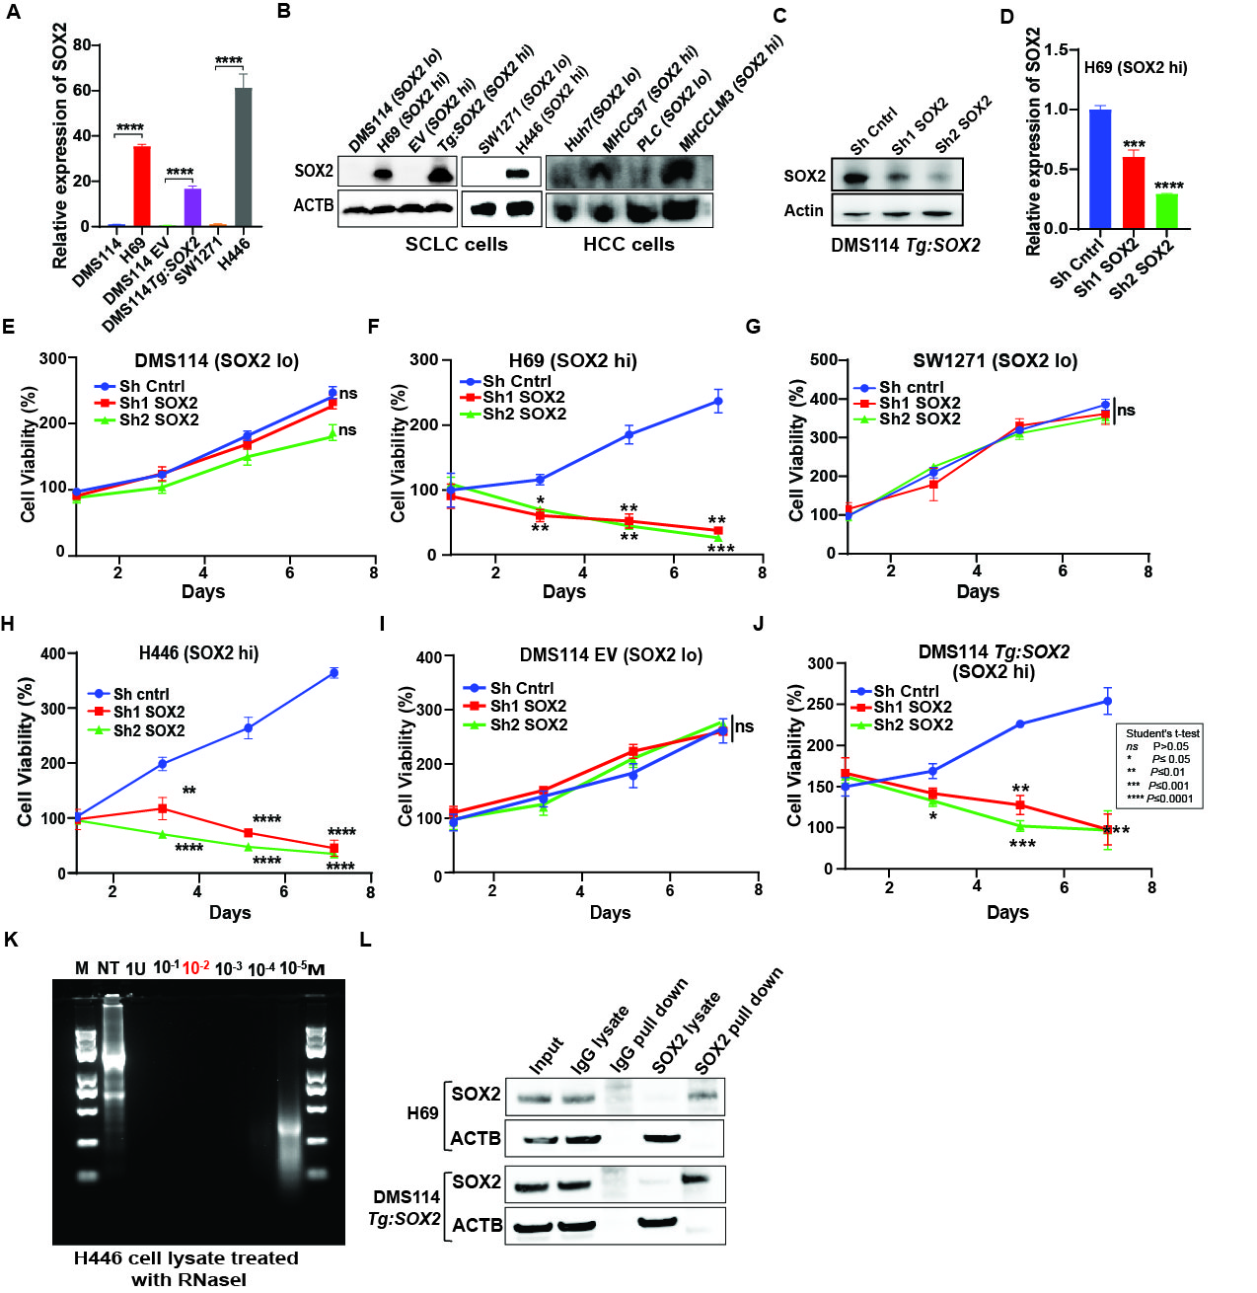
Fig. S1: SOX2 is indispensable for SOX2-expressing cancer cells. (A) qRT-PCR detection of SOX2 in endogenous and isogenic SOX2 hi and lo SCLC cell lines, normalized to ACTB. (B) Western blot for SOX2 and ACTB in endogenous and isogenic SOX2 hi and lo SCLC and HCC cell lines. (C) Western blot of SOX2 and ACTB in DMS114 Tg:SOX2 cells treated with scrambled control or short hairpin RNAs (shRNAs) for SOX2 knockdown. (D) qRT-PCR detection of SOX2 in H69 cells treated with scrambled control or shRNA SOX2 knockdown, normalized to ACTB. CellTiter-Glo cell viability assay for (E) DMS114 SOX2 lo, (F) H69 SOX2-hi, (G) SW1271 SOX2 lo, (H) H446 SOX2 hi, (I) DMS114 empty vector control (EV), and (J) DMS114 Tg:SOX2 cell lines treated with scrambled control or shRNAs for SOX2 knockdown. (K) Gel electrophoresis of total RNA purified from H446 cell lysate treated with varying amounts of RNaseI. (L) Western blot for SOX2 and ACTB in H69 and DMS114 Tg:SOX2 cell lysate input, lysate after IgG pulldown sample, lysate after SOX2 pulldown, and SOX2 pulldown sample. Statistical analysis was performed using Student’s two tailed t-test. Data are presented as mean ± SEM, n=3.

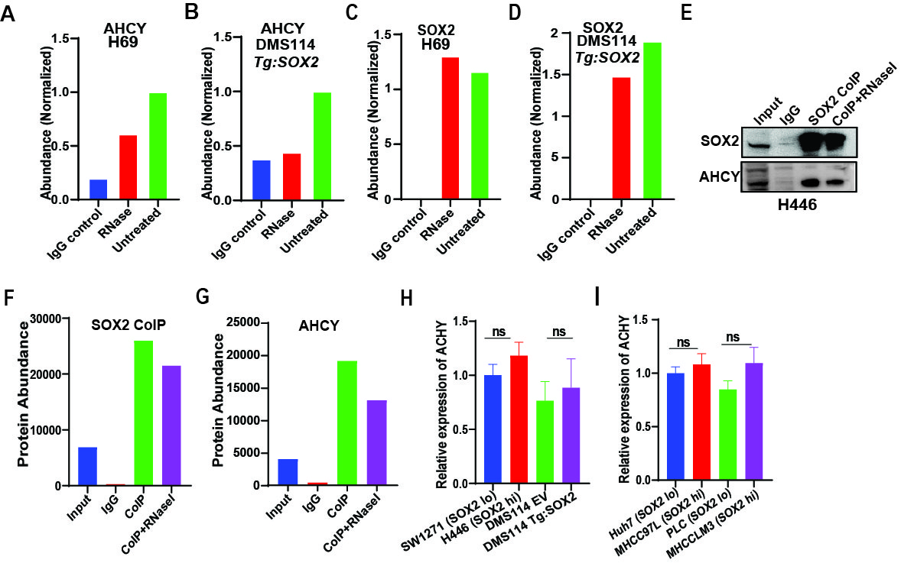
Fig. S2: SPRINT identifies AHCY as an RNA-dependent SOX2 binder. SPRINT MS abundances of AHCY protein in (A) H69 and (B) DMS114 Tg:SOX2 cells in IgG control, SOX2 co-IP with RNase treatment, and SOX2 co-IP alone. SPRINT MS abundances of SOX2 protein in (C) H69 and (D) DMS114 Tg:SOX2 cells in IgG control, SOX2 co-IP with RNase treatment, and SOX2 co-IP alone. (E) Western blot of SOX2 and AHCY in SOX2 co-IP with and without RNase treatment in H446 cells. (F, G) Quantification of the SOX2 and AHCY Western blot in (E). (H,I) qRT-PCR detection of AHCY in SCLC and HCC cell lines normalized to ACTB. Statistical analysis was performed using Student’s two tailed t-test. Data is presented as mean ± SEM, n=3.
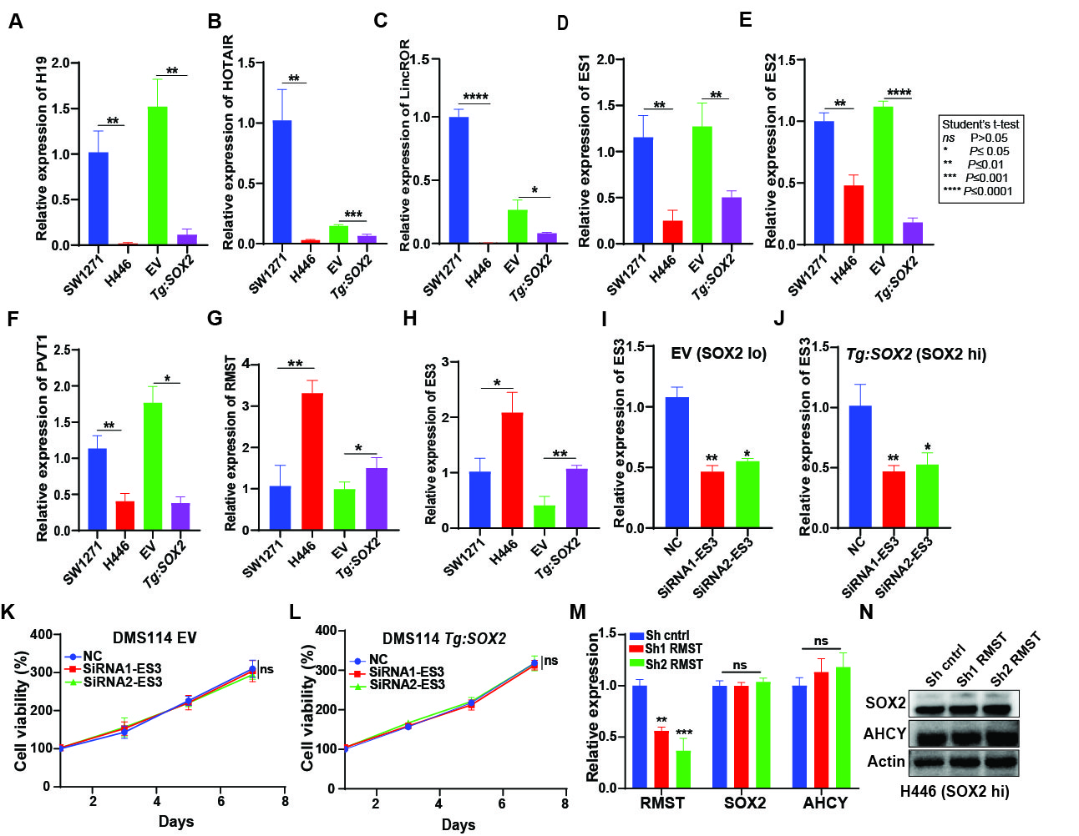
Fig. S3. Identification of lncRNAs bound by SOX2 and AHCY. qRT-PCR detection of lncRNAs (A) H19, (B) HOTAIR, (C) LincROR, (D) ES1, (E) ES2, and (F) PVT1 in SOX2 lo and hi SCLC cell lines, normalized to 18S rRNA. qRT-PCR detection of lncRNA RMST in (G) and ES3 in SOX2 lo and hi SCLC cell lines, normalized to ACTB. qRT-PCR detection of ES3 in (I) DMS114 EV and (J) DMS114 Tg:SOX2 cells treated with scrambled control or shRNAs for ES3 knockdown, normalized to ACTB. (K) CellTiter-Glo cell viability of DMS114 EV and (L) DMS114 Tg:SOX2 cells treated with scrambled control and siRNAs for ES3 knockdown. (M) qRT-PCR detection of RMST, AHCY, and SOX2 in H446 cells treated with scrambled control or shRNAs for RMST knockdown, normalized to ACTB. (N) Western blot of SOX2, AHCY, and ACTB in H446 cells treated with scrambled control or shRNAs for RMST knockdown. Statistical analysis was performed using Student’s two tailed t-test. Data is presented as mean ± SEM, n=3.

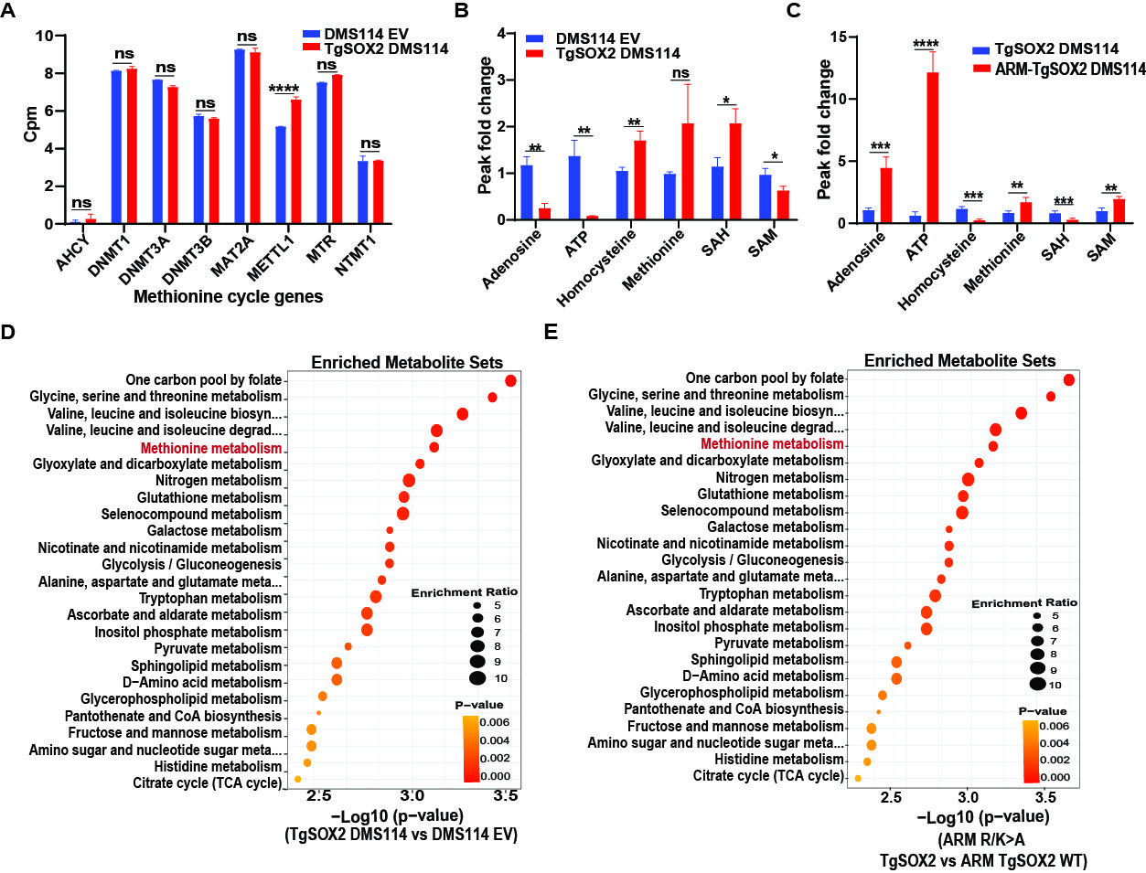
Fig. S4. SOX alters the methionine cycle in a non-transcriptional manner. (A) Gene expression of methionine cycle genes from RNA-seq performed on DMS114 EV and DMS114 Tg:SOX2 cells, n=3. (B) LC-MS/MS abundance fold changes of methionine cycle metabolites detected in (B) DMS114 Tg:SOX2 compared to DMS114 EV and (C) DMS114 Tg:SOX2 ARM mutant compared to DMS114 Tg:SOX2 cells. Metabolite Set Enrichment Analysis (MSEA) of differentially detected metabolites in (D) DMS114 Tg:SOX2 compared to DMS114 EV and (E) DMS114 Tg:SOX2 ARM mutant compared to DMS114 Tg:SOX2 cells. Statistical analysis was performed using Student’s two tailed t-test. Data is presented as mean ± SEM.
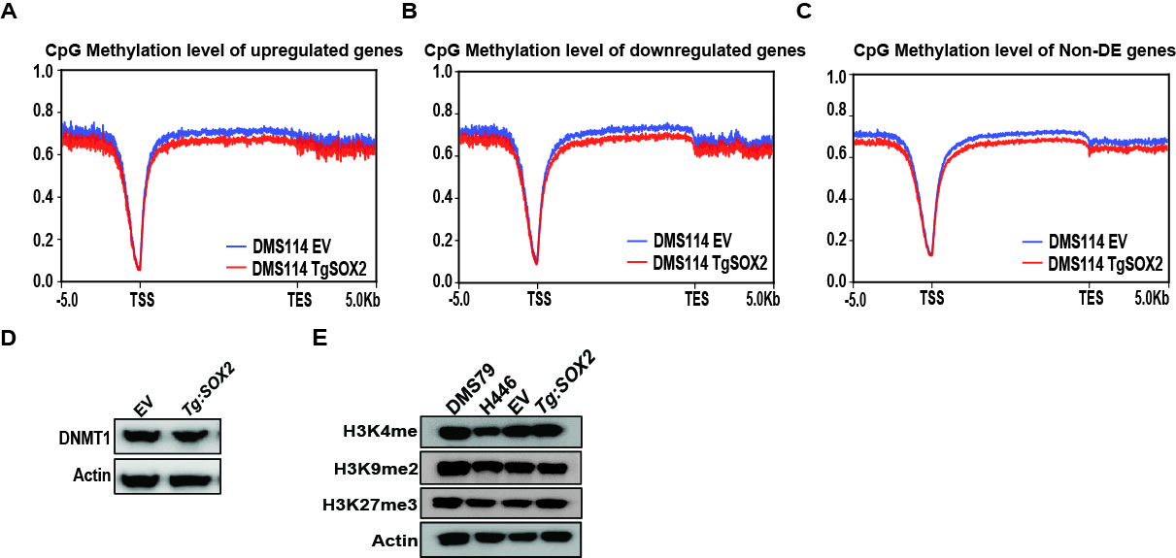
Fig. S5. SOX2 induces global DNA hypomethylation. (A) CpG methylation levels of differentially expressed (DE) (A) upregulated, (B) downregulated, and (C) unchanged, non-DE genes in DMS114 Tg:SOX2 compared to DMS114 EV cells. (D) Western blot for DNMT1 and ACTB in DMS114 EV and DMS114 Tg:SOX2 cells. (E) Western blot for histone methylation marks and ACTB in SOX2 lo and hi SCLC cells.

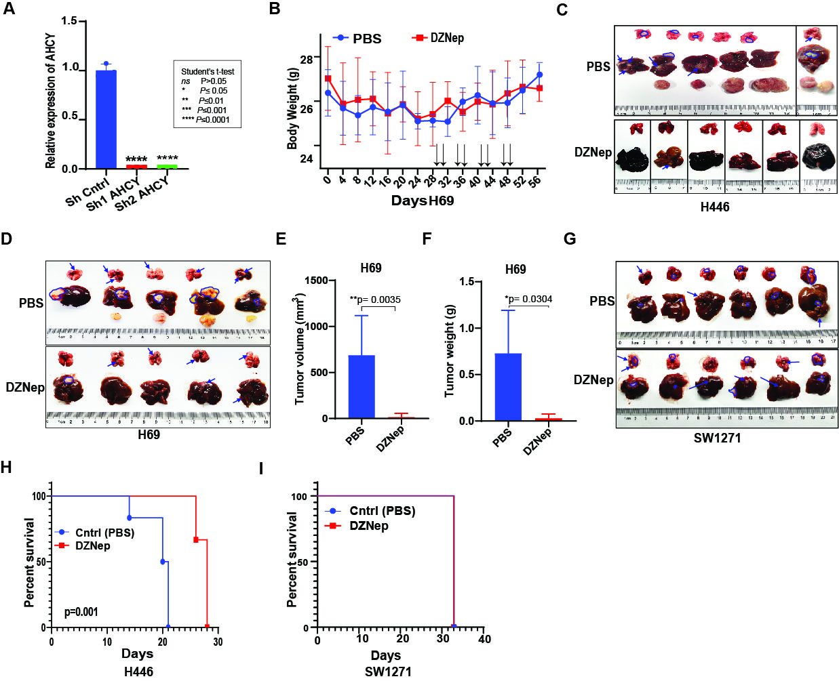
Fig. S6. DZNep targets SOX2-high cancers. (A) qRT-PCR detection of AHCY in DMS114 Tg:SOX2 cells treated with scrambled control or shRNA AHCY knockdown, normalized to ACTB. (B) Body weight of orthotopic SCLC hi SOX2 H69-Luc mouse model treated with intra-peritoneal (i.p.) injection of phosphate buffer saline (PBS) or DZNep on days indicated by arrows. Excised lung, liver, and abdominal tumor metastases with tumor tissue marked from (C) H446-Luc and (D) H69-Luc orthotopic SCLC mouse models treated with PBS or DZNep from Figure 6. (E) Tumor volume and (F) tumor weight of excised tumors from the H69-Luc experiments. (G) SW1271-Luc CDX orthotopic SCLC mouse models treated with PBS or DZNep. Excised lung, liver, and abdominal tumor metastases with tumor tissue marked by arrows. Kaplan–Meier survival curves of survival for (H) H446-Luc and (I) SW1271-Luc orthotopic SCLC mouse models treated with PBS or DZNep from Figure 7. Statistical analysis was performed using Student’s two tailed t-test. Data is presented as mean ± SEM, n=3 for qRT-PCR and n=6 for mouse experiments.

Tables
TABLE S1: List of RNA-dependent SOX2 binding proteins identified via SPRINT.
Genes | Functions | References
IARS1, HARS1, LARS1 | Transfer of specific amino acids to their cognate tRNA | ²⁵
RPLP0, RPLP1, RPLP2 | Integral ribosomal components | ^{26,27}
AHCY | DNA methylation maintenance, inhibitor of methyltransferases activity | ²¹
MCM7 | DNA replication | ⁶⁸
IPO9, PSIP1, | Genome integrity | ^{69,70}
SF3B4 | Splicing | ⁷¹
PRPS2 | Nucleotide biosynthesis | ⁷²
PSMD3 | Protein degradation | ⁷³
ABCF1 | Transcriptional co-activation | ⁷⁴
PPIB | Protein folding | ⁷⁵
MAP1B | Microtubule regulation | ⁷⁶
TMSB4X | Filament formation | ⁷⁷
MAP4 | Microtubule assembly | ⁷⁸
RBM3 | Protein synthesis | ²⁸
ANKRD40 | unknown | ⁷⁹

TABLE S2: List of significantly differentially expressed (DE) genes and non-DE data in RNA-seq of DMS114 Tg:SOX2 compared to DMS114 EV related to supplementary figure 5.
TABLE S3: List of differentially detected metabolites in LC-MS/MS metabolite profiling of DMS114 Tg:SOX2 compared to DMS114 EV, related to figure 4 and supplementary figure 4.
TABLE S4: List of differentially detected metabolites in LC-MS/MS metabolite profiling of DMS114 TgSOX2 ARM mutant compared to DMS114 Tg:SOX2, related to figure 4 and supplementary figure 4.
TABLE S5. Antibodies
Antibodies | Vendor | Catalogue number
SOX2 Rabbit polyclonal,IF, WB | CST | 2748
SOX2 ab for COIP MS | Abcam | Ab97959
SOX2 monoclonal Ab | Invitrogen | 14-9811-82
Anti-RAb ß-Tubulin | Abcam | Ab6064
Goat polyclonal anti-mouse Alexa Fluor 594 | Abcam | Ab150116
Goat polyclonal anti-rabbit Alexa Fluor 488 | Abcam | Ab150077
Goat pAb Rat IgG | Abcam | Ab150167
Rabbit polyclonal AHCY | Protein tech | 10757-2-AP
AHCY monoclonal ab | Protein tech | 66019-1-PBS
Mouse monoclonal PCNT | Abcam | ab28144
Rabbit mAB H2AX | CST | 9718
Rabbit monoclonal 5mC | Beyotime | AF5722
Rabbit polyclonal actin | Protein tech | 6624-1-Ig
H3K4me | Abcam | Ab8895
H3K9me2 | Active motif | 39240
H3K9me3 | CST | CST13969
H3K27me3 | CST | CST9733
H3 | CST | 14269
Anti lamin A/C | CST | 4777
Anti mouse BrdU | Protein tech | 66241-1-Ig
Caspase 3 | CST | 9662
Cleaved caspase 3 | CST | 9661
PARP | CST | 9532
Cleaved PARP | CST | 9541

TABLE S6: Commercial kits
Kit | Vendor | Catalogue#
RNA extraction kit | Qiagen | 74106
cDNA synthesis kit | Thermo Scientific | K1622
qPCR SYBR mix | Bimake | B21202
Promega CTG kit | Promega | G7570
FISH kit | Beyotime | R0306S
Biotin labeling SP6/T7 | Beyotime | R7061S
Lipofectamine 3000 | Invitrogen | L3000150

TABLE S7: Chemicals
Chemical | Vendor | Catalogue#
DZNep | MCE | HY-12186
NP-40 | Beyotime | P0013F
Formaldehyde | Sigma Aldrich | F8755
Blasticidin | Thermo Scientific | A1113803
puromycin | Thermo Scientific | A1112903
IP lysis Buffer | Thermo Scientific | 87788

TABLE S8: Experimental models
Experimental models | Source | Identifier
DMS114 | ATCC | CRL-2066
NCI-H69 | ATCC | HTB-119
SW1271 | ATCC | CRL-2177
NCI-H446 | ATCC | HTB-171
293T | ATCC | CRL-3216
MRC5 | ATCC | CCL-171
DMS79 | ATCC | CRL-2049
NSG mice | GemPharmatech | N/A

TABLE S9: Primers and oligonucleotides
Oligonucleotide primers | Forward | Reverse
ACTB | 5'-ACAGAGCCTCGCCTTTGCC-3' | 5'-GAGGATGCCTCTCTTGCTCTG-3'
AHCY | ATTCCGGTGTATGCCTGGAAG | GAGATGCCTCGGATGCCTG
H19 | GCGCGTAGTGGTTCTGATTG | AGTGCAGGGTCCGAGGTATT
ES3 | ACAGTCCTCAGCCTCCTGAA | TGGGTTGGTGTTCTCCTCTC
Hotair | GGTAGAAAAAGCAACCACGAAGC | ACATAAACCTCTGTCTGTGAGTGCC
RMST | CACCTTGGATCTAAGCAGCA | AGGCATTTAGGCCACATACG
Malat1 | GCTCTGTGGTGTGGGATTGA | GTGGCAAAATGGCGGACTTT
LincROR | GAAGGTTCAACATGGAAACTGG | TCGGGAAAGGATTCCAGCAC
HPRT | CCTGGCGTCGTGATTAGTGA | CGAGCAAGACGTTCAGTCCT
SCMH1 | CCACAGTAGTTGGACTGACAGG | ACAGTTCCCAATAGGCTGGATT
POU2F1 | TTTCCTCAGCTTTCCTGCAT | TGAAAACCGAACAACTTTCCT
PAX5 | TCCTCACCCTTCCTCACTGT | CCAGCCCCAGATGATTCTTA
NF1 | TGCATTTCTAGCCACTGCTG | ATGGCACACATCCACTTCTT
HOXA10 | GCAGTCCCACAGAGGAAAAA | TGGGAAAAGAACATCATTGC
IKZF1 | CTTATACACACACTTCAAGATTATGC | GCCTCTCACTCCACGCTGT
MYT1 | TACTTGCCTTTGGGGTGAAG | GCCACCAAAAGTGTGACTGA
MAPT | TACAGGAGGTGGAGAAAGC | GTCTCCCGGCTCGTTCCT
PDGFD | GGCCCCAGTGTGTAGTCTTT | ACTTTCTTTCCATTCAGGGGTA
18S rRNA | GCTTAATTTGACTCAACACGGGA | AGCTATCAATCTGTCAATCCTGTC
SOX2 | CAAGATGCACAACTCGGAGA | GCTTAGCCTCGTCGATGAAC
FISH probes
Homo-RMST-antisense-1 | 5'-(Cy5)TACgATCAgTCACCCACTgCCATCCTgCTgTgAAT-3'
Homo-RMST-antisense-2 | 5'-(Cy5)TgTTCTTTAACTgCCAACTTATCAgATgTgACA-3
Homo-RMST-antisense-3 | 5'-(Cy5)TggTTTCAgCCAgTCTTATAgAgAgACAgAACA-3'
Recombinant DNA | ShRNA 1 | ShRNA 2
AHCY | GTCAGGAGGGCAACATCTTTGCTCGAGCAAAGATGTTGCCCTCCTGAC | TCAAGGTGCCTGCCATCAATGCTCGAGCATTGATGGCAGGCACCTTGA
SOX2 | GCTGGAGCAACGGCAGCTACACTCGAGTGTAGCTGCCGTTGCTCCAGC | GCATGGCTCTTGGCTCCATGGCTCGAGCCATGGAGCCAAGAGCCATGC
RMST | GCTGGCTAATGTCATAATTCTCGAGAATTATGACATTAGCCAGC | CCACCACGGTTGTTTACAACTCGAGTTGTAAACAACCGTGGTGG
ES3 | GAAGACUGACACUGCCCAAUCTT | GGACUGAACUAUAUUUAAAUCTT

TABLE S10: Deposited data and software
Deposited data | GEO Accession number | Link to access data
WGBS data | GSE285441 | token: erclueeezfsfzon
RNA-seq data | GSE285441 | token: erclueeezfsfzon
Proteomics | PXD069283 | https://www.iprox.cn/page/SSV024.html;url=1760795611345ezO9 with password x2Pl
Software
Image processing | Image J | https://imagej.net/ij
Prism | GraphPad | https://www.graphpad.com
R version 4.3.2 |  | https://cran.r-project.org/

