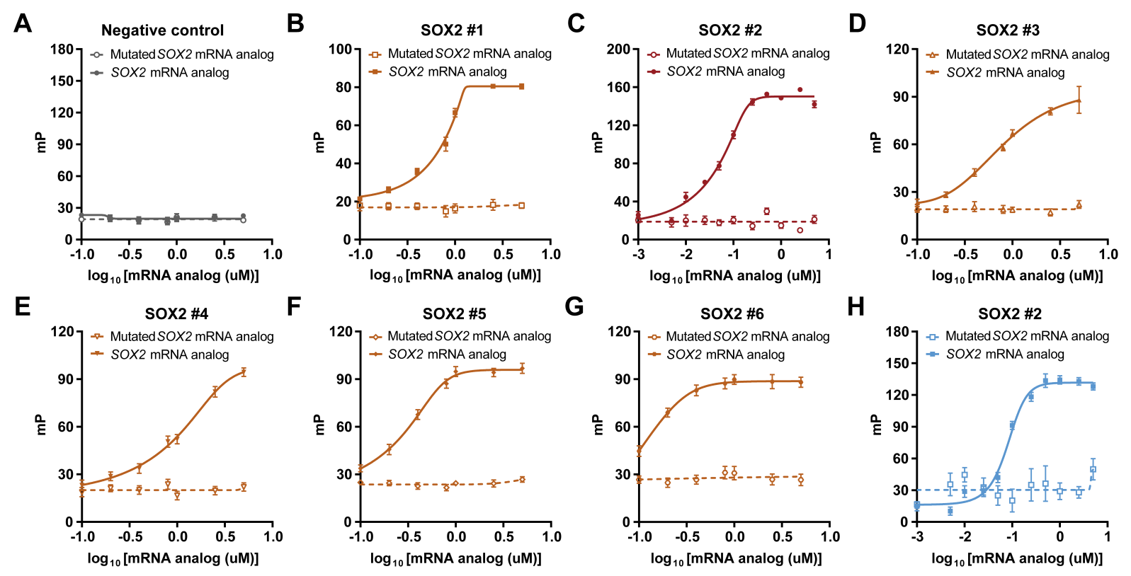
Supplemental Figures & Tables:

Fig. S1. SOX2 probe validation with synthetic mRNA analogs. (A) FA response curves of TAMRA-labeled negative control probe with corresponding target and probe binding site-mutated mRNA analogs set #1. (B-D) FA response curves of TAMRA-labeled SOX2 probes #1-3 with corresponding target and probe binding site-mutated mRNA analogs set #1. (E) FA response curves of TAMRA-labeled SOX2 probe #4 with corresponding target and probe binding site-mutated mRNA analogs set #2. (F-G) FA response curves of TAMRA-labeled SOX2 probes #5 and #6 with corresponding target and probe binding site-mutated mRNA analogs set #3. (H) FA response curves of CY5-labeled SOX2 probe #2 with corresponding target and probe binding site-mutated mRNA analogs set #1. Data is presented as mean ± SD, n = 2

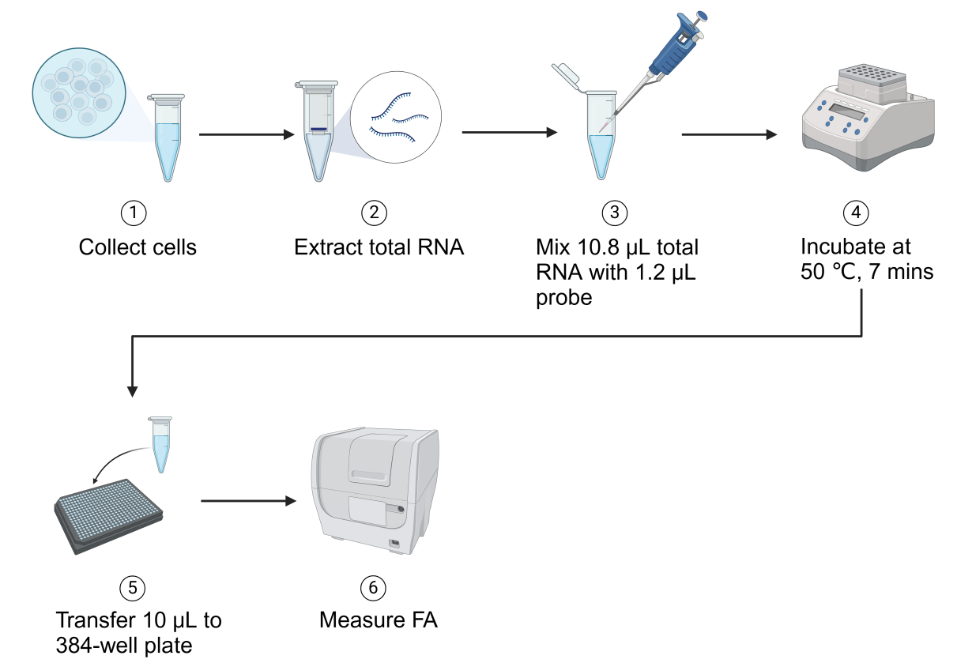
Fig. S2. Workflow of CFAR probe detection in purified total RNA. Created with BioRender.com/h19x140.

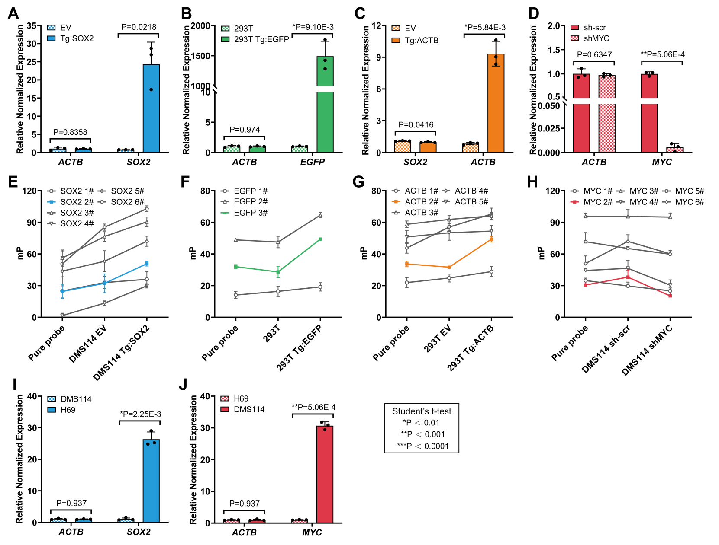
Fig. S3. CFAR probe selection. (A) qPCR measurements of ACTB and SOX2 in DMS114 Empty Vector and DMS114 Tg:SOX2 cells, normalized to GAPDH. (B) qPCR measurements of ACTB and EGFP in WT HEK293T cells and HEK293T Tg:EGFP cells, normalized to GAPDH. (C) qPCR measurements of SOX2 and ACTB in HEK293T Empty Vector and HEK293T Tg:ACTB cells, normalized to GAPDH. (D) qPCR measurements of ACTB and MYC in HEK293T scrambled shRNA control and HEK293T MYC shRNA knockdown cells, normalized to 18S rRNA. (E) CFAR measurements of SOX2 mRNA carried out with SOX2 probes and purified total RNA from DMS114 empty vector control cells and DMS114 cells expressing SOX2. (F) CFAR measurements of EGFP mRNA carried out with EGFP probes and purified total RNA from wildtype HEK293T cells and HEK293T cells expressing EGFP. (G) CFAR measurements of ACTB mRNA carried out with ACTB probes and purified total RNA from HEK293T empty vector control cells and HEK293T cells expressing ACTB. (H) CFAR measurements of MYC mRNA carried out with MYC probes and purified total RNA from DMS114 scrambled shRNA control cells and DMS114 MYC shRNA knockdown cells. (I) qPCR measurements of ACTB and SOX2 in DMS114 and H69 cells, normalized to GAPDH. (J) qPCR measurements of ACTB and MYC in DMS114 and H69 cells, normalized to 18S rRNA. Data is presented as mean ± SD, n = 3. Probes highlighted in color were used for downstream experiments.

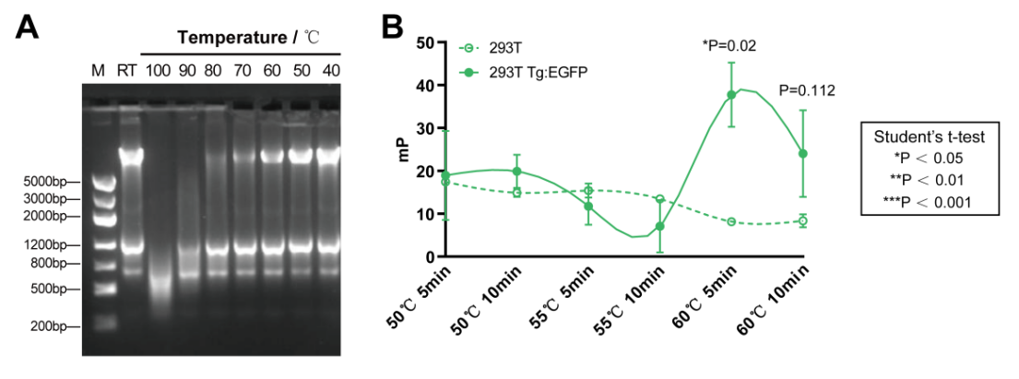
Fig. S4. Incubation temperature optimization. (A) Agarose gel electrophoresis of purified total RNA from HEK293T cells (100ng/μL) incubated at different temperatures for 5 mins. M: Marker; RT: Room Temperature. (B) CFAR measurements of EGFP mRNA in total RNA purified from WT HEK293T cells and HEK293T cells expressing EGFP under different incubation conditions. Data is presented as mean ± SD, n = 3.

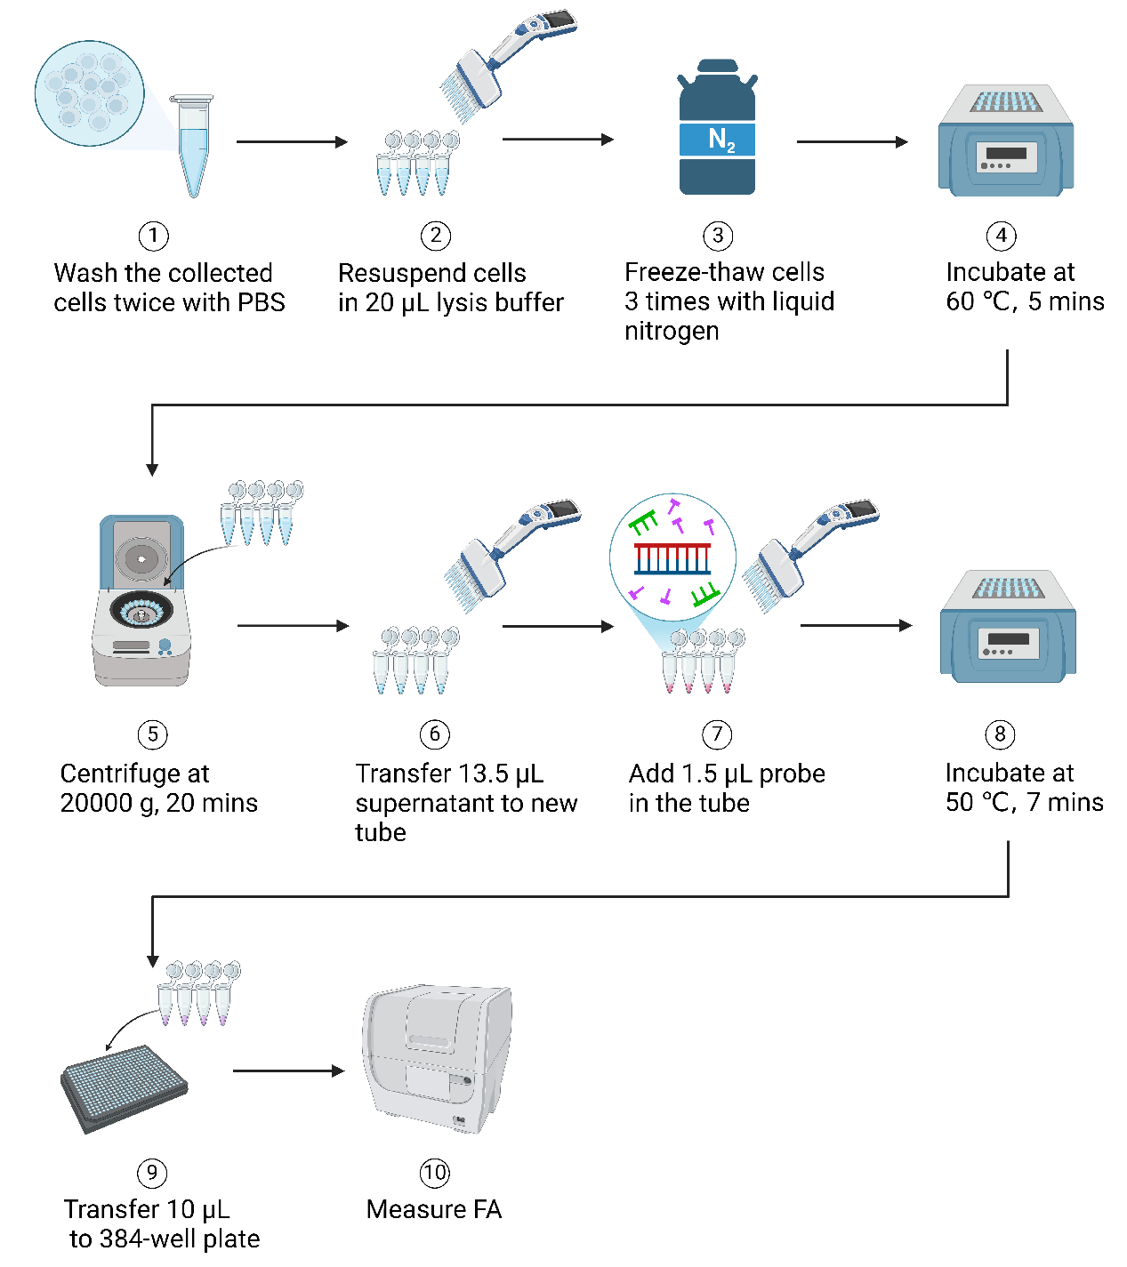
Fig. S5. CFAR workflow for cellular gene expression detection. Created with BioRender.com/h53q375.

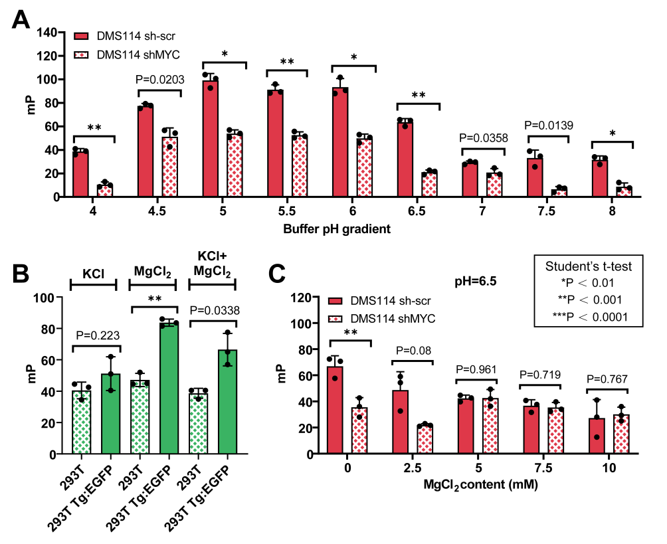
Fig. S6. Lysis buffer optimization. (A) CFAR measurements of MYC mRNA in DMS114 scrambled shRNA and DMS114 MYC shRNA knockdown with lysis buffer pH gradient. (B) CFAR measurements of EGFP mRNA in WT HEK293T and HEK293T Tg:EGFP cells with different lysis buffer salt additives. (C) CFAR measurements of MYC mRNA in DMS114 scrambled shRNA and DMS114 MYC shRNA knockdown under an MgCl₂ concentration gradient with constant pH of 6.5. Data is presented as mean ± SD, n = 3.

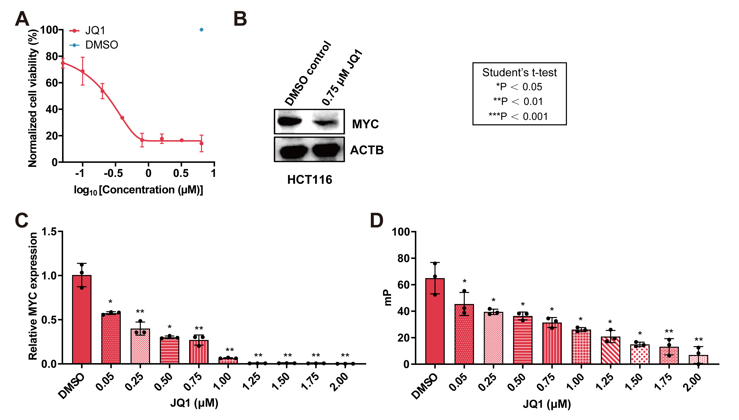
Fig. S7. JQ1 control optimization for high-throughput MYC detection. (A) Dose-response cell viability curve of HCT116 cells treated with JQ1 for 72 hrs, determined by CellTiter-Glo assay. (B) Western blot for MYC and ACTB in HCT116 treated with 0.75 μM JQ1 for 12 hrs. (C) Dose-response qPCR measurements of MYC expression in HCT116 cells incubated with JQ1 for 12 hrs. (D) Dose-response CFAR measurements of MYC expression in HCT116 cells incubated with JQ1 for 12 hrs. Data is presented as mean ± SD, n = 3.

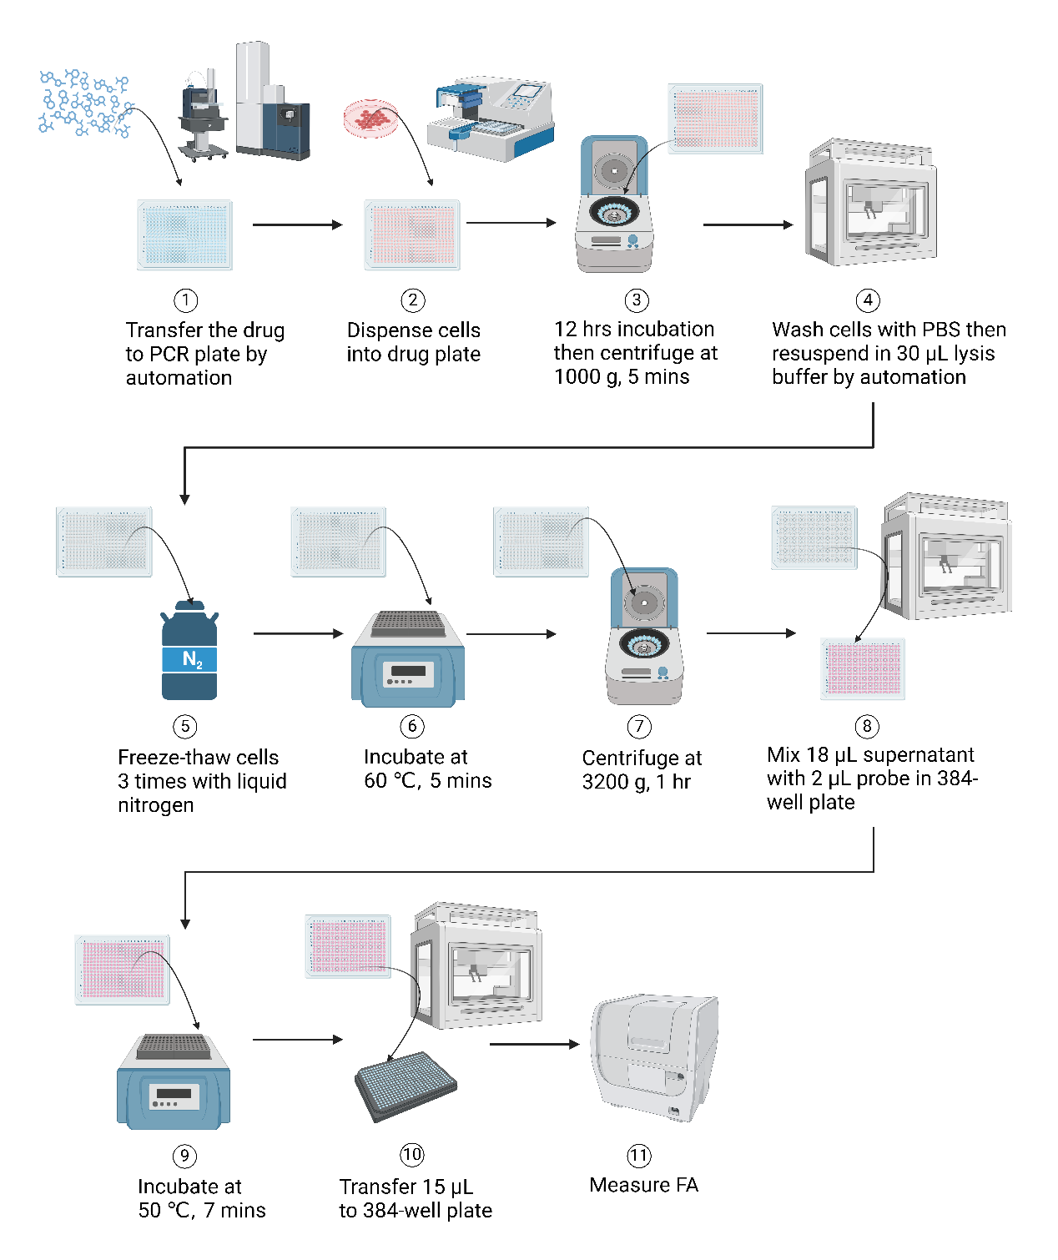
Fig. S8. CFAR workflow for high-throughput screening. Created with BioRender.com/x07m384.

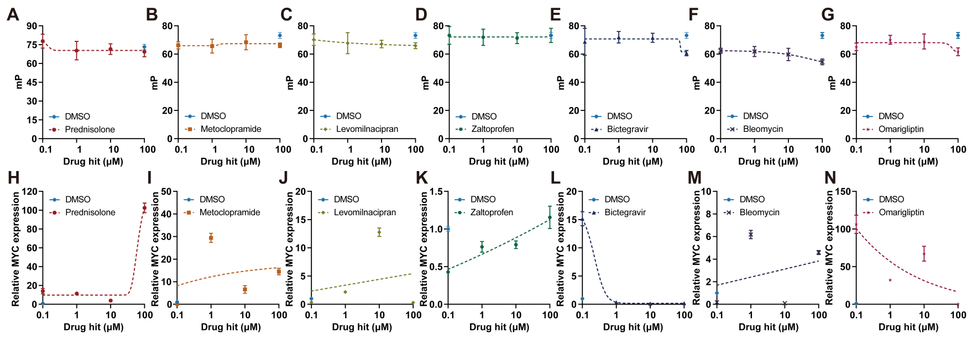
Fig. S9. MYC expression-modulating compound validation by CFAR and qPCR. (A-G) CFAR dose-response curves of MYC expression in HCT116 incubated with 7 hit compounds for 12 hrs. (H-N) qPCR dose-response curves of MYC expression in HCT116 incubated with the same 7 hit compounds for 12 hrs, normalized to 18S rRNA. Data is presented as mean ± SD, n = 3.

Fig. S10. Validation of MYC expression modulating hit compounds. (A) Cell viability curves of the cell line panel treated with (A) imatinib, (B) hypericin, and (C) doxorubucin for 72 hrs, determined by CellTiter-Glo assay. (D, E, F) Corresponding IC₅₀ values for (A, B, C). Correlation between MYC expression and (G) imatinib, (H) hypericin, and (I) doxorubucin response (log₂ fold change) in DepMap PRISM colorectal adenocarcinoma cell lines. Data is presented as mean ± SD, n = 3.

Table S1. Probe information for CFAR assays.
Probe name | Target gene | Sequence (5' to 3') | Modification
Negative control | - | AGGTCTATATGCTCAGGTAG | 5' 6-TAMRA
SOX2 #1 | SOX2 | CCTTGACAACTCCTGATACT | 5' 6-TAMRA
SOX2 #2 | SOX2 | CCTTTTGCAAACACTCTCTT | 5' 6-TAMRA, 5' CY5
SOX2 #3 | SOX2 | AGTCCTAGTCTTAAAGAGGC | 5' 6-TAMRA
SOX2 #4 | SOX2 | GTATTTATAATCCGGGTGCT | 5' 6-TAMRA
SOX2 #5 | SOX2 | TCTTTTGCAGCTGTCATTTG | 5' 6-TAMRA
SOX2 #6 | SOX2 | TTTTTGCGTGAGTGTGGATG | 5' 6-TAMRA
EGFP #1 | EGFP | TGAACTTGTGGCCGTTTACG | 5' 6-TAMRA
EGFP #2 | EGFP | TTGAAGTCGATGCCCTTCAG | 5' 6-TAMRA
EGFP #3 | EGFP | TTGTCGGCCATGATATAGAC | 5' 6-TAMRA
ACTB #1 | ACTB | ACATAGGAATCCTTCTGACC | 5' 6-TAMRA
ACTB #2 | ACTB | TCTTCATGAGGTAGTCAGTC | 5' 6-TAMRA
ACTB #3 | ACTB | TCATTGCCAATGGTGATGAC | 5' 6-TAMRA
ACTB #4 | ACTB | CTTGATCTTCATTGTGCTGG | 5' 6-TAMRA
ACTB #5 | ACTB | GACTTCCTGTAACAACGCAT | 5' 6-TAMRA
MYC #1 | MYC | CCCGAAAAAAATCCAGCGTC | 5' 6-TAMRA
MYC #2 | MYC | TCATAGTTCCTGTTGGTGAA | 5' 6-TAMRA, 5' CY5
MYC #3 | MYC | AGTAGAAATACGGCTGCACC | 5' 6-TAMRA
MYC #4 | MYC | AAACTCTGGTTCACCATGTC | 5' 6-TAMRA
MYC #5 | MYC | TTGAGAGGGTAGGGGAAGAC | 5' 6-TAMRA
MYC #6 | MYC | TTTCAGTCTCAAGACTCAGC | 5' 6-TAMRA

Table S2. SOX2 mRNA analog information.
Oligo name | Sequence (5' to 3') | MW | %GC
Analog #1 | GUUCAAAAAAGUAUCAGGAGUUGUC  AAGGCAGAGAAGAGAGUGUUUGCAA  AAGGGGGAAAGUAGUUUGCUGCCUC  UUUAAGACUAGGACUGAGAGAAAGA | 32583.65 | 42
Mutant analog #1 | GUUCAAAAAGCGGAUUUUCAUAUGC  AACGCAGAGUUUACCCUGAAAGCGU  AUACGGGAAAGUAGUUUGCUCGCCA  AAAAAUCUUGCCUAGGAGAGAAAGA | 32280.45 | 42
Analog #2 | GACGAGGCUAAGCGGCUGCGAGCGC  UGCACAUGAAGGAGCACCCGGAUUA  UAAAUACCGGCCCCGGCGGAAAACC  AAGACGCUCAUGAAGAAGGAUAAGU | 32477.7 | 56
Mutant analog #2 | GACGAGGCUAAGCGGCUGCGAGCGC  UGCACAUGAAGGUUUCCAGAACAGU  AUCCCAACGGCCCCGGCGGAAAACC  AAGACGCUCAUGAAGAAGGAUAAGU | 32414.64 | 56
Analog #3 | AAAAAUCCCAUCACCCACAGCAAAU  GACAGCUGCAAAAGAGAACACCAAU  CCCAUCCACACUCACGCAAAAACCG  CGAUGCCGACAAGAAAACUUUUAUG | 31998.51 | 45
Mutant analog #3 | AAAAAUCCCAUCACCCACAGGCACG  AAUUUGGGCUAAAAUGAACACCAAU  CCGAUCCACACAUUUAAAGGGGCCG  CGAUGCCGACAAGAAAACUUUUAUG | 32083.43 | 45

Table S3. MYC down-regulating hit compound information. High-throughput CFAR MYC expression detection was performed on HCT116 cells treated with a library of 3,139 approved drugs and active pharmaceutical ingredients, with JQ1 as positive control, for 12 hrs. The following 20 notable hits that significantly downregulated MYC were identified. 9 hits were selected for secondary validation by CFAR and qPCR. 4 MYC down-regulating compounds showed reproducible responses.
Compound name | mP  fold change | Target | Pathway | CFAR validated | qPCR  validated
Rhodamine B | 0.10 | Staining Fluorescent Dye | Others | - | -
Imatinib Mesylate | 0.19 | Bcr-Abl,c-Kit,PDGFR | Protein Tyrosine Kinase | Yes | Yes
6-Aminopenicillanic acid | 0.20 | Anti-infection | Microbiology | - | -
Chlorprothixene | 0.27 | Dopamine Receptor | Neuronal Signaling | Yes | Yes
Afatinib | 0.37 | ErbB Receptor | Protein Tyrosine Kinase | Yes | Yes
Levomilnacipran Hydrochloride | 0.40 | 5-HT Receptor | Neuronal Signaling | No | No
Zaltoprofen | 0.47 | COX | Neuronal Signaling | No | No
SulfadiMethoxine sodium | 0.66 | Anti-infection | Microbiology | - | -
Daunorubicin HCl | 0.67 | Topoisomerase | DNA Damage | - | -
Deoxycholic acid | 0.69 | Bile Acids | Others | - | -
Metoclopramide HCl | 0.69 | Dopamine Receptor | Neuronal Signaling | - | -
Metoclopramide hydrochloride hydrate | 0.69 | Dopamine Receptor | Neuronal Signaling | No | No
Prednisolone Acetate | 0.70 | Glucocorticoid Receptor | Endocrinology & Hormones | No | No
Rufinamide | 0.70 | Sodium Channel | Transmembrane Transporters | - | -
Prucalopride Succinate | 0.72 | 5-HT Receptor | Neuronal Signaling | - | -
Diacerein | 0.72 | IL Receptor | Others | - | -
PA-824 | 0.73 | Anti-infection | Microbiology | - | -
Doxorubicin HCl | 0.74 | Topoisomerase Ⅱ | DNA Damage | Yes | Yes
Bictegravir Sodium | 0.74 | HIV-1 Integrase | Proteases | No | Yes
Valrubicin | 0.74 | PKC | TGF-beta/Smad | - | -

Table S4. MYC up-regulating hit compound information. The following 5 notable hits that downregulated MYC were identified from the screen. 3 hits were selected for secondary validation by CFAR and qPCR. One MYC up-regulating compound showed a reproducible response.
Compound name | mP  fold change | Target | Pathway | CFAR validated | qPCR  validated
Hypericin | 1.58 | MAO | Metabolism | Yes | Yes
Insulin (human) | 1.50 | IGF-1R | Protein Tyrosine Kinase | - | -
Omarigliptin | 1.43 | DPP-4 | Proteases | No | No
Imidazole | 1.41 | Corrosion Inhibitor | Others | - | -
Bleomycin | 1.39 | DNA/RNA Synthesis | DNA Damage | No | No

